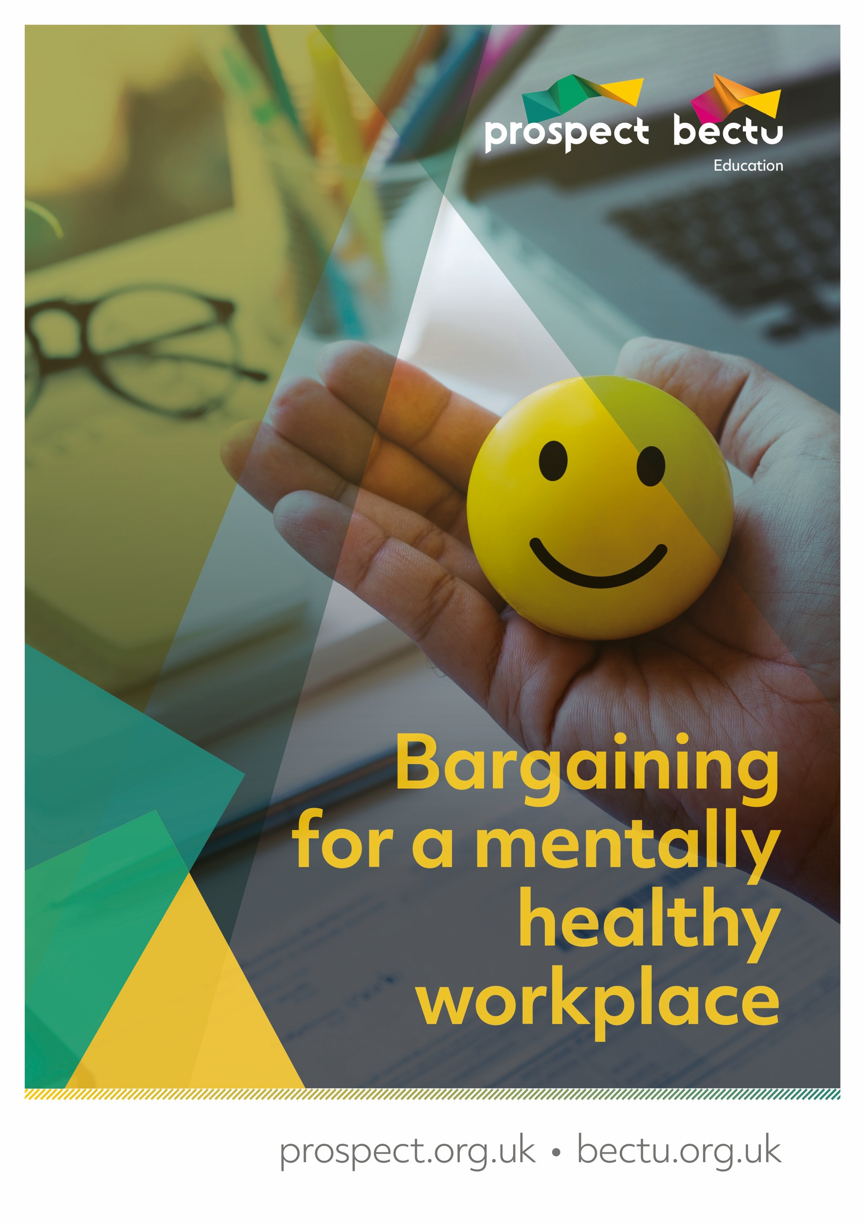

Bargaining for a mentally healthy workplace

Contents
Welcome to the course 4
Course programme 5
About Prospect 6
Equality and diversity statement 7
Activity 1: Paired introductions 8
What is mental health? 9
What about stress? 9
Mental health conditions 9
Social model of disability 12
Activity 2: Mental health conditions 13
The law 14
Health and Safety at Work etc Act 1974 14
Reasonable practicability 14
Risk assessment 15
Consultation 16
Activity 3: What is reasonably practicable? 17
The Management Standards 18
What are the standards? 19
Activity 4: Homeworkers 22
Homework activity: Organisational stress risk assessment, part one 23
Activity 5: Organisational stress risk assessment, part two 25
Mental health policies 26
Primary, secondary and tertiary interventions 27
Activity 6: Workplace policies and practices 28
Activity 7: Raising the profile of mental health in the workplace. 29
Further resources 30
Appendix: Course slides 31

Welcome to the course
Welcome to the Bargaining for a mentally healthy workplace course. On this course you will explore the different mental health conditions that may affect colleagues in the workplace and develop knowledge and understanding that will help you bargain for better provision to reduce risk and support members’ mental health.

The law
The course will consider how the law can support colleagues with mental health conditions, as defined in the Equality Act 2010. It will also consider the obligations placed on employers by health and safety law to address sources of stress in the workplace.

Workplace policies and practices
The course will consider what currently happens in the workplace around mental health, focusing on workplace policies and organisational stress risk assessments, and help participants assess employers’ provision and where this needs to be improved.
We will consider best practice approaches to holistic mental health and wellbeing workplace programmes, looking at proactive and reactive approaches

Raising the profile and bargaining for mental health
Participants will explore opportunities to raise awareness of mental health in the workplace. The course will help build knowledge and confidence in taking a collective bargaining approach to improving employer provision and practices to support good mental health and tackle stress.

Course programme

Class one
- Introduction to the course
- What is mental health? What is stress?
- Social determinants of mental health
- Rates of work-related stress, depression and anxiety
- The Health and Safety at Work Act, the Management Standards and stress risk assessment
- Homework activity

Class two
- The Management Standards and stress risk assessment, continued
- The Equality Act
- Reasonable adjustments
- Mental health policies
- Organising for mental health

About Prospect
Most of the larger unions in the UK have grown and evolved through mergers and acquisitions with other unions, staff associations and professional bodies – either through necessity or strategy.
Prospect is no exception, having absorbed various groups of professional and specialist staff. It is now the tenth largest union in Britain out of the sixty-six affiliated to the Trades Union Congress – the umbrella body for Britain’s unions – and the most diverse.
Prospect was formed in 2001 through the merger of the Engineers and Managers Association and the Institution of Professionals, Managers and Specialists. IPMS originated from the Royal Corps of Naval Constructors of 1916, so the new union inherited extensive history.
The EMA’s power station managers and electricity distribution engineers complemented the IPMS demographic (scientists, engineers and managers in the defence, energy, heritage, environment and transport sectors) and strengthened our bargaining power.
Prospect merged with the telecoms professionals in Connect union in 2010 and with Aspect, which represents professionals in education, children’s services and social care in 2012. In January 2017, Bectu, the media and entertainment union, joined us to create a sector which includes broadcasting, cinema, film, digital media, independent production, leisure, IT and telecoms, theatre and the arts.
Despite the expansion, the union has managed to maintain four key principles of industrial relations that are consistently important to members, whichever union they originated from:
- we represent professional staff
- we are not affiliated to any party political
- one of our objectives is ‘…to promote the advancement and efficiency of industries and organisations where members are employed’
- as an affiliate, we enjoy the resources of the TUC.

Equality and diversity statement
Prospect is dedicated to providing training for all its representatives and activists that aspires to the highest standards of respect for difference and diversity.
This statement is inspired by our trade union values of justice, fairness, democracy, solidarity and equality. As a trade union, we oppose any view, action or organisation that undermines the ability of working people to act collectively to pursue their democratically determined policies and objectives.
We are opposed to discrimination against people on the basis of their gender, nationality, ethnicity, religion, disability, sexual orientation, marital status, social class, age, politics or education.
We defend the right to freedom of expression and to political opinions and beliefs except where these conflict with, or tend to undermine, the freedom of other people from discrimination on the grounds listed above.
In particular, we are opposed to sexist, racist and fascist ideologies and will not permit such views to be promoted at Prospect education events.
We will seek to ensure that all Prospect training is accessible to all who wish to attend. Recruitment to courses will be open, fair and in line with our commitments above.
All courses will allow opinions to be put forward and defended (consistent with the statement above). All members who attend Prospect courses are entitled to respect.
Members who want to raise issues relating to our commitment to equality and diversity, or if they wish to lodge a complaint about any incident or failure concerning this policy, should use the following procedure:
- any issue occurring during a course to be raised with the tutor
- if this is not practicable, or if the complaint is not dealt with to the satisfaction of the member, it should be raised with Prospect’s education officer or the education and skills manager
- if a member is not satisfied, the matter should be referred to the General Secretary.

Activity 1: Paired introductions

Aims
To help you to:
- get to know more about each other
- work out your aims for the course
- practise interviewing, listening and note-taking.

Task
Work with another person to find out some basic information about their workplace and union experience so you can introduce them to the group when asked. Use the following headings for your interview:
- name
- job and employer
- role in the union
- why they’ve come on the course
- any mental health activities/achievements at work so far
- what they want to get out of the course.
Report back concisely – you’ll only have about two minutes each!

What is mental health?
There are many different definitions of mental health. The World Health Organisation (WHO) defines mental health as “a state of wellbeing in which every individual realises his or her own potential, can cope with the normal stresses of life, can work productively and fruitfully, and is able to make a contribution to her or his community”.
The Public Health Agency of Canada says that mental health is “the capacity of each and all of us to feel, think, and act in ways that enhance our ability to enjoy life and deal with the challenges we face. It is a positive sense of emotional and spiritual wellbeing that respects the importance of culture, equity, social justice, interconnections and personal dignity”.
However we define mental health, we all have it. It is a spectrum, and we will move from one part of the spectrum to another over time.
What causes us to move from one part of the spectrum to another is complex. For many people there is likely to be a complicated combination of factors, and different people could be more deeply affected by certain things than others. There is a strong body of research which suggests that mental health problems develop following adverse life experiences, including ones which happened in childhood.
Research also suggests that an individual’s mental health is strongly associated with the wider society in which we live. Certain groups are at higher risk of having poor mental health because of greater exposure and vulnerability to unfavourable social, economic and environmental circumstances.
According to the WHO: “Determinants of mental health and mental disorders include not only individual attributes such as the ability to manage one’s thoughts, emotions, behaviours and interactions with others, but also social, cultural, economic, political and environmental factors such as national policies, social protection, standards of living, working conditions, and community support.
“Stress, genetics, nutrition, perinatal infections and exposure to environmental hazards are also contributing factors to mental disorders.”

What about stress?
Stress is not a mental health diagnosis and is not a recognised mental health condition. However, it can lead to or trigger a range of mental and physical health problems.
The Health and Safety Executive defines stress as “the adverse reaction people have to excessive pressures or other types of demand placed on them”.
This distinguishes between “pressure”, which can be good for you in moderation, and “stress” which is always damaging. Some pressure can make us more alert and help us to perform better – think, for example, of deadlines, job interviews or public speaking. On the other hand, sustained or relentless pressure that exceeds our ability to cope can exhaust us and damage our health.
Our ability to cope is with stress is multi-faceted and depends on our own skills and previous experience, and the social support we are given. It can change from day to day depending on our circumstances.

Mental health conditions
Mental health conditions, also sometimes called mental illnesses, disorders or problems, are patterns of thinking, feeling, behaviour or mood that correlate with a diagnostic criteria. Diagnostic criteria for mental health conditions are codified in two publications: the American Psychiatric Association’s Diagnostic and Statistical Manual (DSM) and the Mental, Behavioural or Neurodevelopmental Disorders chapter of the WHO’s Classification of Diseases and Related Health Problems (ICD). They group manifestations of mental distress into discrete categories. There are dozens of discreet and subtly different disorders and the information in the following list – taken from ICD – is not exhaustive but includes information on the significant conditions. Descriptive details are taken from ICD, the NHS and Mind.
We all have a right to describe our experiences in the way that makes most sense to us. But not everyone who meets the criteria for mental health problems are comfortable with such diagnoses. For some people, diagnosis can be helpful, validating and providing an explanation for their feelings or behaviours. For some people, however, diagnostic labels can be problematic for a range of reasons, perhaps because they are stigmatising or fail to take account of an individual’s life experiences. We should be open to different terms according to how people define their own experiences of mental health, and validate the lived experience of people who are suffering.

Mood disorders
- Depression – characterised by feeling “low” and losing pleasure in things that were once enjoyable. These symptoms may be combined with others, such as feeling tearful, irritable or tired most of the time, changes in appetite, and problems with sleep, concentration and memory.
- Bipolar disorder – a potentially lifelong mood disorder characterised by episodes of mania (abnormally elevated mood), episodes of depressed mood and, potentially, psychotic symptoms such as hallucinations or delusions.

Anxiety or fear related disorders
- Anxiety (or generalised anxiety disorder) – characterised by experiencing a number of different worries that are excessive and out of proportion to a particular situation, and having difficulty in controlling one's worries.
- Panic disorder – unexpected and recurring panic attacks, and worrying about having another panic attack. A panic attack may happen because of a particular situation (something that the person fears or wants to avoid), or it may have no obvious cause.
- Phobias – Marked and excessive fear or anxiety that consistently occurs when exposed to one or more specific objects or situations (e.g., proximity to certain animals, flying, heights, closed spaces, sight of blood or injury) and that is out of proportion to actual danger.

Obsessive-compulsive disorders
- Obsessive-compulsive disorders (OCD) – thoughts, images or impulses that keep coming into the mind and are difficult to get rid of (called obsessions), and a strong feeling that the person must carry out or repeat certain physical acts or mental processes (called compulsions).
- Body dysmorphic disorder – persistent preoccupation with one or more perceived defects or flaws in appearance that are either unnoticeable or only slightly noticeable to others.
- Hoarding disorder – accumulation of possessions due to excessive acquisition of or difficulty discarding possessions.

Personality disorders
There are several different types of personality disorder, and each manifest in different patterns of attitudes, beliefs and behaviours, which can cause longstanding problems. They may include problems in functioning of aspects of the self (e.g., identity, self-worth, accuracy of self-view, self-direction), and/or interpersonal dysfunction (e.g., ability to develop and maintain close and mutually satisfying relationships, ability to understand others’ perspectives and to manage conflict in relationships).

Disorders specifically associated with stress
- Post-traumatic stress disorder (PTSD) – psychological and physical symptoms that can sometimes follow particular threatening or distressing events. A common symptom of PTSD is repeated and intrusive distressing memories of the event.
- Adjustment disorder – a maladaptive reaction to an identifiable stressor or stressors, such as divorce, illness or conflicts at home or work. It is characterised by preoccupation with the stressor or its consequences, including excessive worry, recurrent and distressing thoughts about the stressor, or constant rumination about its implications, as well as by failure to adapt to the stressor.

Dissociative disorders
- Dissociative amnesia – characterised by an inability to recall important memories, typically of recent traumatic or stressful events, that is inconsistent with ordinary forgetting.
- Dissociative identity disorder (once known as multiple personality disorder) – disruption of identity in which there are two or more distinct personality states (dissociative identities) associated with discontinuity in the sense of self and agency.
- Depersonalisation-derealisation disorder – characterized by persistent or recurrent experiences of depersonalization, derealization, or both.
- Depersonalisation – experiencing the self as strange or unreal, or feeling detached from, or as though one were an outside observer of, one’s thoughts, feelings, sensations, body, or actions.
- Derealisation – experiencing other people, objects or the world as strange or unreal (e.g., dreamlike, distant, foggy, lifeless, colourless, or visually distorted) or feeling detached from one’s surroundings.

Feeding or eating disorders
- Anorexia Nervosa – significantly low body weight for the individual’s height, age and developmental stage that is not due to another health condition or availability of food. Accompanied by persistent behaviours to prevent the restoration of normal weight, such as reducing energy intake (restricted eating) or increasing energy expenditure (e.g., excessive exercise), typically associated with a fear of weight gain.
- Bulimia Nervosa – frequent, recurrent episodes of binge eating, where the individual experiences a subjective loss of control over eating. It is accompanied by compensatory behaviours aimed at preventing weight gain (e.g., self-induced vomiting, strenuous exercise).

Schizophrenia or other primary psychotic disorders
- Schizophrenia – a severe, long-term mental health disorder characterised by profound disruptions in thinking, which can affect language, perception and the sense of self. It often includes psychotic experiences, such as hearing voices or delusions.
- Schizoaffective disorder – an episodic disorder that is marked by a combination of schizophrenia symptoms and mood disorder symptoms, such as depression or mania.
- Schizotypal disorder – characterised by an enduring pattern of eccentricities in behaviour, appearance and speech, accompanied by cognitive and perceptual distortions, unusual beliefs and difficulties with interpersonal relationships.

Social model of disability
The social model of disability was developed by disabled people as a challenge to traditional understandings of disability. These focused on the individual, seeing disability as located within individual disabled people, restricting what they could do and might result in them being dependent and unable to live a “normal” life.
The social model, on the other hand, says that people are disabled by barriers in society, not by their impairment or difference – or perceived impairment or difference. Barriers can be physical, like buildings not having accessible entrances, or they can be caused by people's attitudes and prejudice. Disability was therefore understood as a discriminatory and oppressive response to people seen as having an impairment, rather than a characteristic attached to the individual.

Activity 2: Mental health conditions
This activity will help you to:
- identify different types of mental health conditions.
- consider the impact for members with mental health conditions.

Task
As a group:
- identify the different types of mental health conditions you are aware of
- Consider what the impact of having these conditions could be in the workplace. What issues may arise for the members affected?
The tutor will lead a discussion around the topic.

The law
There are two sets of laws that govern an employer’s approach to addressing stress and mental health in the workplace – the Equality Act and health and safety law. These are addressed below. While there are no health and safety laws that specifically address work-related stress and the health conditions it can cause, it falls under the general provisions of the Health and Safety at Work etc Act 1974.

Health and Safety at Work etc Act 1974
The Health and Safety at Work etc Act 1974 (HSWA) governs employers’ approaches to reducing the risk of workers being injured or made ill because of work. Although it does not specifically mention stress or mental ill health, the Act contains general duties on employers to ensure the safety, health and welfare of all employees and others affected by risks arising out of work, which implicitly covers stress and mental ill health.
The HSWA is written in very general terms. It places broad duties on different groups or people in the workplace, including employers, the self-employed, controllers of premises, designers, manufacturers, suppliers and importers and employees. HSWA is designed to cover all hazards, all workplaces and all people at risk.
The general duties placed on employers are the central part of the act, since it is employers who create and can control the risks they are exposed to. The core duties are:
- Section 2 of the Act places a duty on employers to ensure the safety, health and welfare at work of employees. It states: “It shall be the duty of every employer to ensure, as far as is reasonably practicable, the health, safety and welfare at work of all [their] employees”.
- Section 3 is very similar, except it places a duty on employers to ensure they do not endanger the health, safety and welfare anyone affected by their work activities who is not an employee. This covers people such as contractors, passersby and customers.
The HSWA does not specify how this should be achieved. There are additional regulations, codes of practice and guidance which build upon and provide more detail about these general duties and how to meet them in a variety of situations. One of these regulations governs risk assessment, which an employer must carry out in order to decide how to protect workers from harm – including stress and mental ill health. Risk assessment is addressed in more detail below.
The HSWA is a criminal act. In England and Wales, the Health and Safety Executive (HSE), local authorities or other regulators (depending on the sector) investigate incidents and can bring prosecutions on behalf of the Crown. In Scotland, prosecutions are brought by Crown Office and Procurator Fiscal Service, with the support of and following investigations by the HSE or local authorities. There is a separate health and safety regulator in Northern Ireland, the HSE NI.

Reasonable practicability
As outlined above, many duties in the HSWA are qualified by the term “reasonably practicable”. It also appears in other regulations. Reasonably practicable duties mean that the reduction in risk produced by a particular measure must be judged against the sacrifice involved in introducing it.
In effect, it is like a set of scales, with risk on one side, and the cost, time and trouble involved in controlling the risk on the other. It recognises that risk is a spectrum and not absolute, and that it may not always be desirable to completely remove risk because, if it was, a beneficial activity would not be able to take place.
Only when the sacrifice is very great compared with the risk (in “gross disproportion”, according to case law) does the employer have a valid legal reason not to introduce the measure to control the risk. This means that there is a presumption that employers will introduce a measure – it is weighted in favour of health and safety, rather than cost.
While this means that employers can argue that the cost of introducing a measure cannot be justified by the benefit, the union may have a different idea of what is reasonably practicable to the employer and that a particular proposed measure does not adequately discharge the legal duty. In these circumstances, the union will need to negotiate with the employer for its implementation.
Under the Act, a lack of money on behalf of the employer to introduce an improvement is not an acceptable argument for not introducing a protective measure. If it can be shown that an improvement is necessary and the benefits it will produce outweigh its costs, failure to introduce it cannot be justified on lack of cash grounds.

Risk assessment
Just like hazards that can cause us physical harm, employers have a legal duty to assess the risk of employees sustaining psychological harm and take steps to prevent it from occurring.
The Management of Health and Safety at Work Regulations 1999 (MHSWR) require employers to carry out a “suitable and sufficient” assessment of the health and safety risks faced by workers. Like the HSWA, this does not explicitly reference stress or mental ill health, but it is covered under the general provisions to protect workers’ health.
When carrying out a risk assessment, regardless of whether the issue being considered is one of psychological or physical health and safety, an employer must:
- identify all things that can cause harm (these are called “hazards”);
- decide how likely it is that people will be harmed and how serious it could be (this is known as the risk);
- work out how to prevent that harm from occurring, and implement the steps identified;
- record the process; and
- review and update the risk assessment when it is no longer valid or effective
The law states that a risk assessment must be “suitable and sufficient”. The HSE says that this means the risk assessment should show that:
- a proper check was made, taking into account all things that could cause harm;
- the obvious significant risks are deal with, taking into account the number of people who could be involved;
- the precautions are reasonable, and the remaining risk is low as is reasonably practicable; and
- workers or their representatives were involved in the process.
Employers often argue that it is very difficult to tackle stress because everyone reacts to pressure differently. While this is true, health and safety law primarily requires employers to manage and reduce exposure to things that cause harm. Employers must therefore focus on tackling and reducing recognised causes of stress. There is more information on this in the Management Standards section below.

Consultation
Under the Safety Representatives and Safety Committees Regulations, employers have a legal obligation to consult trade union health and safety representatives:
- before introducing any measure which may substantially affect employees’ health and safety;
- on any information or training regarding health and safety; and
- on the health and safety consequences of the introduction of new technologies.
All of these points relate to stress as much as any other health and safety issue. Even if there aren’t health and safety representatives in the workplace, the employer must still consult staff, which will ensure that all stressors and experiences are appropriately taken account of.

Activity 3: What is reasonably practicable?
The activity will help you to:
- Develop familiarity with the “reasonable practicability” in practice and how it relates to real world-situations.
- Developing understanding of how to use the principle to negotiate with the employer for better protections.

Task
In pairs:
- Read the scenario below
- Evaluate:
- Has the employer has done all that is reasonably practicable to protect staff?
- Could the employer introduce better measures in the circumstances? Can you give any examples?
- How could you use the principle of reducing risk to the lowest level reasonably practicable to argue for better protections?
- Choose a spokesperson who will report back to the group

Scenario
You are a rep working for a large manufacturing company in the north west of England, whose parent company is based in the United States. The employer is preparing a hybrid working policy which formalises the working arrangements that have been in place since COVID restrictions on workplace attendance were relaxed. The employer is proposing to adopt a three-two working pattern, where staff work in the office for three days a week and at home for two days a week, with core hours of 9am to 5pm.
Before the pandemic, the finance team would often have to work outside standard UK office hours to maintain communication with colleagues in the US, but members in this team report that, since the pandemic, the amount of out-of-hours work has increased significantly in response to the extension of working hours of US colleagues.
You and your members working in the finance team had hoped the new hybrid working arrangements would contain provisions to reign in working hours, but it has not been addressed.
You have told your employer that members are experiencing stress and that it must take steps to protect them. The employer has responded by saying it has no control over the working hours of staffing working in the US, and that communication between the two teams is vital, but has said that all line managers will be provided with training on how to support staff in maintaining a healthy work-life balance, and a module on work-life balance will be added to the company’s e-learning platform. In the time since this was introduced, a member of this team has been signed off with stress.

The Management Standards
Workplace stressors are nearly always a consequence of how organisations are run or work is designed, so employers must address these organisational factors in the risk assessment in order to tackle them.
To help with the process of risk assessment, the Health and Safety Executive developed the Management Standards. Earlier we mentioned that guidance can indicate how an employer must discharge its duty under the HSWA. The Management Standards provides guidance and a methodology on how to do this in relation to stress. Following the Management Standards is not a legal requirement, but if employers do not follow it they must find another suitable way to meet the requirement.
At the core of the Management Standards are six statements about the ideal design of work in organisations. They group together factors at work which research has shown cause people stress, making the process of hazard identification easier. Failure to manage these factors causes stress and is associated with poor health, lower productivity and increased accident and sickness absence rates. In a sense, it addresses the first stage of the risk assessment (identifying the things that can cause people harm).
Because they are standards, they can be used to assess and benchmark how well an employer is managing the risk of psychological harm occurring and develop methods to reduce that risk.
The overarching themes of the six standards are:
- demands – issues such as workload, work patterns and the work environment
- control – how much say people have in the way they do their work
- support – the encouragement, sponsorship and resources provided by the organisation, line management and colleagues
- relationships – promoting positive working to avoid conflict and dealing with unacceptable behaviour
- role – whether people understand their role and do not have conflicting roles
- change – how organisational change (large or small) is managed and communicated.
Managing stress effectively requires good engagement and partnership working between employers and employees. Although many measures to tackle stress are straightforward to implement, they do need commitment and resources.

What are the standards?

Demands
The standard is: “Employees indicate that they are able to cope with the demands of their jobs.”
What should be happening:
- The organisation provides employees with adequate and achievable demands in relation to the agreed hours of work
- People's skills and abilities are matched to the job demands
- Jobs are designed to be within the capabilities of employees
- Employees' concerns about their work environment are addressed

Control
The standard is: “Employees indicate that they are able to have a say about the way they do their work.”
What should be happening:
- where possible, employees have control over their pace of work
- employees are encouraged to use their skills and initiative
- employees are encouraged to develop new skills to help them undertake new and challenging work
- the employer encourages employees to develop their skills
- employees have a say over when breaks can be taken
- employees are consulted over work patterns.

Support
The standard is: “Employees indicate that they receive adequate information and support from their colleagues and superiors.”
What should be happening:
- the employer has policies and procedures to adequately support employees
- systems are in place to enable and encourage managers to support their staff
- systems are in place to enable and encourage employees to support their colleagues
- employees know what support is available and how and when to access it
- employees know how to access the required resources to do their job
- employees receive regular and constructive feedback.

Relationships
The standard is: “Employees indicate that they are not subjected to unacceptable behaviours, eg bullying at work.”
What should be happening:
- the employer promotes positive behaviours at work to avoid conflict and ensure fairness
- the employer has agreed policies and procedures to prevent or resolve unacceptable behaviour
- systems are in place to enable and encourage managers to deal with unacceptable behaviour
- systems are in place to enable and encourage employees to report unacceptable behaviour.

Role
The standard is: “Employees indicate that they understand their role and responsibilities.”
What should be happening:
- the employer ensures the different requirements it places on employees are compatible
- the employer provides information to enable employees to understand their role and responsibilities
- the employer ensures the requirements it places on employees are clear
- systems are in place to enable employees to raise concerns about any uncertainties or conflicts they have in their role and responsibilities.

Change
The standard is: “Employees indicate that the organisation engages them frequently when undergoing an organisational change.”
What should be happening:
- the employer provides employees with timely information to enable them to understand the reasons for proposed changes
- the employer ensures adequate employee consultation on changes and provides opportunities for employees to influence proposals
- employees are aware of the probable impact of any changes to their jobs. If necessary, employees are given training to support any changes in their jobs
- employees are aware of timetables for changes
- employees have access to relevant support during changes.

The Equality Act
The Equality Act legally protects people with certain specific characteristics from discrimination in the workplace and in wider society.
The protected characteristics are: age, disability, gender reassignment, marriage and civil partnership, race, religion or belief, sex, sexual orientation, and pregnancy and maternity.
For many people, mental health problems will be considered a disability under the Equality Act. For the purposes of the Act, a person is disabled if they:
- Have a physical or mental impairment. This includes the effects or symptoms of any illness and includes the side effects of any medication.
- The impairment is long-term – it has lasted or is likely to last for at least 12 months. This includes fluctuating or recurring conditions such as depression.
- The impairment has a substantial adverse effect on their ability to carry out normal day-to-day activities – “substantial” means more than small or minor.
The Act specifically excludes addiction to or dependency on alcohol or any other substance, unless it is a consequence of a substance being prescribed.
To ensure equality for people who are disabled, employers may be required to change the way employment is structured, remove physical barriers or provide individuals with extra support where a disabled worker would be at a substantial disadvantage without them. Under the Equality Act, these changes are known as “reasonable adjustments”. Those with mental health problems may be entitled to reasonable adjustments.
Any adjustment must remedy the disadvantage that the disabled person faces. Ultimately it is for employment tribunals to determine whether an adjustment is reasonable.
They would consider a range of factors, including the effectiveness of the adjustment; the extent to which it is practicable for the employer to make the change; any financial or other costs involved; and the employer’s financial and other resources.
However, reasonable adjustments for mental health problems could include, for example:
- Flexible working hours
- Work from home
- Reducing workload work volume
- Changes to the physical working environment
- Increased supervision
- Increase support from other members of staff
- Additional training
- A phased return to work
- Job redeployment
An individual does not have to be diagnosed with a mental health condition in order to have reasonable adjustments. The duty applies when the employer is aware or should reasonably be aware that an employee has an impairment.
In practice, employers unfortunately often want evidence that an individual is disabled – particularly when it comes to hidden disabilities, such as mental health problems. Reps may want to consider what sources of information are available to the employer for them to be reasonably aware of a member’s mental health condition, for example occupational health information.
It has been established, through case law, that the duty to determine reasonable adjustments rests with the employer. An employer cannot argue that its duty has been discharged because the employee cannot suggest any suitable adjustments:
There is no onus on the disabled worker to suggest what adjustments should be made (although it is good practice for employers to ask). However, where the disabled person does so, the employer should consider whether such adjustments would help overcome the substantial disadvantage, and whether they are reasonable.

Activity 4: Homeworkers
This activity will help you to:
- Develop familiarity with the HSE’s Management Standards and organisational approaches to stress

Task
As a class, discuss the stressors which home workers may experience.
The tutor will then lead a discussion about how these relate the to the Management Standards.

Homework activity: Organisational stress risk assessment, part one
This activity will help you to:
- Develop familiarity with the HSE’s Management Standards and organisational approaches to stress
- Develop familiarity with factors in the workplace which may be causing stress

Task
- Read through the case study below
- Identify four stressors faced by the group
- Using the Management Standards as a guide, identify one possible measure to reduce the risk for each stressor. Consider the standards’ “states to be achieved”.
- Make clear but brief notes on your findings in an electronic document, clearly identifying the stressor in the case study and the potential solution
- Get a copy of your employer’s mental health policy (this is not for this exercise, but for an activity during the following class).

The IT support officers
There are 10 people working in the Alpha Industries IT team. Their usual places of work are spread across the business’s three sites, but since the pandemic all members of staff work from home two days a week according to a rota, apart from the team’s head and deputy head, who work from home when they choose. Their roles and their locations are:
London site | North-East site | North-West site
- Head of IT x 1  - Deputy head of IT x1  - IT projects officer x 1  - Data officer x 1  - IT support officer x 2 | - IT support officer x 2 | - IT support officer x 2
As part of the risk assessment, you hold a discussion group with the six IT support officers. They are all members.
They tell you that, day to day, they are fairly busy responding to requests from members of staff. Requests for support come via an online system – staff in the business who need help raise a support ticket. Support requests can range from addressing problems with laptops and phones to software faults and troubleshooting. The IT support officers are also responsible for providing training to new recruits and on new software.
New tickets are placed into a queue. When a member of the team marks a ticket as complete, the system automatically assigns them a new ticket to complete. They can have many active tickets at once. The system does not triage of tickets, so they are randomly assigned to members of the team. The IT team operates under a number of service level agreements (SLAs) which dictate the length of time that a team member has in order to resolve and complete a ticket.
Members of the team report that, before the pandemic, their workload was high but about manageable. However, there was an influx of support requests when the organisation switched to homeworking at the start of the pandemic. In response, the business decreased the SLAs, meaning that the IT support officers had less time to resolve a ticket. The aim was to get through more tickets. Although the organisation is now hybrid working, members of the team say their workload has not decreased, partly because the business rolled out a number of new software programmes to support hybrid working and for which they receive a large number of support requests.
The employees based in the north east and north west tell you that they do not have much contact with the head and deputy head of the team, apart from during their performance appraisals every three months. Staff in the London office say they are annoyed that the head and deputy head can choose when and how often they work from home, while they themselves have no choice over their schedule (although they recognise the need to have staff present in the office in case of service requests). They say they do not see them very often.
The IT department’s business plan for the year contains a commitment to migrate the business to Microsoft 365 by the end of quarter two, which is now only a few months away. The IT support officers have not been told anything about how or when it will happen, despite the fact they will be expected to troubleshoot any problems and provide training to staff. IT support officers based at regional sites are particularly worried as they receive little support from their manager.

Activity 5: Organisational stress risk assessment, part two
This activity will help you to:
- Develop familiarity with the HSE’s Management Standards and organisational approaches to stress
- How to collectively raise and tackle stressors with employers

Task
In your groups, work through all group members’ responses to the homework activity – aim to get through as many as possible in the allotted time.
Reflect and evaluate how you would negotiate with the employer for these measures to be implemented. For example, among other things consider:
- How will the employer respond to the proposals?
- Do you think you could be successful in securing the measures? What are your strengths and weaknesses?
- How easy will they be to implement?
- Who on the employer side will need to implement them?
- How will you raise the issue with the employer – with an individual or in a committee?
- Does your branch need to take a view on the measures? Are there any policy implications?
- Who will need to get involved from your branch?
Nominate a spokesperson to report back to the group

Mental health policies
Good mental health policies establish the employer’s commitment to promoting mental health and removing or minimising psychologically harmful work practices.
The mental health policy should link to and identify how it relates to other policies and procedures, e.g. health and safety, disciplinary procedures, sickness absence, performance management, substance abuse and dependency, training and development, etc.
A good policy will contain:
- The employer’s commitment to promoting and protecting employee’s mental health
- A definition of mental health
- A commitment to, and methods for, promoting awareness of mental health and tackling stigma
- Roles and responsibilities of the people in the organisation who have specific obligations and functions under the policy, including:
- line managers (e.g. supporting employees with mental health problems);
- human resources (e.g. monitoring the effectiveness of the policy and referral to HR-linked services such as occupational health or the EAP);
- occupational health (e.g. carrying out occupational health assessments);
- employees (e.g. responsibilities to colleagues); and
- union reps (e.g. promoting mental health, supporting members, representing members and monitoring the impact of workplace policies and procedures on mental health).
- The practical arrangements in place to achieve the statement of intent, including:
- the presence and maintenance of a stress risk assessment and action plan;
- reasonable adjustments (see section above), for current workers and during recruitment and selection; and
- methods for monitoring employee mental health at an organisational level.
- A list of key internal and external sources of information, support and advice
- A commitment to provide training, including raising awareness, and roles and responsibilities
- Information regarding recruitment and selection
- What methods will be used to monitor the effectiveness of the policy, and a commitment to keep the policy under review.

Primary, secondary and tertiary interventions
When looking to address any health issue, either in national or local environments, there are three categories or “levels” of intervention. In the context of stress and mental health, they can be considered as in the table below. Each level of intervention has a role to play in a holistic mental health programme. Measures to support employees if they develop a mental health problem and, for example, help them return to work must be implemented alongside efforts to reduce work and job factors that cause stress.

Primary | Secondary | Tertiary
An intervention that modifies or eliminates stressors, targeting problem at source. It deals with aspects of work design, the organisation and management. It is targeted at the group level, rather than the individual employee. | An intervention that tends to help individuals manage stress without trying to eliminate or modify workplace stressors. It will typically assist individuals to identify stress symptoms in themselves and others, or acquire or improve coping skills. | An intervention that seeks to assist individuals who are experiencing on-going problems emanating either from the work environment or their work lives. The purpose is to adapt individual behaviour and lifestyle without much reference to changing organisational practices.
Reduce or eliminate causative risk factors (risk reduction). | Early identification and treatment. Coping techniques. | Stop the condition from getting worse and help people return to health.
Risk assessment, provision of appropriate resources, tackling bullying, reducing workload etc | Training, provision of information, mental health first aiders etc | Provision of counselling, employee assistance programme, reasonable adjustments, mental health first aiders etc

Activity 6: Workplace policies and practices

Aims
This activity will help you to:
- consider current workplace policies and practices in relation to mental health.
- identify improvements for policies and practices
- establish best practice for policies and practices.

Task
In pairs, compare and discuss your employers’ policies. Discuss and answer the following questions:
- Does the policy cover all areas you believe are necessary? What areas should it cover?
- ls this policy a reflection of what actually happens, in practice, in the workplace? Identify any improvements needed.
- If your employer does not have a mental health policy, are there any plans to develop such a policy?
- What other workplace policies/procedures cover mental health?
- Which policy, if either, is the strongest and why?

Report back
Prepare a report for the rest of the group. Elect a spokesperson to share your report.

Activity 7: Raising the profile of mental health in the workplace.

Aims
This activity will help you to:
- Identify strategies for developing awareness of mental health in the workplace.
- Establish best practice for developing a positive approach for workplace mental health and wellbeing.

Task
In small groups, develop a plan to raise the profile of mental health and raise awareness at work.
You may wish to consider ways in which you can progress mental health with the employer, identify negotiating and campaigning opportunities, different methods for raising awareness in the workplace, policy development etc. Consider who you will work with and how you will involve members, other reps and the branch.
Identify the benefits of having a workplace which has a positive approach to mental health and wellbeing, for colleagues, the employer and the union.

Report back
Elect a spokesperson, to share your plan with the rest of the group.

Further resources
- Prospect guides (you will need to log in to the website to access)
- Members' guide to home and remote working https://library.prospect.org.uk/download/2020/00419
- Members' guide to promoting mental health at work https://library.prospect.org.uk/download/2020/00379
- Members' guide to preventing work-related stress https://library.prospect.org.uk/download/2020/00393
- Harassment and bullying
https://library.prospect.org.uk/download/2007/00549
- Members' guide to equality at work
https://library.prospect.org.uk/download/2008/00092
- Disability resource pack for reps and members https://library.prospect.org.uk/download/2019/01862
- Toolkit: How good is my employer’s stress risk assessment? https://library.prospect.org.uk/download/2019/00631
- Remploy’s workplace mental health service
Remploy's workplace mental health support service – Mental Health At Work

Appendix: Course slides

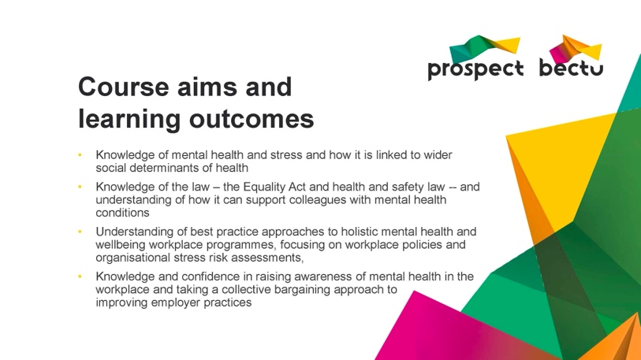 | Notes:

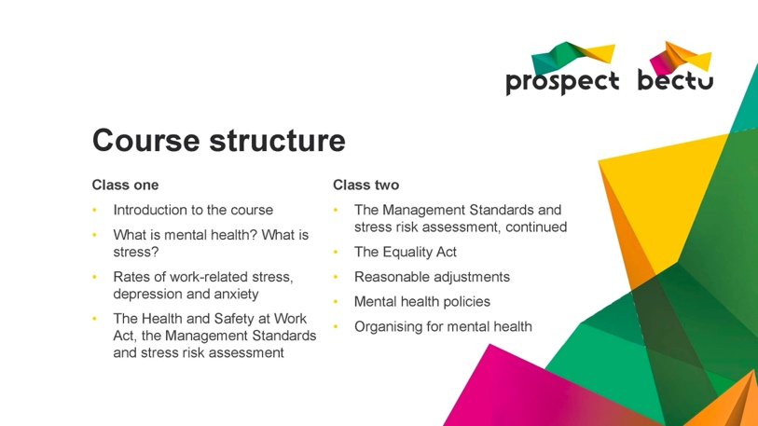 | Notes:

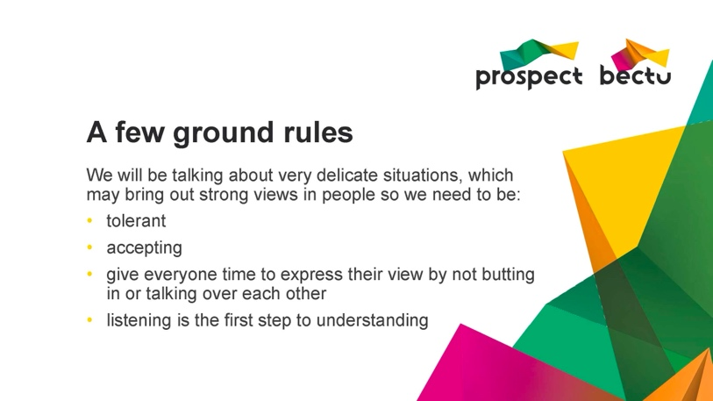 | Notes:

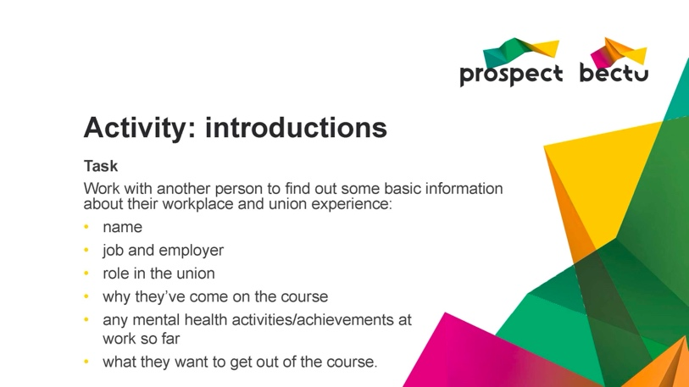 | Notes:

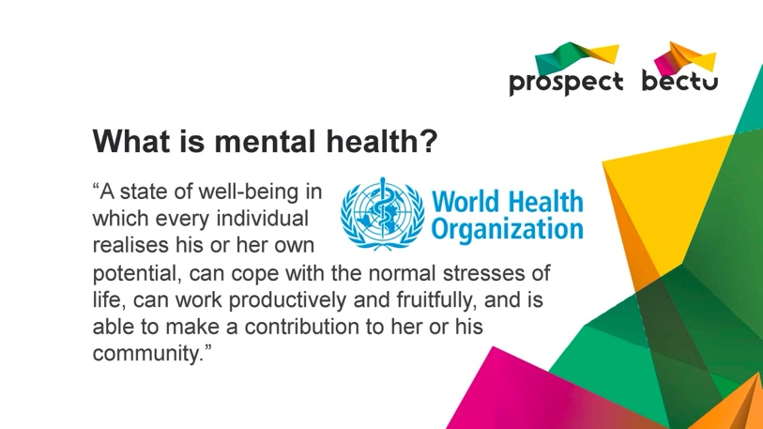 | Notes:

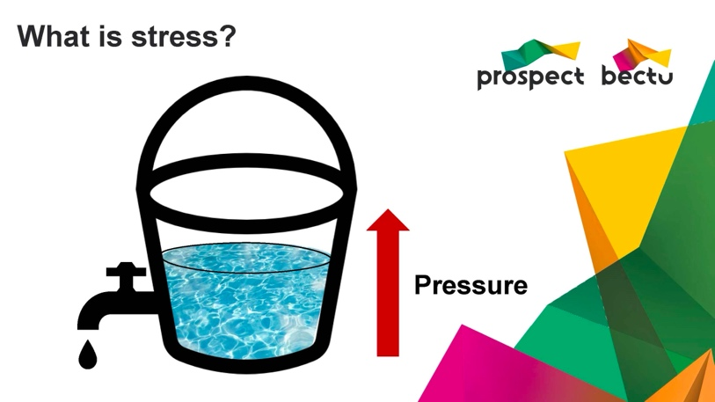 | Notes:

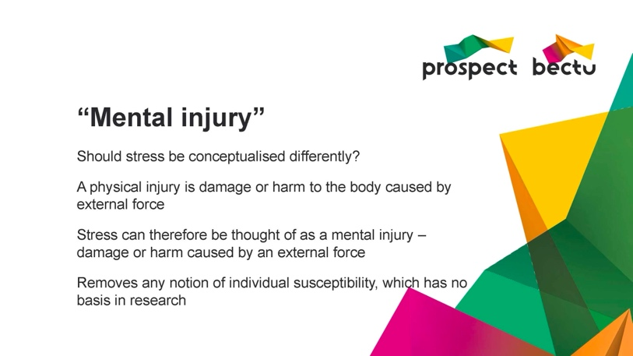 | Notes:

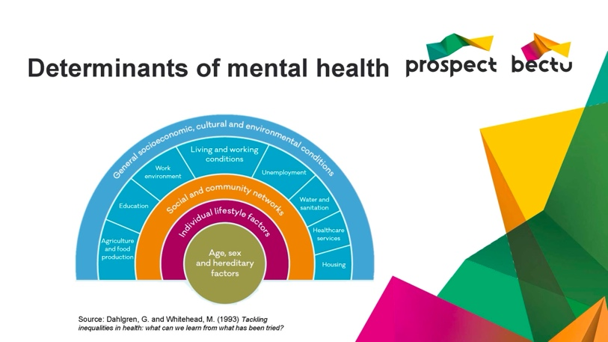 | Notes:

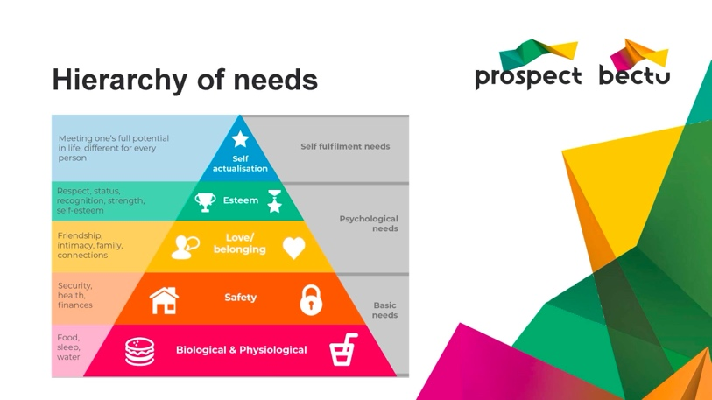 | Notes:

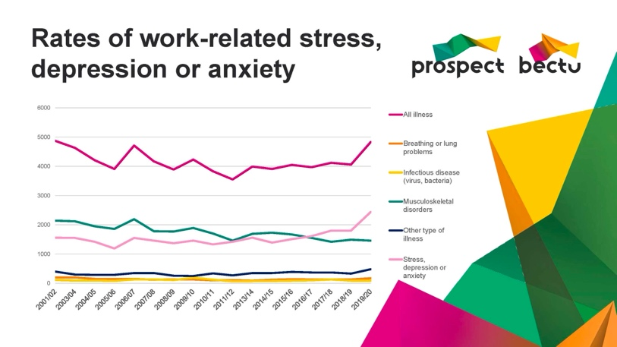 | Notes:

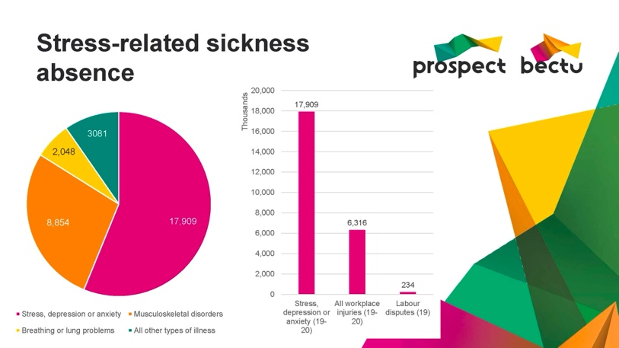 | Notes:

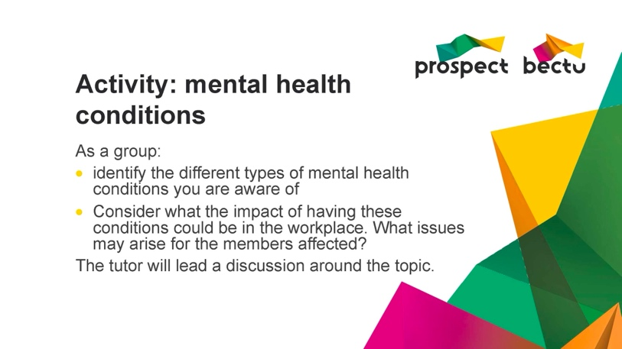 | Notes:

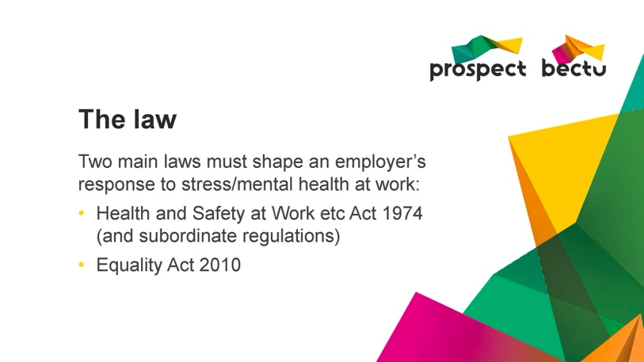 | Notes:

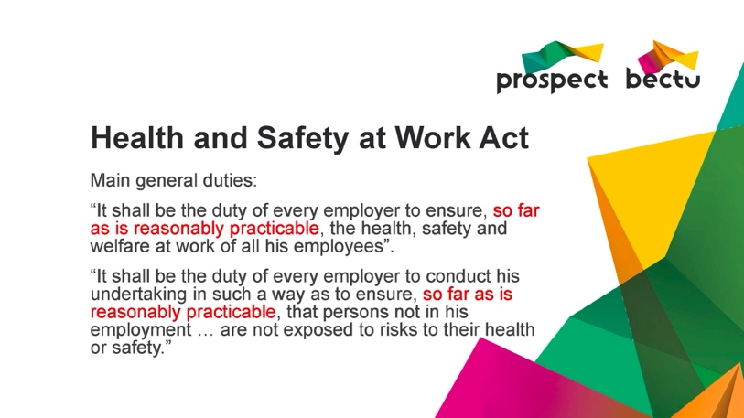 | Notes:

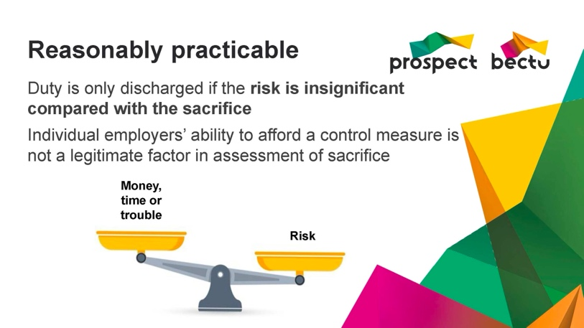 | Notes:

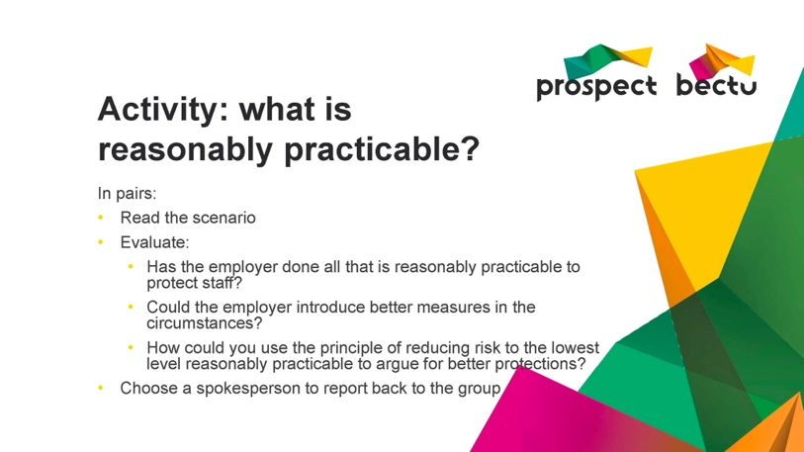 | Notes:

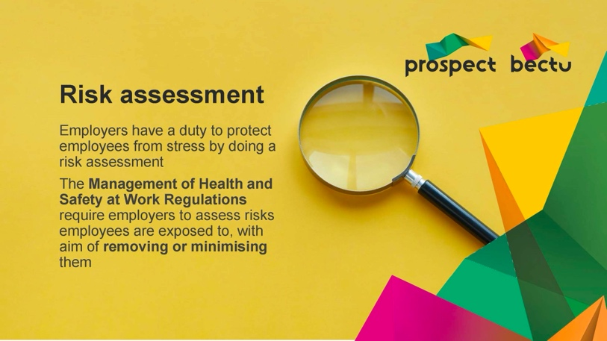 | Notes:

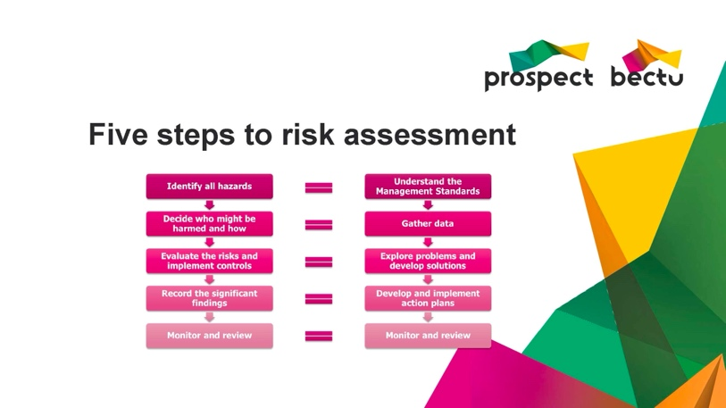 | Notes:

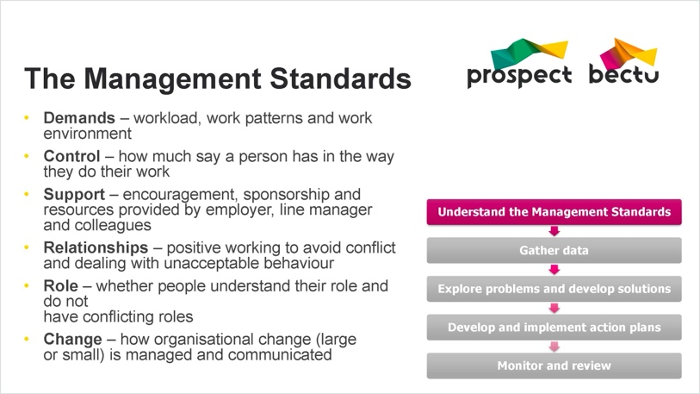 | Notes:

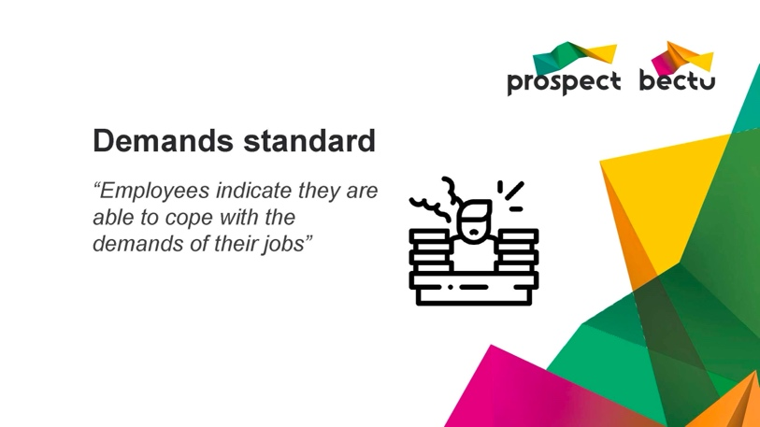 | Notes:

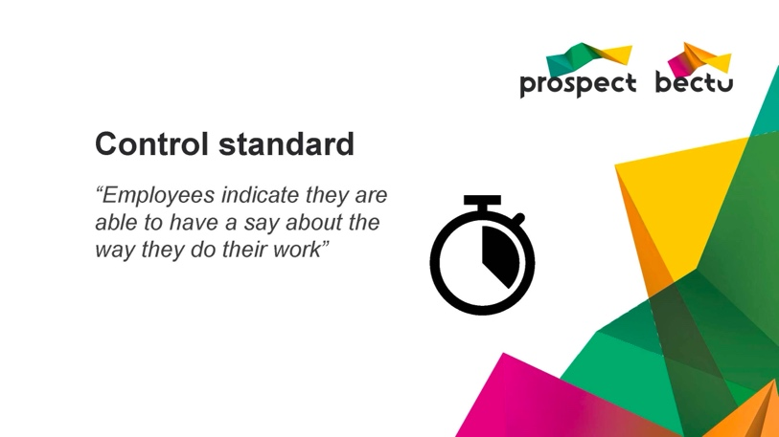 | Notes:

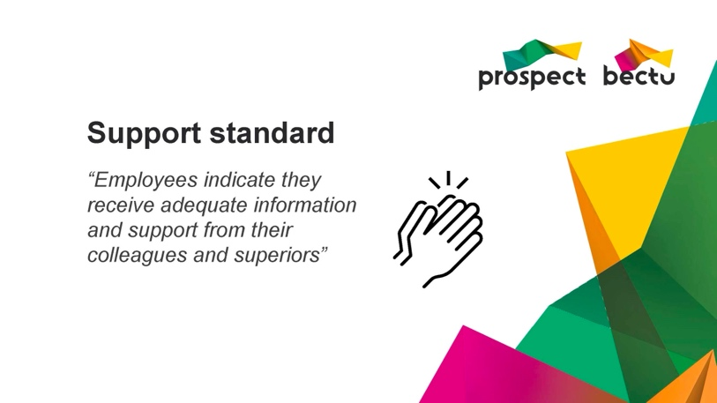 | Notes:

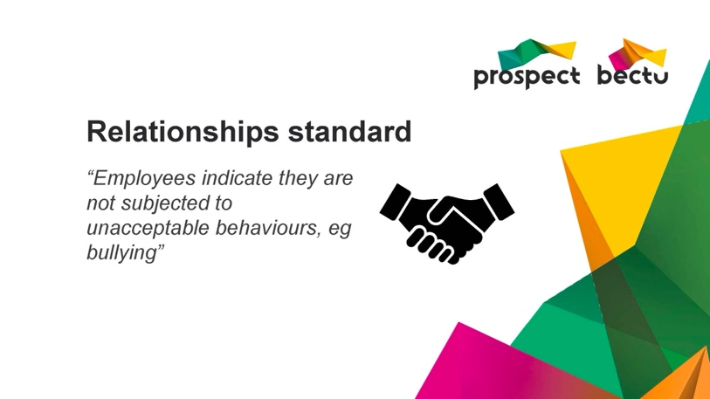 | Notes:

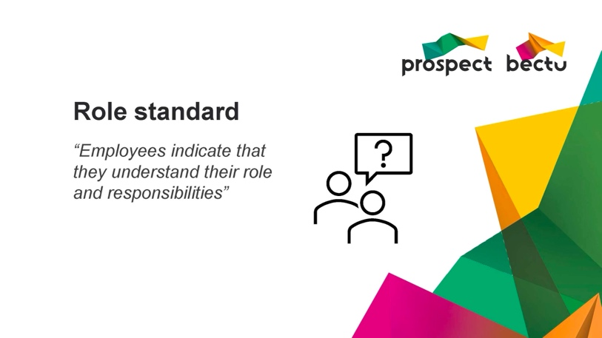 | Notes:

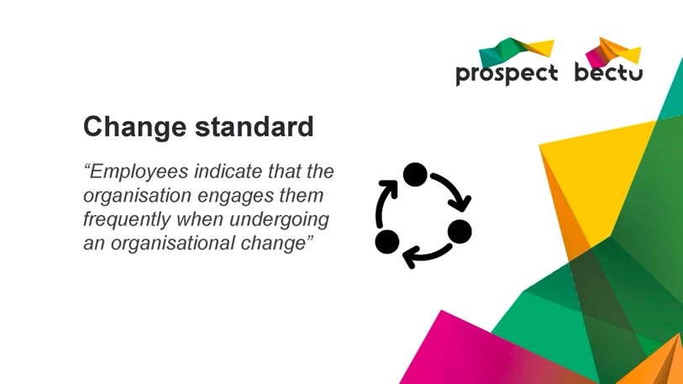 | Notes:

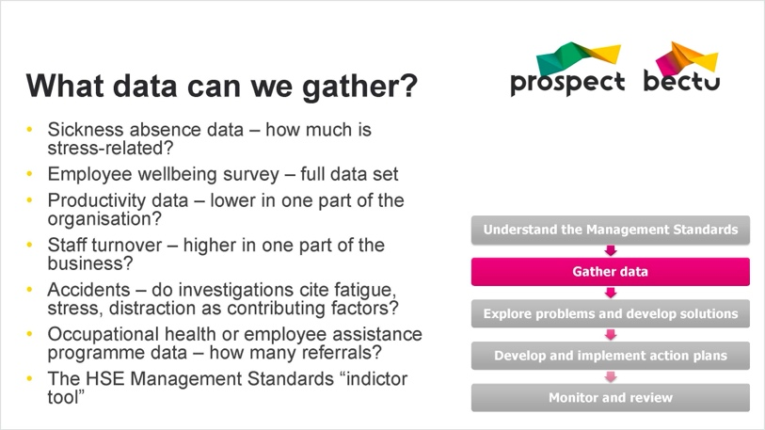 | Notes:

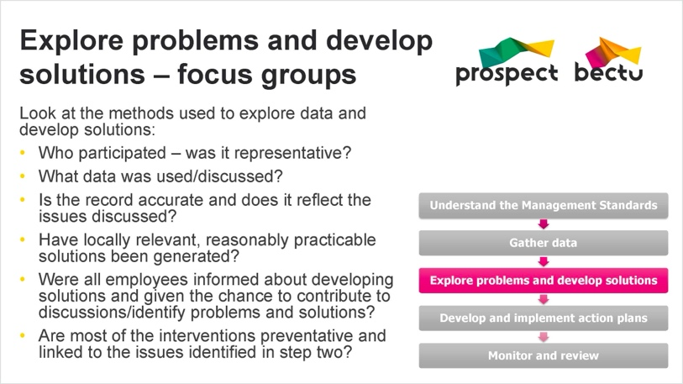 | Notes:

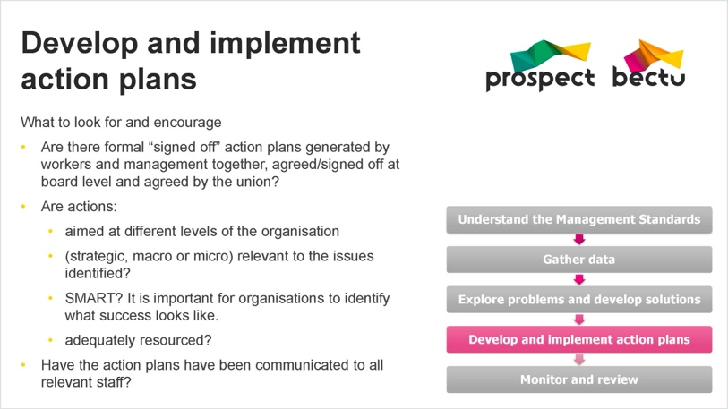 | Notes:

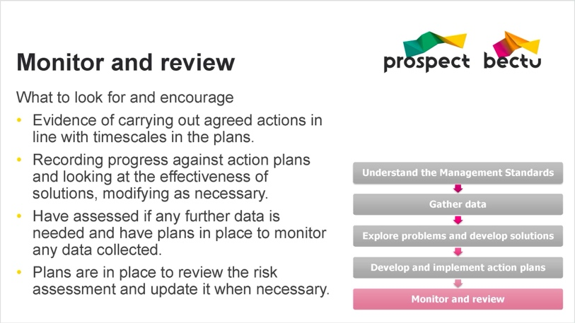 | Notes:

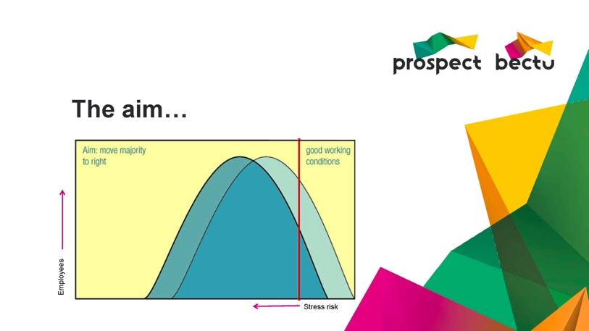 | Notes:

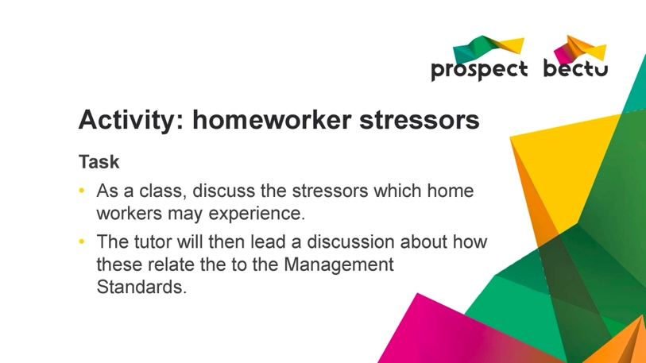 | Notes:

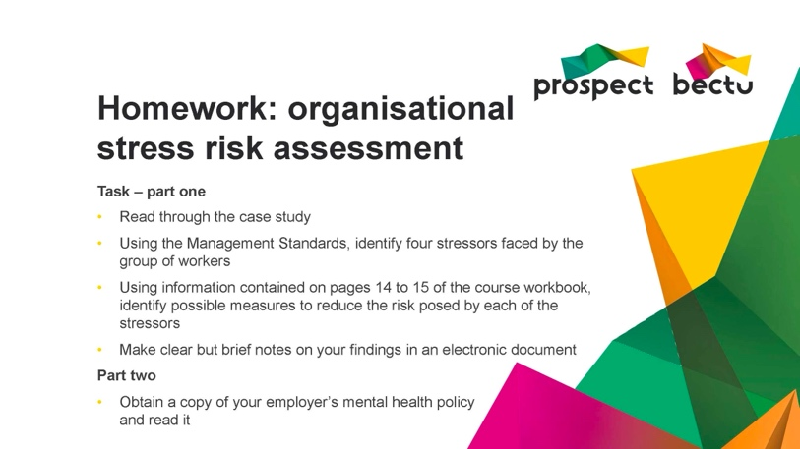 | Notes:

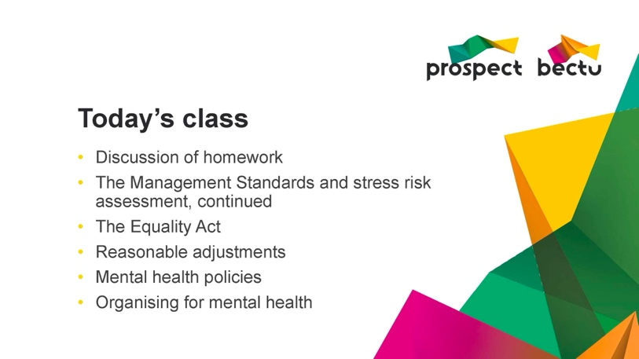 | Notes:

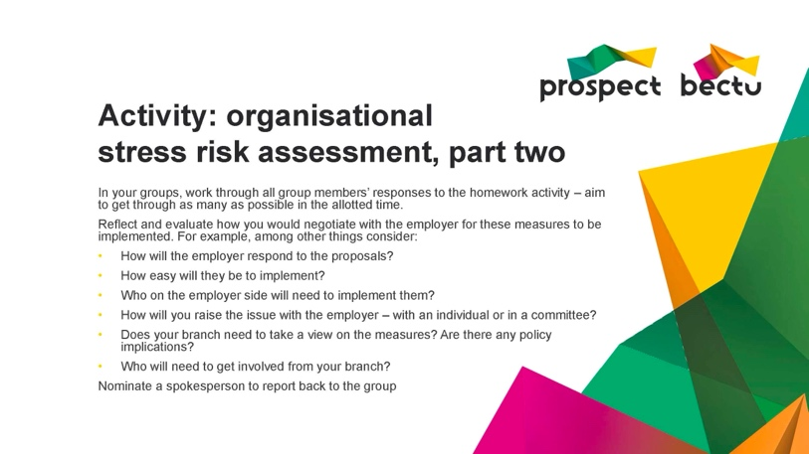 | Notes:

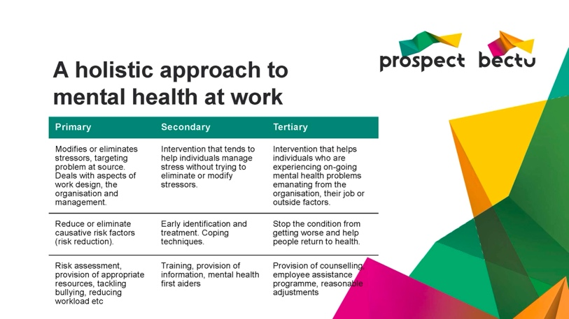 | Notes:

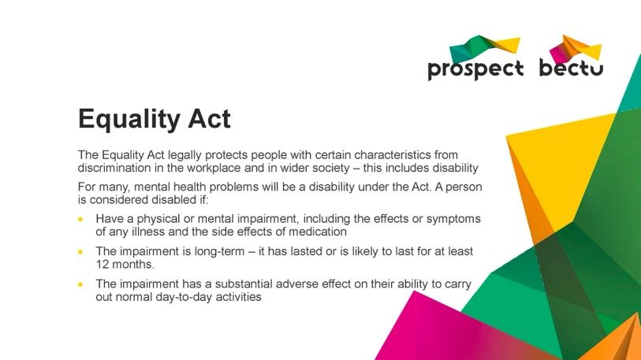 | Notes:

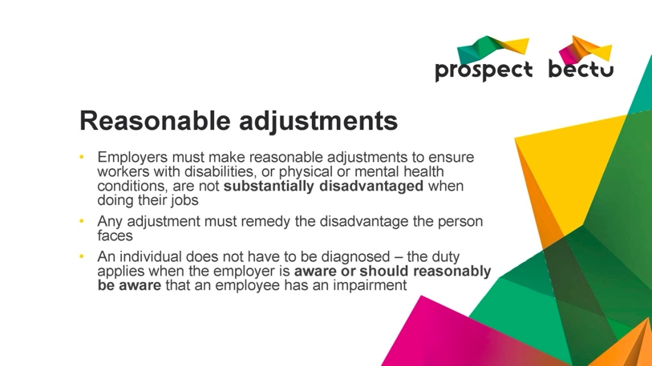 | Notes:

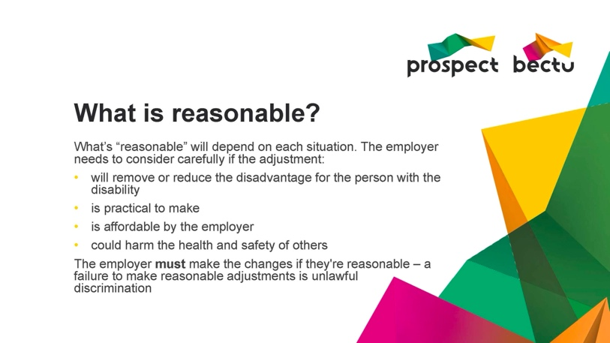 | Notes:

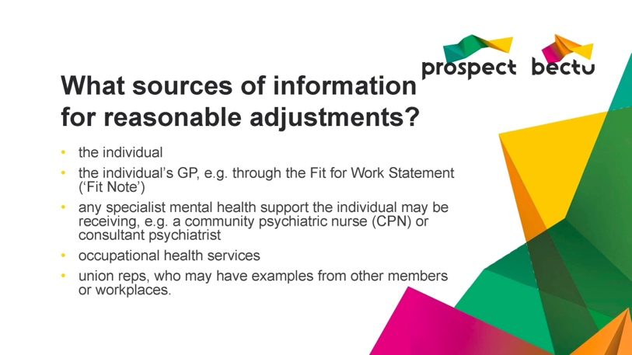 | Notes:

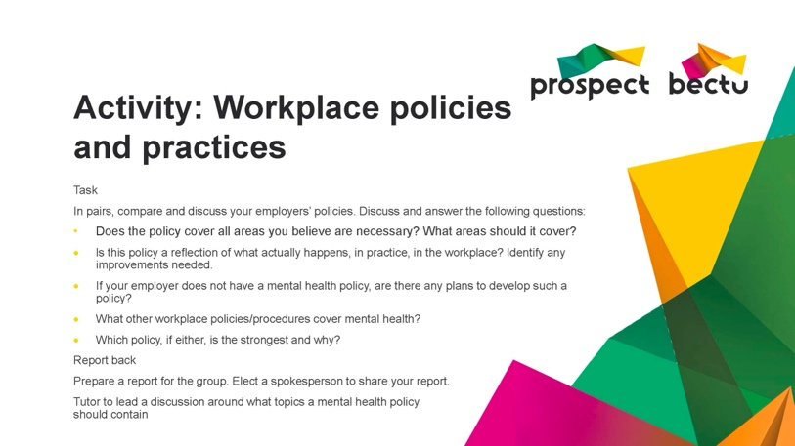 | Notes:

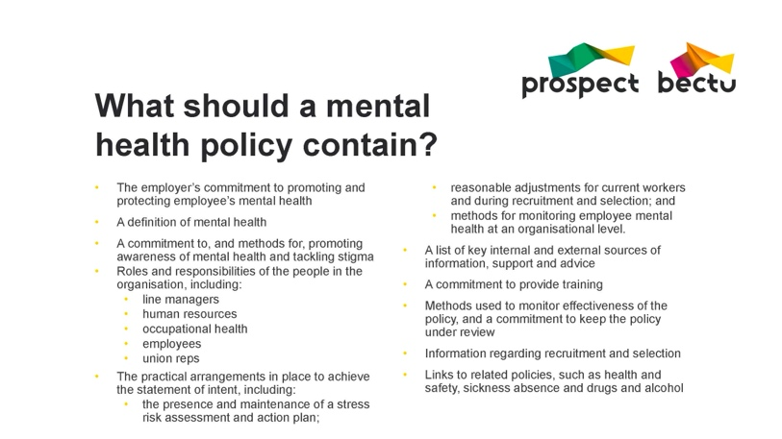 | Notes:

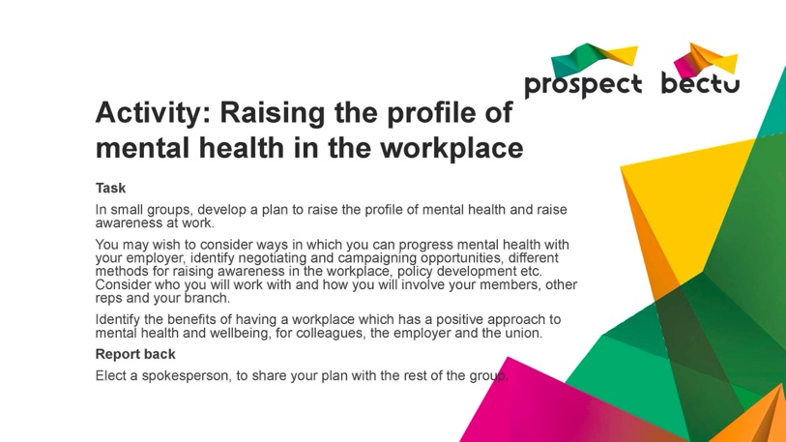 | Notes:

