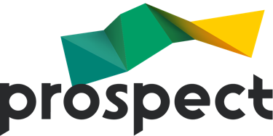
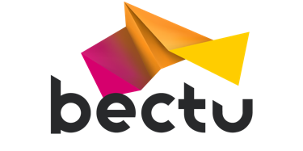

REPS TRAINING COURSES – Privacy notice
Prospect provides training courses for workplace union representatives to ensure they have the skills and knowledge required to undertake their trade union role effectively in their workplace.

The information we collect
The personal data we collect from you are:
- Contact details
- Email
- Union membership number
- Employer details
- On-line identification data
The special category data we collect from you are:
- Equality data
- Trade union membership

How we use this information
The personal data we collect will be used for the following purposes:
- The administration of the online booking process
- To contact you regarding any matter arising from your booking or attendance on the course.
- To distribute a student list to the course tutor.
- To keep a record of course attendance.
- To manage Zoom sessions, including providing the chat function and close caption transcription.
- Equality monitoring

Lawful basis for processing
The lawful basis for processing your data is:
- Contractual
- Zoom – Legitimate interest
- Equality data - Consent

Special category data
Legitimate activities by a trade union
Equality data - Explicit consent
Personal data shared by students during the training session are manifestly made public by the data subject.

Who will process your data?
Your data will be processed by the following organisations:
- Third parties overseas, covered by Standard data protection clauses.
- Eventbrite
- Zoom

How will we keep your data secure?
Data will be kept in an encrypted format on secure servers.

Retention
Your data will be retained for the following periods:
Prospect will retain specific data for 3 years.

Your rights as a data subject
At any point while we are in possession of or processing your personal data, you, the data subject, have the following rights:
- Right to withdraw consent
- Right of access – you have the right to request a copy of the information that we hold about you.
- Right of rectification – you have a right to correct data that we hold about you that is inaccurate or incomplete.
- Right to be forgotten – in certain circumstances you can ask for the data we hold about you to be erased from our records.
- Right to restriction of processing – where certain conditions apply to have a right to restrict the processing.
- Right to Data Portability.

Complaints
If you have any questions, concerns or a complaint about the way we are collecting or using your personal data, or if you wish to exercise your rights under GDPR please contact the Data Protection Compliance Officer at Prospect.
- Post: Prospect, New Prospect House, 8 Leake Street, London. SE1 7NN
- Email: datacompliance@prospect.org.uk
- Phone: 0207346 0911
However, you have the right to lodge a complaint directly with the supervisory authority, the ICO.
- Information Commissioner's Office (ICO)
Wycliffe House, Water Lane, Wilmslow, SK9 5AF
https://ico.org.uk/concerns/ Telephone: 0303 123 1113

