**GROW**

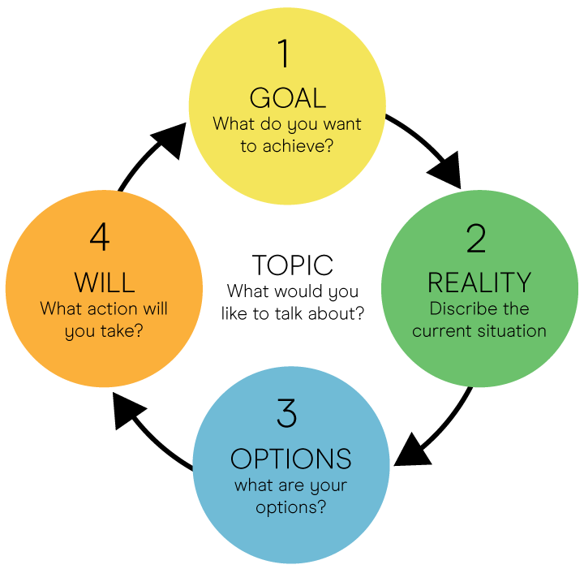

**Goal**

What do you want to achieve?

**Reality**

What do you want to change?

Why is this an issue now?

What is working well that you want to keep?

What have you tried?

What are the challenges you expect to meet?

What will be crucial to success?

**Options**

How would you start?

Have you approached a similar situation before?

In what ways are you limiting your options?

Check back to your goal – what else would you need to do?

**Will**

From your list of options, which one really jumps out at you?

Which option would have the most impact?

What actions will you take?

How are you going to take that action?

When will you take that action?

What support do you need?

On a scale of 1 to 10 how committed are you to this action?

What would need to happen for this to be a 10?

**Opportunities  
What are your goals?**

**External**

**Internal**

**Positive**

**Negative**

**Threats  
What are your obstacles?**

**Weaknesses**

**What could you improve?**

**Strengths**

**What do you do well?**

**ROAR**

* **R**ight now  
  What do you specifically want to focus on?
* **O**ptions  
  What are they? What are the upsides and downsides of each. What is your preferred option and why?
* **A**ction  
  What will be your first step (when, who, where – be specific). What subsequent actions will you need to take? How committed are you on a scale of 1-10 to taking these actions? What would make it a 10?
* **R**esults  
  What is the desired outcome and how will you know when you have been successful?