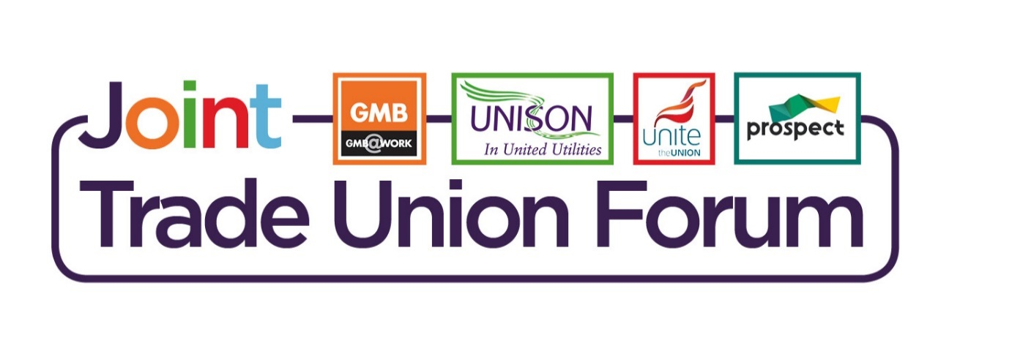

**2025 - 2027** **Pay Update**

**Dear Member**

This year’s full and final offer on pay is as follows.

**A two-year offer** covering 1 April 2025 to 31 March 2027

1. **Year 1 :** 4.5% headline increase
2. **Year 2** : 3.5% headline increase or inflation plus 1.1% *(whichever is the greater)*
3. **Inflation for Year 2** will be set at CPIH November 2025
4. **‘A Wellbeing Day’ -** one additional day off to be taken during each year. Year 1 – to be taken by 31 March 2026. Year 2 – to be taken by 31 March 2027
5. **Standby Review,** retainers for stand by weekday will be increased to £25 and weekend to £44 and backdated to December 2024.

A further increase of 4.5% upon acceptance of this year’s award will be applied from the date of acceptance.

There will be a standby meal allowance for operational staff in bands 5 and 6, up to a value of £9 that can be claimed when working away from home on standby or unplanned overtime for more than 4 hours continuously.

The JTUF (Joint Trade Union Forum) are satisfied with the outcome of the negotiations to *recommend* *acceptance,* there will be a follow up communication and a survey link to cast your vote, the ballot will run from 14th April to the 25th April.

Don’t forget to check your junk email folder if you haven’t received this.

Many thanks

The JTUF.