**Minutes of the General Meeting**

**10th April 2025**

**Royal Station Hotel, Carnforth**

1. Present

Don Forrester – Chair (DF), Fran Butler - Secretary (FB), Alan Bradley (AB), Bryan Knowles (BK), Ian Catterall (IC), Ian Driver (IRD), Luis Eckersley (LE), Peter Brough (PB), Phil Storer (PS), Roly Guegan (RG), Tony Moss (TM)

1. Apologies for Absence

John Jenkinson (JJ), Willie Reid (WR), Yvonne Hargreaves (YH) and Keith Pitman (KP)

1. Minutes of General Meeting (25th April 2024)

The minutes were approved, and accepted as a true record. Minutes of the previous AGM (17th October 2024) will be approved at the next AGM (16th October 2025).

1. Matters Arising:
2. Northern/HO Speaker – As required of previous actions, FB has again been in contact with northern office, in an attempt to secure a speaker for today’s meeting. Unfortunately, although the NWRMG had attempted to schedule meetings to better fit with northern and head office, and had made all parties aware of meeting dates immediately after the AGM of 17th October 2024, neither Jez Stewart nor Neil Walsh, was available to attend. Although Neil Walsh did offer to join remotely, conference facilities were considered insufficient, and he subsequently declined. Again, somewhat disappointing as the NWRMG, mindful of keeping costs to a minimum, and thereby maintaining financial viability, has always avoided the larger, more expensive hotels. Discussion ensued and attendees again expressed concern about the lack of speaker and the fact that, although requested by FB, Neil Walsh had been unable to send a report/presentation. FB agreed to formalise concerns in an email to northern office.

**Action GM2501 –** FB to write to Jez Stewart expressing our dissatisfaction and disappointment with the service

1. Actions from the AGM of 24th October 2023 – Following Jez Stewart’s informative presentation, FB contacted him regarding an update. The following was provided on 8th April 2025:

BT has never been handled from the NW office, but retired members are placed in regional retired members groups as YH has been. If we receive an approach that is BT specific i.e. pensions, we would refer into the appropriate officer centrally.

1. ADC 2024 Actions Taken – This was published by the National Committee in December 2024 and, subsequently circulated to members.
2. Meeting Dates & Venue/Facilities – In view of Neil Walsh’s misgivings, there was some further discussion about the venue but it was unanimously agreed that the Royal Station Hotel provided extremely good facilities, with service and refreshments ideally suited to the Group. FB mentioned that the hotel had been in contact, prior to the meeting, to say that there was a projector available. FB agreed to investigate further.

**Action GM2502** – FB to liaise with the Royal Station Hotel

1. Winter Fuel Allowance – FB reported that template letters had been produced and made available to members. These letters have been used by attendees and members generally but, though acknowledged, have had little or no impact. The chairman then explained that he had been in communication with Catherine (Cat) Smith MP. Cat stressed that she agreed with the campaign to maintain the WFA and that she has abstained the vote. She did make it clear, however, that personal letters from retirees, are more impactful and encouraged their ongoing use.

AB then informed the meeting that Age UK had recently (18th February 2025) delivered a petition to the Prime Minister. The petition, signed by over 650,000 people, calls for the Government to ensure that older people are able to be sufficiently warm, through the colder months, by:

* re-instating the Winter Fuel Payment for older people who receive a wider range of benefits than just Pension Credit
* reforming and significantly extending eligibility for the Warm Home Discount
* bringing in a social tariff to give people on low incomes, or those with high costs due to disability, a guaranteed discounted energy deal
* or by pursuing a combination of these kinds of measures.

1. WASPI –As deaths and savings increase, the campaign continues with WASPI solicitors served (9th April 2025) with the Government’s ‘Notice of Acknowledgement of Service and Summary Grounds of Resistance’, effectively the Government’s formal written defence. WASPI have asked permission, of the Government, to publish the documentation, a request they expect to be denied. The case continues.

Attendees expressed their disgust at the Government’s disregard for the ongoing hardships, not just of WASPI women, but of those affected by the Horizon (Post Office) and the Infected Blood scandals.

**Update**: As of 11:46 on 15th April 2025, the ‘Women Against State Pension Equality’ reports:

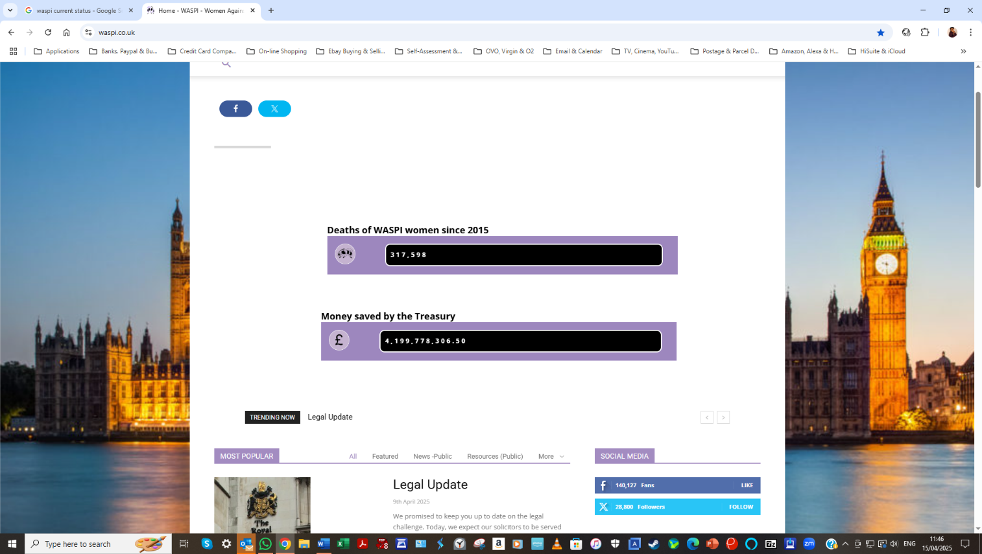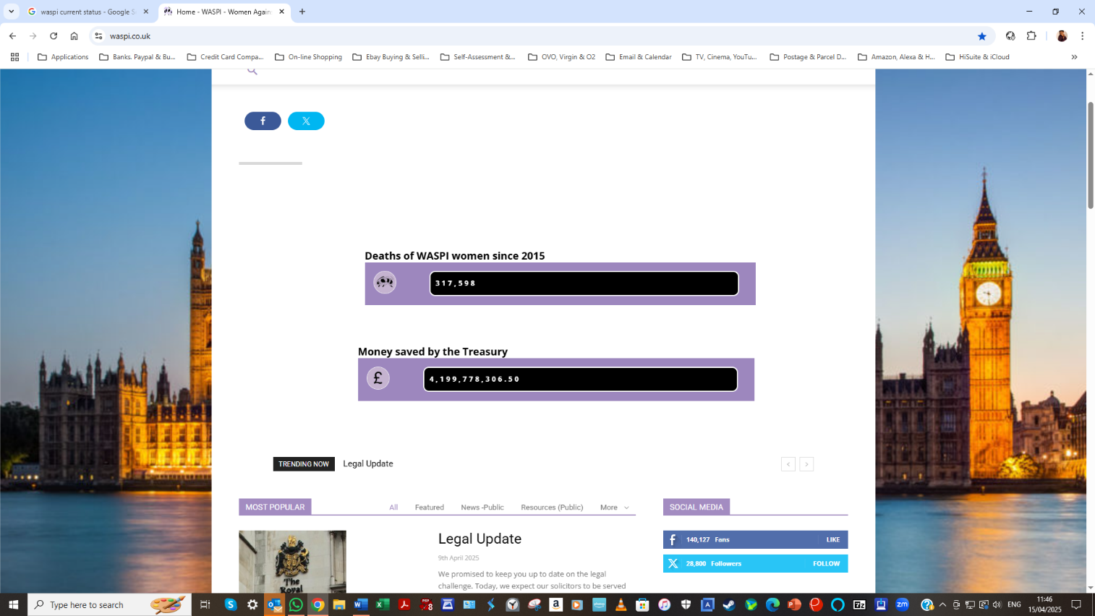

1. Guest Speaker

No available speaker but FB agreed to chase up a report from Neil Walsh.

**Action GM2503** – FB to liaise with Neil Walsh

1. ADC 2025 Delegate Report (delivered by Ian Driver)

Twenty-nine delegates were officially nominated but only 25 attended, some by Zoom. Following last year’s debacle, the Chair of Standing Orders read out a statement of defence, stating that the SOC was simply doing its job. This year’s SOC report was accepted nemcom.

David Harding then gave his President’s introduction, his last, as he will be stood down after the conference. However, the only item of interest was in regard to Group Secretary and the fact that there have been six changes in staff since 2019. Our latest incumbent, John Ferrett, then presented the Annual Report, with the position and voting strength of the RMG, within Prospect, being the issue of greatest concern. Talks between the NC and Prospect officers, continue.

1. Motions (see ActionsTakenRMGADC2025Draft02Apr25 for details):

* The 35 motions on the order paper were split into eleven sections; Climate Change, Health, Energy, RMG Organisation, Prospect Organisation, Rule Changes, Finance, Pensions, Communications, Universal Benefits and Pensions.
* Three motions; 33, 34 and 35 were ruled out-of-order and hence, 32 motions were debated. Of the 32 motions, 19 were carried, 8 were remitted, 4 were lost and 1 fell due to there being no moving delegate.
* Two emergency motions were accepted by conference, both concerning pensions. EM01 was carried, EM02 (from the NWRMG) was remitted to the NC.
* Of the motions carried/remitted, those of particular relevance to the NWRMG and potentially further discussion, were as follows:
* Motion 2 (Remitted) – Dementia/Alzheimer’s and the possible link(s) with Electricity Supply Workers
* Motion 4 (Carried) – Poor treatment of the RMG at the 2014 National Conference
* Composite Motion 11 (Carried) – RMG stall at the next and future National Conference(s)
* Motion 14 (Remitted) – Poor search capabilities of the Prospect website
* Motion 18 (Remitted) – The DWP’s proposal for a 'Fraud Plan' is seen as an infringement of privacy and therefore open to abuse
* Motion 19 (Remitted) – Concern about the continued closure of banks and the lack of banking hubs
* Motion 20 (Carried) – Refusal by traders to accept cash
* Motion 22 (Carried) – Highlight the “68 Is Too Late” campaign & seek to make it Prospect policy
* Motion 23 (Carried) – Call on Prospect to oppose the means testing of the State Pension
* Motion 24 (Lost) – This motion highlights the gap between old and new State Pension Schemes and asks Prospect to campaign for all pensioners to be paid under the new. The motion was lost in recognition of the substantial extra cost and, the belief that the Government will argue any change to be unjustifiable
* Motion 29 (Carried) - Call on Prospect to oppose the means testing of the WFA
* EM01 (Carried) – Safeguards against utilising pension funds for infrastructure projects
* EM02 (Remitted) – GMP reconciliation exercise as highlighted by CNPP members’ letters. Submitted by the NWRMG, on behalf of our members, this issue was raised by JJ in January 2025. As a result of the GMP reconciliation exercise, currently being carried out by CNPP Trustees and HMRC, many already retired members, have been informed that their company pensions will be reduced.

This is now known to be due to an error in calculations, for persons who were contracted out of SERPS, whereby the GMP portion of their pension should have been annually uprated at a different percentage to the remainder. However, this difference is only apparent after retirees reach State Pension Age but, for those who have been in receipt of SP for some time, the effect is significant. Indeed, one member has reported an overpayment in excess of £10K and a reduction in pension of 8.5%.

Members are rightly unhappy, particularly since notification of the error came ‘out-of-the-blue’, with no explanation. What’s more, FB has since discovered that the GMP reconciliation applies to all final salary schemes and that Prospect has been actively involved for several years. However, the NWRMG are not aware of this ever being brought to the RMG and, even though FB and JJ have been trying to get assistance/information from northern and head office, little has been done other than to suggest members write to the CNPP themselves, a decision made independently by most of those affected.

Jez Stewart did send confirmation that Prospect are awaiting responses to members’ letters and, that a similar intervention, within the Civil Service, had eliminated any question of repaying perceived overpayment but, the reporting of same by FB, gave attendees little reason to express anything other than their dissatisfaction.

Indeed, pensions are currently the one area on which members are allowed to make their views heard, so for Prospect to be so lacking in this regard, is far from satisfactory. Moreover, Neil Walsh’s lack of attendance, both here and at the RMG Annual Conference, rather than assuaging members’ concerns, has in fact made members more dissatisfied, with several attendees questioning the relevance of Prospect.

The NWRMG now believe that a formal complaint to the General Secretary is in order and the secretary was tasked to write to him.

**Update**: At the RMG National Committee meeting, held 17th April 2025, John Ferrett (RMG Group Secretary), made the following statement concerning the GMP reconciliation issue:

“It’s important to acknowledge that things are in hand. We have given advice to members who have contacted us about how they can challenge what the scheme is doing. We are also contacting the trustees directly to ask some questions on behalf of members. It’s important to see how the scheme responds to these initiatives. We will assess any response and support members in taking any further steps that are needed.”

**Action GM2503 –** FB to write to Mike Clancy expressing our dissatisfaction

1. Officer & SOC Elections

* Officer elections saw Andrew Ruffhead elected as President and Tom James as Vice-President with both appointments unopposed.
* The SOC election, which went to ballot was won by Fran Butler with 17 votes (Mike Kain – 5 votes and Quentin Keeling – 2 votes).

1. National Committee Representative Report

Although little to report from the latest meeting, DF highlighted the following:

1. Motion 32 (ADC 2025) – Following the support of Motion 45 (BNC 2024), Motion 32, citing the resolution carried at the 2024 TUC called for the NC/NEC to pursue the TUC resolution, especially with regard to; the recognition of the State of Palestine and, the ending of all licenses for arms traded with Israel. The motion, which was remitted at the ADC, has subsequently been discussed by the NC who voted against taking it further
2. Concerns over the Government’s proposals to change from RPI to Consumer Prices Index including owner occupiers' housing costs (CPIH)
3. National Pensioners Convention (NPC) is moving towards a Public Limited Company, in order to protect its officers and officials from financial liability. If this action fails the NPC may fold, leaving Pensioners without a formal lobbying group, a group on which Prospect depend
4. Representation by Prospect and their lack of accountability to RMG. The NEC decide how and where motions are handled and National Officers are not effectively supporting retired members.

**Action GM2504 –** FB to circulate the minutes of the NC meeting as soon as they are available.

1. General Discussion
2. Pensions

* Triple Lock – Although still in place and likely to be maintained for this Parliament, Prospect encourages members to lobby their MPs for retention of the triple lock, and for its inclusion in manifestos for the next general election
* CNPP and GMP reconciliation – As discussed at Item 6, members are unhappy with the service provided by Prospect and the national officers. Although it remains likely that, in line with the affected Civil Service schemes, there will be no clawback of overpayment, this has yet to be formalised with the scheme employers. Members remain hopeful that it will also be possible to agree a marked-time introduction of corrected rates but, unfortunately the scheme has already applied the new rates so this is now unlikely. In addition, most members are still waiting for confirmation of how the overpayments etc., have been calculated and, whether any overpaid tax has been allowed for in the overpayment and new rates, e.g. if an overpayment of £10K applies, is this net or gross of tax, as tax will have been charged at 20% (or potentially 40% in some cases).

1. Current State of Social Care

* Carer Allowance - LE raised the issue of State Pension and how it will affect the carer’s allowance since it will likely take his earnings above the threshold for eligibility. How are the payable Benefits affected by each other? There was a general consensus that a discussion with the DWP was needed, especially if LE, or indeed any retiree had been informed that the maximum SP could not be achieved. Under certain circumstances, including acting as a carer, when unable to earn NI, it is possible to claim NI credit.

**Update:** Members wishing to check their state pension forecast or NI record, can do so on the Gov.UK website at https://www.tax.service.gov.uk/check-your-state-pension and/or <https://www.tax.service.gov.uk/check-your-state-pension/account/nirecord>. To check whether you can pay additional NI contributions to ‘fill any gaps’ due to contracting out, for example, contact the Future Pension Centre on 0800 731 0175.

1. Defence in UK Hands? AB made his concerns known to the group, stressing the ongoing need to Lobby Government, for example:

* Scunthorpe Steel Works – Coal availability and the fact that, with our supplies almost exhausted, the coal will potentially be purchased from Russia
* Cobham Limited (Bournemouth) – Famous for its specialised equipment, Cobham is particularly renowned for its aerial refuelling equipment first demonstrated in 1949. Since its inception in 1934, the company has grown and diversified into various markets including electronic warfare and specialised pilot communication. Indeed, Cobham's air-to-air refuelling system played a major part in the Falklands War (1982) enabling RAF’s Vulcan bombers to reach and liberate the Argentinian-held airfield at Port Stanley. It is this company that was sold, using US Advent Private equity and, subsequently broken up and sold on to foreign aerospace and defence companies, with USA and France the major protagonists.
* Ultra Electronics – With its roots in the domestic radio market, Ultra diversified to become an active supplier to the aerospace sector. It produces equipment crucial to the MOD, including controls for nuclear submarines. Ultra fell foul of privatisation in 2021 when it was acquired by the now American-owned Cobham.
* Meggit – A world leader in aerospace, defence and energy, Meggit plc was acquired by Parker US in 2022. A company that can trace its history back to 1850, Meggit is a major supplier of components and sub-systems, including braking systems, fire protection, safety systems, power and motion solutions, fuel systems, avionics, and sensors. Their products are used in commercial, business, and defence aircraft, as well as in various energy applications.
* Chemring Group - Operates in four market sectors; Countermeasures – protecting aircraft, ships and land platforms against guided missile threats, Sensors & Electronics – equipment to detect and disable concealed IEDs (improvised explosive devices), unexploded ordnance, electronic warfare and chemical and biological threats, Pyrotechnics & Munitions – products for use in navy, army and air force applications and Energetic Systems – propellant, explosives, missile and ammunition components, thrusters, initiators and other components for the space sector. In addition, the corporation owns Chemring Nobel (formerly Dyno Nobel), a major world manufacturer of explosives and electronic detonators. Chemring is now attracting attention from private equity firm Bain Capital and with an offer of $1.39B on the table, it seems likely that the High Court will ultimately approve the sale.

Attendees raised other concerns, particularly regarding US imports and defence spending, with the wastage and financial losses incurred. Worthy of discussion at the AGM, the issue of defence and national security will be added to the agenda as a Matters Arising.

**Action GM2505 –** FB to include ‘Privatisation of the Defence Industry’ on the agenda for the October AGM

1. AOB

:

1. CNPP Issue & Lack of Support from Prospect – The committee and members of the NWRMG were sorry not to see JJ at the meeting and want to make him and other members, similarly affected, our ongoing support.

**Action GM2505 –** FB to write to JJ and post an appropriate comment on the SL Pensioners United WhatsApp

1. Dates of Next Meetings:

:

1. 21st August 2025 (Committee Meeting)
2. 16th October 2025 (AGM)

Fran Butler

Secretary Prospect NWRMG

18th April 2025