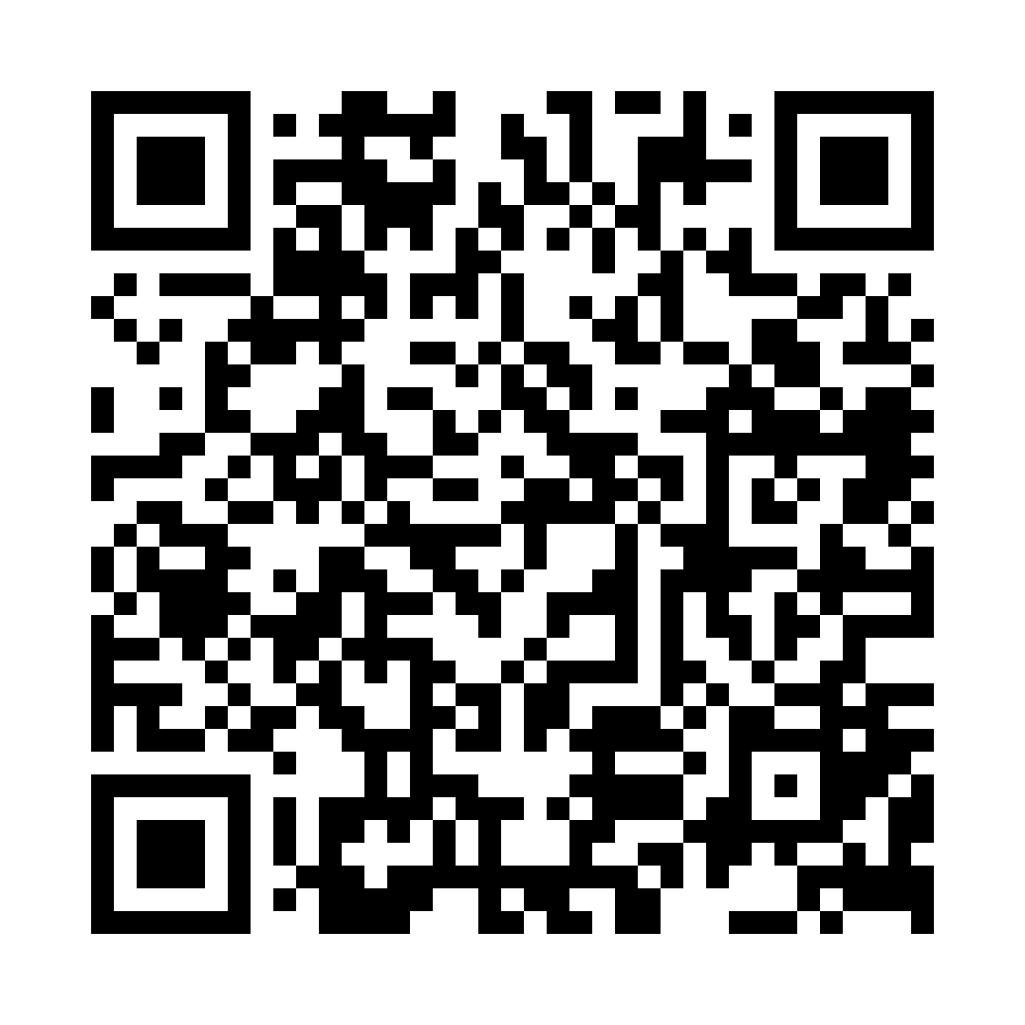

The survey will close 23rd May 2025.

Please spare a minute to complete this short survey about pay at NML. All responses are anonymous.

Ready to Join?

Prospect.org.uk

**National Museums of Liverpool (NML) 2025 – Pay Survey**

Prospect NML branch is campaigning for greater transparency around pay at NML.

**Do you understand how pay at NML works?**