Activity J: Sharon’s grievance
In groups, look at the information that Sharon has brought to you and assess a plan to go forward with a formal grievance (see page 107/108 for guidance).

Sharon’s department has a policy that shifts can be swapped in line with the policy below:
Shift swap policy
This policy is designed to allow shift workers to trade shifts with each other, enabling them the flexibility to meet both their work responsibilities and personal needs without having to sacrifice one or the other.
Existing organisation policies and guidelines must still be followed by shift swappers.
This policy applies to all full-time or part-time shift work employees
Shift swapping can be suspended or terminated if it does not comply with business needs or it affects employees’ performance, having worked long hours for a stretched period without rest.
The timeframe for the application of shift swapping, in order to facilitate proper resource planning, is up to three days after the shift roster is issued.

The normal way the shift swapping is done is by texting a colleague that they wish to swap and asking if they can swap with them. The texts are sent through a large whatsapp group.
Sharon’s colleague Dave is fairly new and she has started receiving unwanted texts from him. Sharon has asked him to stop, which seems to have worked but he has moved on to texting Mandy now.
She had a word with her manager and he said: “Well he stopped. If it starts again I will say something.”
Sharon believes that the system should be changed so that staff don’t have to share phone numbers or have to be Whatsapp at all, eg a Google docs calendar.
She shows you Dave’s texts.

Dave’s texts
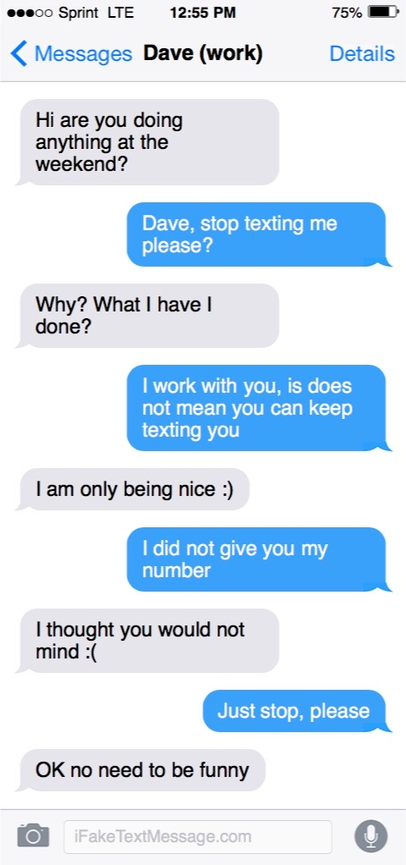
Grievance letter over Personal phone number use

Dear Hannah, HR manager
I am writing to raise a formal grievance.
I have a problem with the insecure use of my and others personal phone numbers for company procedure to swap shifts by using Whatsapp. Last week I raised the issue with my line manager Philip that my co-worker Dave has been sending me unwanted texts. He gained my phone number through the company Whatsapp group for swapping shifts. Though I spoke to Dave informally and he stopped texting me. Though Philip feels the issue is resolved, I feel that the company is failing to protect personal data from being misused.
I have evidence in the form of the attached screen shots.
I would be grateful if you could let me know when I can meet you to talk about my grievance.
I would like to be accompanied at the meeting by my Prospect/Bectu rep.
Yours sincerely,
Sharon

Action plan for Sharon’s case

