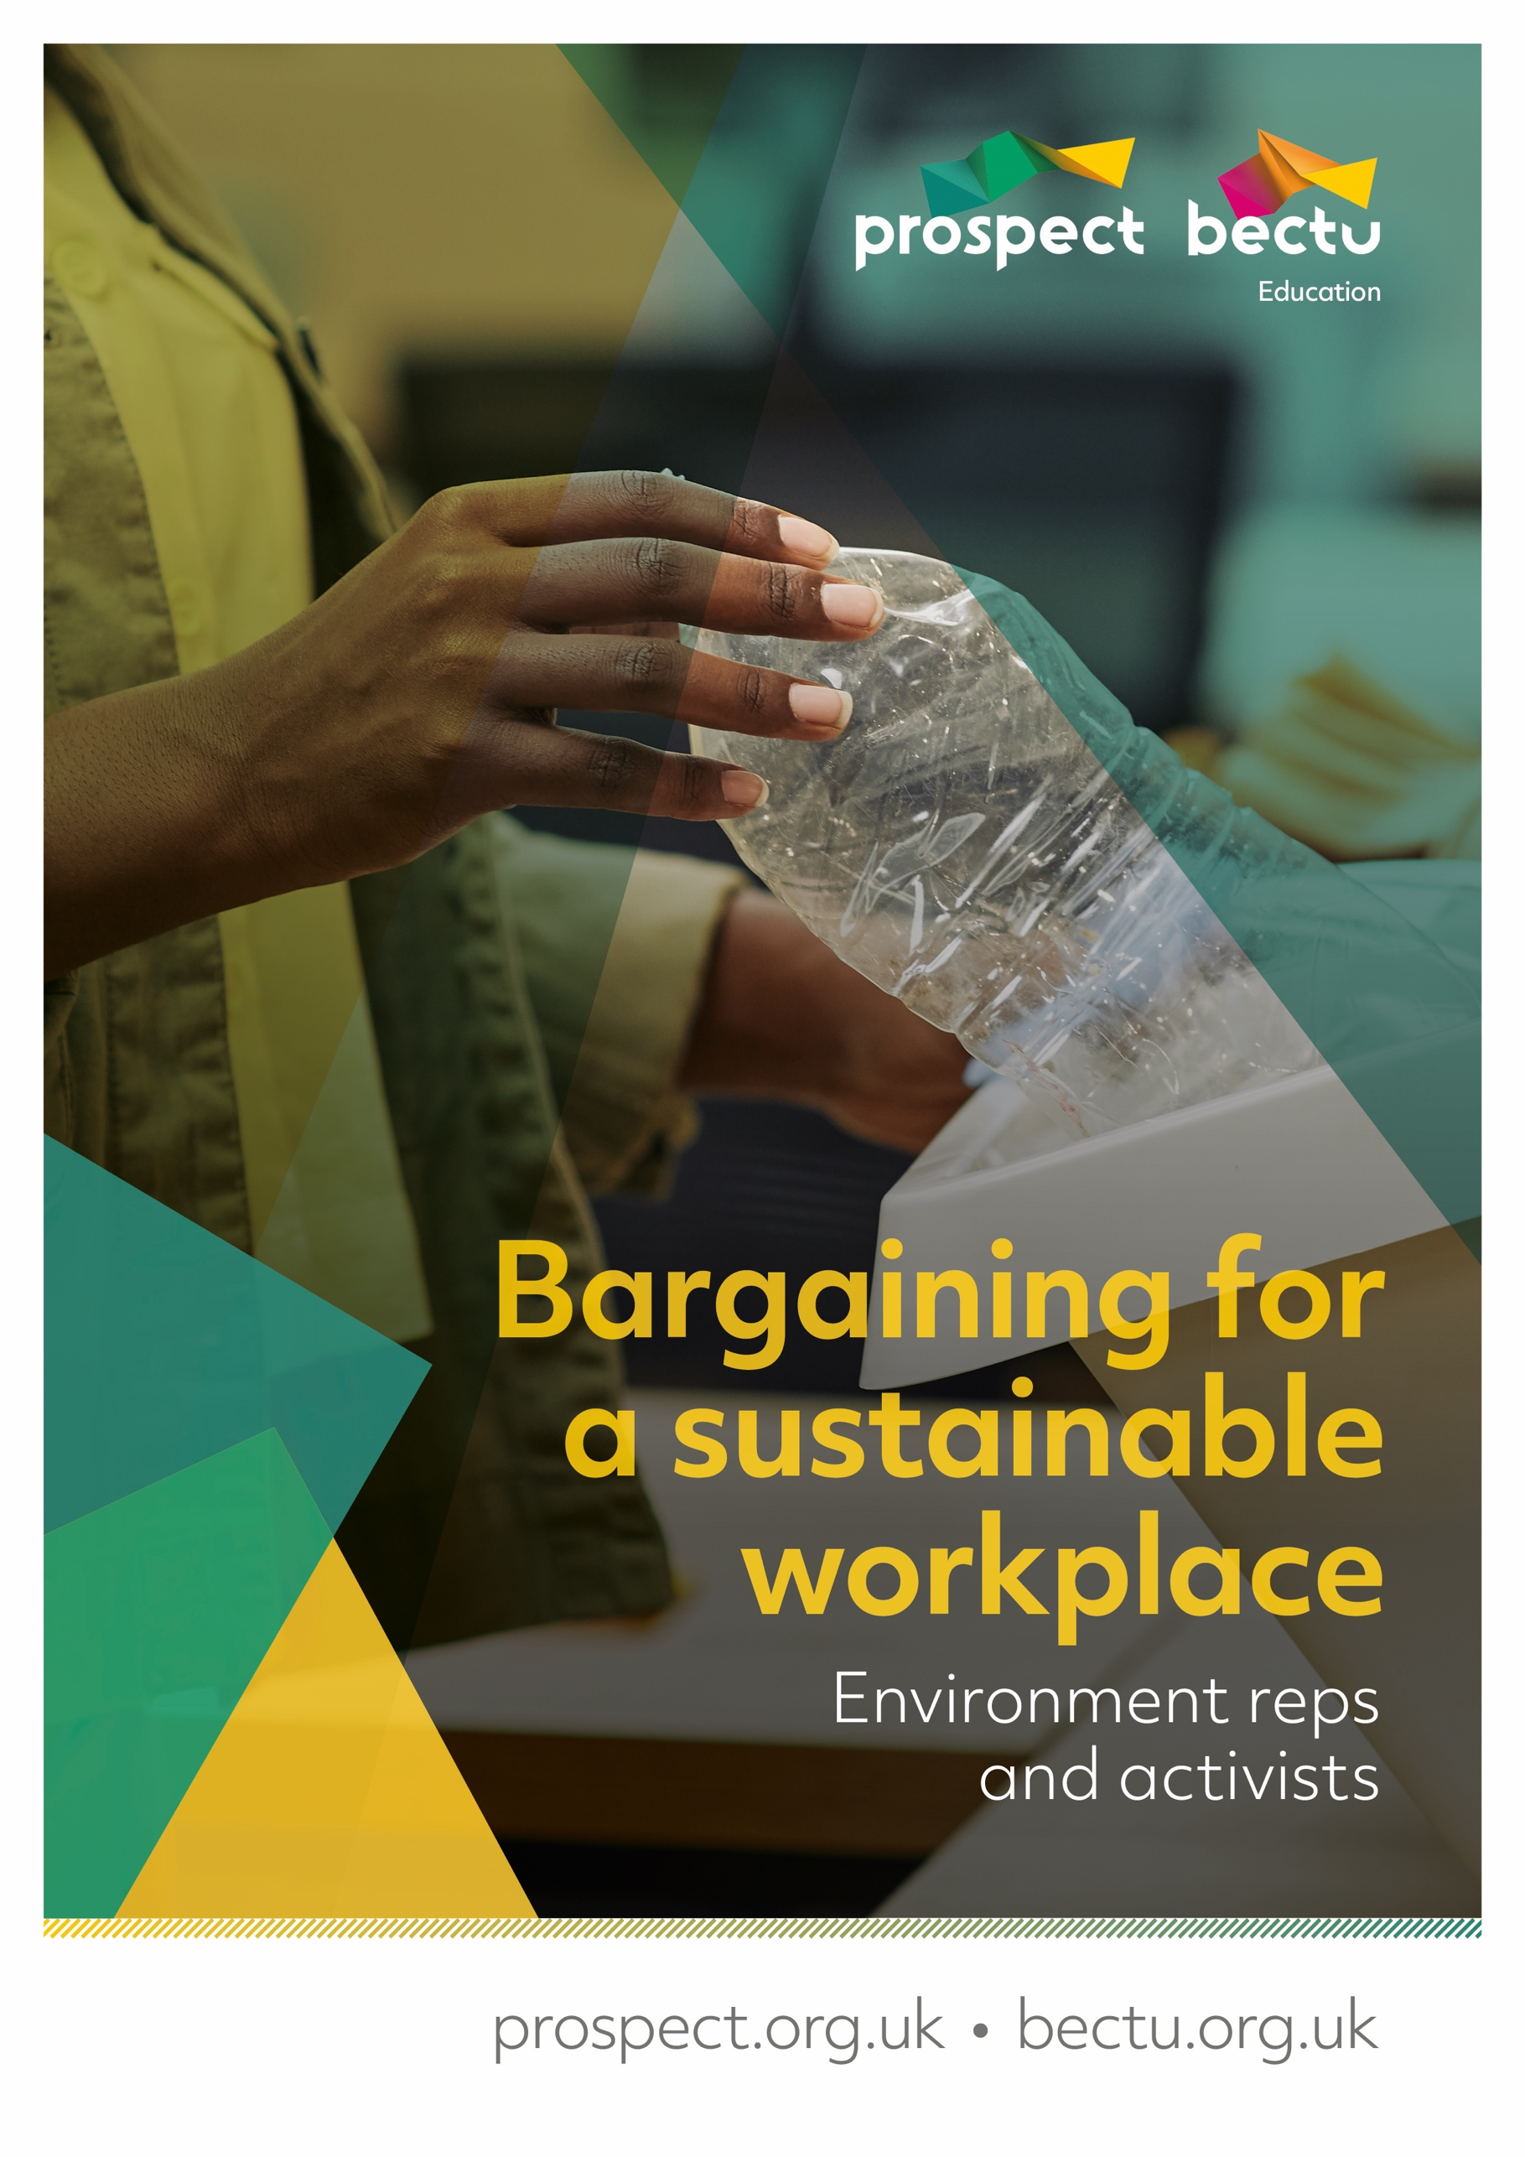
W
Table of Contents
Course timeline 4
Course overview 5
Learning outcomes 5
Glossary 6
About Prospect 7
What happens on trade union courses? 8
The tutor’s role 8
Your role 8
Using your knowledge and skills 9
Equality and diversity statement 10
Getting started 11
Activity A: Introductions 11
How Prospect works 12
Unit 1 Climate and the branch agenda 13
The climate emergency 13
Pollution (UN definition) 13
When do you think it started? 13
There have been successes! 14
Climate Change is a trade Union Issue 14
Prospect resources 15
More reading here 15
What is Prospect calling on the Government to do? 16
Your sphere of influence 16
Activity- What can I change? 16
What change can happen in the workplace? 16
Structural targets 17
Activity: branch structure 17
Climate and the branch agenda 18
Unit 2 The role of the environment rep 19
A rep’s rights. 19
Your legal rights and responsibilities 19
Duties 19
Activities 19
Facilities agreements 19
Where do environment reps stand? 20
Negotiating on a green agenda 20
Establishing a green committee 20
Code of practice for Prospect and Bectu representatives 21
Unit 3 Overcoming barriers 22
Activity: discussion on barriers 22
Having difficult conversations 23
Why isn’t happening already? 23
Arguments for change Unions 23
Arguments for change employers 24
Climate laws and targets 24
Unit 4 Preparing for the session. 25
Identifying the issue 26
Homework Activity Part A 26
Unit 5 Building your branch. 28
Ingredients of union influence 29
Building union influence 30
The virtuous circle 30
Discussion points: 30
How branch democracy works 30
Unit 6 Effective campaigning for union reps 31
What is campaigning? 31
Activity: Thinking about campaigning 32
The building blocks of effective campaign planning 34
Identifying the issue 34
Activity B: Testing your campaign issue. 35
Activity C: Analyse the strengths and weaknesses of your campaign issue 36
Build a campaign team 37
Determining goals 38
Creating campaign goals 38
Taking things forward 38
Campaign message and slogan 38
Target 40
Secondary target 40
Allies 40
Spectrum of allies 40
Activity D: Identify targets and allies 41
Strategy 42
Tactics 42
Top tips for campaigns 42
Some reasons campaigns fail 42
Remember 43
Case studies. 43
Starting point. 44
Networks to get involved with 44
Strategies within workplaces 44
Actions for a sustainable workplace 45
Action planning 46
Appendix 1: Writing a motion to conference 47
What? 47
Who? 47
Why? 47
EFRA branch motion to national conference 2020 48
Appendix 2: The big issues in sustainability 49
Pollution 49
Biodiversity and ecological health 50
Human factors 51
Collective action on pollution and biodiversity 52
Appendix 3: Asking allies for support. 53
Appendix 4: Suggestions for tactics 54
Appendix 5: Data protection 55
Appendix 6: Useful links 57

Course timeline

Day 1
- Unit 1: Climate and the branch agenda
- Unit 2: Role of the rep
- Unit 3: Overcoming barriers
- Unit 4: Preparation for the next session

Day 2
- Unit 5: Building your branch
- Unit 6: Effective campaigning for union reps
- Case studies
- Action plan

Course overview
Welcome to Prospect’s Bargaining for a sustainable workplace.
The vision for this course is to empower reps and activists to turn union strength towards environmental sustainability. Our focus will be on collective approaches, and on the workplace, for two reasons:
Those are the spheres that unions have the greatest power to influence
They are typically neglected, even in employers’ sustainability efforts
The environment rep’s role varies from union to union, and from branch to branch within Prospect. Some Prospect branches have agreements with their employers granting facility time specifically to environment reps, whereas others bundle environmental interests with other rep roles. In every workplace where workers have an interest in environmental issues – so, we might hope, in every workplace – Prospect sees a benefit to the union of embedding those issues in the branch agenda.
Whether you have a formal branch position, or you are an environmental activist looking for new tools, this course aims to show:
- how union structures and methods can help you shape a sustainable workplace
- how environmental issues can provide a hook to grow and engage your membership
We will discuss individual responsibility, and especially individual motivation. However, our goal must be to maximise the impact of our activism. We will spend time establishing how to target our efforts at sustainability issues that:
- offer room for improvement
- motivate members/muster the strength of the union
- are winnable
Just as the environment rep’s role varies from branch to branch, so will the priority campaign issues and methods. We aim to provide a flexible framework for you to develop the ideas and methods that will make an impact in your workplace.
We will be giving an environmental ‘flavour’ to skills required of all union representatives, including how to build a relationship with your members and with your employer. Our greatest strength in tackling environmental issues is through a proactive, forward-looking approach. We will, therefore, focus on organising and campaigning tactics to build power and influence behind your environmental projects.
The training will be very informal and there is no pressure on anyone to do anything they are not comfortable with. There are few lectures, but plenty of discussion and focused problem solving, as these are the most effective methods in adult learning.
Activities include a mixture of solitary ‘homework’, collaborative group work, and two ‘live’ online sessions. These each make essential contributions to your own and the wider group’s learning experience. We ask participants to commit to engage with all activities, including those completed offline, to come prepared for each live session. You can use the course timeline on page 3 to make sure you’re up to date.

Learning outcomes
- Learn about a range of environmental issues, and how they relate to the union agenda.
- Find out how to identify collective issues and build them into campaigns.
- Learn how your campaign can influence policy – in the workplace and in the wider union.
- Make some plans for your workplace.
- Identify information sources to assist negotiations and campaigns.

Glossary

ACAS – The Advisory, Conciliation and Arbitration Service – a public body that provides free and impartial information and advice to employers and employees on all aspects of workplace relations and employment law. https://www.acas.org.uk/
Adaptation – Due to the emissions of greenhouse gas that have already happened, there are some climate change impacts that we simply have no way of being not be able to stop or reverse. This could have a significant impact on some businesses. In order to prepare for this, companies will need to adapt the way they work in future
Anthropogenic climate change – This is the element of climate change that is caused by human activity and is the component that we are most worried about. In simple terms emissions of greenhouses gases, mostly a result of burning fossil fuels, have impacted the earths climate system and resulted in warming and other climate changes.
Carbon footprint – This is a measure of the amount of greenhouse gas emitted into the atmosphere, for example as the activity of an individual. To simplify the measure, the different gases are combined into a single measure known as carbon dioxide equivalent or CO2e. The carbon footprint of an organisation or even a whole nation can also be calculated.
Climate change – Long-term changes in the climate of the earth. Some of these changes are caused by natural variability and some of the changes are caused by human activity (anthropogenic). This includes global warming and also other long term changes like sea level rise, ice sheet losses, ocean acidification, and the increasing frequency of extreme weather events
Collective agreement – Where collective bargaining has led to an agreement, for example pay increase, these agreements are called collective agreements. Collective agreements within the workplace can cover both union and non-union staff as trade unions often negotiate on behalf of the staff employed in a specific group. This group is known as the bargaining unit.
Collective bargaining – If a union is formally recognised by an employer, it can negotiate with the employer over terms and conditions. This is known as 'collective bargaining'.
Conference – Prospect’s national conference is held every two years. Delegates discuss and agree the union’s policies and priorities.
Facilities agreement – An agreement between the employer and the union setting out the provision of facilities and facility time for trade union officials, representatives, and members.
Greenhouse Gases (GHG) – The main greenhouse gas we talk about is carbon dioxide, but you should be aware that there are other gases, like nitrous oxide and methane that also have a greenhouse effect and contribute to climate change
Global warming – The most obvious element of climate change is a long-term increase in average global temperatures, this is why many people just use the term global warming rather than climate change.
Industrial action – Usually happens when a dispute in the workplace can’t be resolved through negotiation. There are three main forms of industrial action:
- strike – where workers refuse to work for the employer
- action short of a strike – where workers take action such as working only to the terms of their contracts, overtime bans or callout bans (sometimes called work to rule)
- lock-out – a work stoppage where the employer stops workers from working.
Mitigation – There is an urgent need to reduce future greenhouse gas emissions and other impacts on the planet. The changes that individuals and businesses can make all contribute to this mitigation (or minimisation) of the future impacts.
Natural variability – The earth is a complex system and its climate is impacted by natural variability such as the position of planets or volcanic eruptions. For many years some people have tried to argue that the global warming that has been observed is only caused by natural variability and is not caused by human activity. However, the scientific evidence does not support this view.
Net Zero – Some people think that this means all greenhouse gas emissions need to stop but this is not totally accurate. The term net-zero is used because it is recognised that there will still continue to be some emissions but these need to be offset (balanced out) by removing carbon dioxide from the atmosphere using natural means (e.g planting trees) or artificial means such as carbon capture and storage.
Prospect Data Protection Compliance Officer –
The person who handles data requests and data on behalf of Prospect datacompliance@prospect.org.uk
Prospect’s Member Contact Centre (MCC) –
A service for members to have their queries answered. Tel. 0300 600 1878 info@prospect.org.uk
Standing orders committee – Standing orders are the set rules a meeting is run by, a standing orders committee is the way those rules are upheld, any motion put to a conference is checked by this committee that it is legal and meets the agreed rules.
Trade Union Congress (TUC) – The umbrella body for the majority of unions in England and Wales.It has 48 member unions representing around 5.5 million people. https://www.tuc.org.uk/

About Prospect
Most of the larger unions in the UK have grown and evolved through mergers and acquisitions with other unions, staff associations and professional bodies – either through necessity or strategy.
Prospect is no exception, having absorbed various groups of professional and specialist staff. It is now the tenth largest union in Britain out of the sixty-six affiliated to the Trades Union Congress – the umbrella body for Britain’s unions – and the most diverse.
Prospect was formed in 2001 through the merger of the Engineers and Managers Association and the Institution of Professionals, Managers and Specialists. IPMS originated from the Royal Corps of Naval Constructors of 1916, so the new union inherited extensive history.
The EMA’s power station managers and electricity distribution engineers complemented the IPMS demographic (scientists, engineers and managers in the defence, energy, heritage, environment and transport sectors) and strengthened our bargaining power.
Prospect merged with the telecoms professionals in Connect union in 2010 and with Aspect, which represents professionals in education, children’s services and social care in 2012. In January 2017, Bectu, the media and entertainment union, joined us to create a sector which includes broadcasting, cinema, film, digital media, independent production, leisure, IT and telecoms, theatre and the arts.
Despite the expansion, the union has managed to maintain four key principles of industrial relations that are consistently important to members, whichever union they originated from:
- we represent professional staff
- we are not affiliated to any party political
- one of our objectives is ‘…to promote the advancement and efficiency of industries and organisations where members are employed’
- as an affiliate, we enjoy the resources of the TUC.

What happens on trade union courses?
For many trade union activists, Prospect courses mark a return to education, sometimes when previous experiences have been less than positive.
Trade union education places great value on the knowledge that union reps bring to the course and seeks to enhance this by working co-operatively to gain new knowledge.
We place great emphasis on team working and involving everybody in the learning process. This not only makes learning interesting and challenging but is rooted in well-researched and tested educational methods.
As part of this approach, we will:
- encourage a cooperative approach to learning.
- allow workplace experiences to be reflected and valued throughout the programme.
- help you to build a useful resource pack to support your union activity.
- encourage a collective approach to your role as a Prospect representative.

The tutor’s role
Trade union tutors are qualified to teach in the ‘learning and skills sector’ (adult education outside of university) and will also have extensive practical experience as trade unionists.
They should be inspiring, accessible, and empowering – you should learn from them! Your tutor will:
- make sure that the expected learning outcomes are clear.
- encourage and facilitate everyone’s participation.
- introduce you to new ideas and concepts .
- giving guidance on how to become an accredited rep.
- help you understand your own preferred learning styles and ensure that everyone can participate and benefit.

Your role
The focus of trade union education is 'learning' rather than 'teaching'. The focus is on you and your colleagues as learners rather than on the tutor (although their role is absolutely vital) as teacher. In particular, we hope you will:
- feel confident to participate fully.
- be able to support your colleagues.
- enjoy the learning process.
- add to your existing knowledge and skill.
- use your new knowledge and skills to support Prospect’s aims in your workplace.
We ask that you take an active part in the course, support your fellow reps and course members when you can and be respectful of other delegates during the course – this will help you promote collective and co-operative activity at your own workplace.
We respect whatever pronoun you wish to be referred to during the course – please write it on your name card or on Zoom/MS Teams for online training.

Using your knowledge and skills
Learning and knowledge are valuable in their own right – they need no justification but as practical people we want to encourage you to develop further.
First, we want your experience of learning with us to encourage you to engage in other forms of learning.
Second, we hope you will use your learning to make a difference at work – for the better.
To help you put your learning to good use we will provide you with a small ‘action plan’ for you to apply at your workplace. We will also support you to carry it out.

Equality and diversity statement
Prospect is dedicated to providing training for all its representatives and activists that aspires to the highest standards of respect for difference and diversity.
This statement is inspired by our trade union values of justice, fairness, democracy, solidarity and equality. As a trade union, we oppose any view, action or organisation that undermines the ability of working people to act collectively to pursue their democratically determined policies and objectives.
We are opposed to discrimination against people on the basis of their gender, nationality, ethnicity, religion, disability, sexual orientation, marital status, social class, age, politics or education.
We defend the right to freedom of expression and to political opinions and beliefs except where these conflict with, or tend to undermine, the freedom of other people from discrimination on the grounds listed above.
In particular, we are opposed to sexist, racist and fascist ideologies and will not permit such views to be promoted at Prospect education events.
We will seek to ensure that all Prospect training is accessible to all who wish to attend. Recruitment to courses will be open, fair and in line with our commitments above.
All courses will allow opinions to be put forward and defended (consistent with the statement above). All members who attend Prospect courses are entitled to respect.
Members who want to raise issues relating to our commitment to equality and diversity, or if they wish to lodge a complaint about any incident or failure concerning this policy, should use the following procedure:
- Any issue occurring during a course to be raised with the tutor
- If this is not practicable, or if the complaint is not dealt with to the satisfaction of the member, it should be raised with Prospect’s education officer or the education and skills manager
- If a member is not satisfied, the matter should be referred to the General Secretary.

Getting started

Activity: Introductions
This is the time to start getting to know your fellow environmental activists and develop your ideas about the sustainability issues that might motivate your branch to action.
We are going to start the first session with introductions – we want to know who you are, but also what motivates you an environmental activist. What should we know about you?
Your name
Your branch/workplace
Your ‘day job’
What is your trade union experience?
Which environmental issue has the greatest impact on your work?
Which environmental issue means the most to you personally? Is it the same one?
Do you have any specific objectives for the course (in addition to the outcomes on page 5?)

How Prospect works
You will have covered union processes, structures and rules when you did the Key Skills for Union Reps (Reps 1) course but it might be useful to remind yourself of how Prospect operates by watching the video “How Prospect Works” on our Vimeo channel:
https://vimeo.com/showcase/prospect-ed
(NB: you should have received the password along with the Reps 1 course materials)
Having done Reps 1 you will also have a better appreciation of who’s who in your branch but in terms of a sustainable workplace you now need to think of those people and positions with regard to what you want to achieve in your workplace and, if you decide to run a campaign, who will assist you.
You may remember from attending Reps part 1 (Essential Skills), how everything we do is as a democracy – to ensure each and every member has a voice. You should also now be aware of the main points of contact in your branch, who you should be communicating with and who you are representing. It’s important to establish that as and Environmental Rep, you will be the main point of contact for anything relating to this work but you will also be representing the union and its members.

Unit 1 Climate and the branch agenda

The climate emergency
We are facing a global climate emergency. There is clear scientific evidence that the observed warming of our climate system is due to human activity. Some people have tried to argue that the changes could be explained by natural variability alone – but the evidence clearly shows that human activity is causing the most recent warming. This human activity includes burning of fossil fuels that releases carbon dioxide into the atmosphere. Most of the warming we are concerned about has happened since the start of the industrial revolution. As a result, the earth is on average, 1 °C warmer than it was in the pre-industrial period. Furthermore, the temperatures are continuing to rise, and the warming could reach 1.5 °C sometime between 2030-2050.
This may not sound like a lot, but the climate is in a delicate balance and this change has a significant impact on our planet. For example, there has been flooding and land loss in some areas due to rising sea levels and there could be more to come. There have also been droughts, crop failures and wildfires in other areas due to rising temperatures and changing patterns of wind and rainfall. Climate-related risks to our natural world and also to human health, livelihoods, food security, water supply, human security, and economic growth are predicted to increase as temperatures rise.
As a result, many countries have declared a climate emergency and are committed to reducing the emissions of greenhouse gases, such as carbon dioxide in order to minimise the future risks. In the UK, the Climate Change Committee (CCC) recommended that the government make laws that ensure that the country has net zero carbon emissions by 2050. Targets do vary in the devolved nations of the UK – for example Scotland have a more ambitious target to reach net-zero by 2045 and Wales have a target to reduce emissions to a lower level (only 95% of 1990 values) by 2050 .

Pollution (UN definition)
The direct or indirect introduction by humans of substances or energy into the environment, resulting in:
- harm to living resources,
- hazards to human health,
- hindrances to human activities,
- impairment to environmental quality,
- and reduction of amenities.

When do you think it started?
A lot longer in time than we think. Edward III, an unlikely environmentalist brought in laws to reduce pollution:
- 1306 – makes burning ‘sea coal’ a capital offence
- 1345 – 2 shilling fine for dumping refuse in the street
- 1369 – bans butchery within the City of London
The Great Smog of London, or Great Smog of 1952, was a severe air pollution event that affected London, England, in December 1952. A period of unusually cold weather, combined with an anticyclone and windless conditions, collected airborne pollutants—mostly arising from the use of coal—to form a thick layer of smog over the city.
Government medical reports in the weeks following the event estimated that up to 4,000 people had died as a direct result of the smog and 100,000 more were made ill by the smog's effects on the human respiratory tract. More recent research suggests that the total number of fatalities may have been considerably greater, with estimates of between 10,000 and 12,000 deaths.
In more recent times it has intensified, Urbanisation concentrates disposal of waste near centres of population. Industrialisation and globalisation have increased consumption and waste levels have made the situation critical.

There have been successes!
- Great London Smog led to the Clean Air Act 1956
- Silent Spring (Rachel Carson,1962) the book led to an international ban on DDT.
- Farman et al., 1985 – unmasking the ozone hole led to a widespread ban on CFCs.

Climate Change is a trade Union Issue
This crisis is a collective problem that demands collective solutions.
Members can provide the pathways to change.
Where do you rate between 1 & 5 the importance your branch gives to environmental issues?
1 being none to 5 being great importance.
Examples of what can be done in the workplace are:
- Identify and eliminate polluting activities.
- Energy use
- Travel
- Natural Spaces
- Rewilding/Wildflowers
- Bees!
- Litter picking
- Community initiatives
This is a trade union issue because climate change has many implications for the future economy and the changes needed to reach net-zero will impact jobs and working environments. Whilst there are declining job opportunities in some areas, there are also new opportunities in growth areas. For some sectors it will be important to ensure that workers are not left behind, and trade unions are campaigning hard for a Just Transition.
Workplaces are also responsible for up to half of UK carbon emissions and so there are many changes that organisations and businesses must do in order to reach the net-zero target.
Changes that are needed include:
- switching from fossil fuels to renewable energy
- using energy more efficiently
- reducing the impact of how we travel
- reducing waste of all kinds
- changing the way we live our lives, what we buy and what we eat for example, to reduce our climate impact.

Individuals can calculate their own carbon footprint using online calculators and there are many online guides and resources giving tips on how to reduce your personal impact.
Simple version: https://footprint.wwf.org.uk/#/
More complex version: https://www.carbonfootprint.com/calculator.aspx
The time for debate is past; this is the time for action. Working together, trade unions, workers and employers can make a real difference to our environmental impact. We should take personal responsibility and make changes in our everyday lives. But that won’t be enough without bigger changes to our workplaces and society. Negotiating and working for change is what unions do best.

Prospect resources
- Prospect has prepared a checklist for branches:
https://library.prospect.org.uk/download/2021/00489
- Many Prospect members work in the energy sector and Prospect has developed a 10-step plan for a green recovery in this sector:
https://library.prospect.org.uk/download/2020/00805

More reading here
- The Intergovernmental Panel on Climate Change (IPCC) is the best place to read the scientific evidence of climate change. Although the reports can be very long and complex, the summary for policy makers sets out the evidence as clearly as it can be put:
https://www.ipcc.ch/
- The Climate Change Committee has prepared some simple information about climate change and has developed briefings for different industrial sectors to warn them of how they will need to adapt to future climate change:
https://www.theccc.org.uk/what-is-climate-change/
https://www.ukclimaterisk.org/independent-assessment-ccra3/briefings/
- The Institute for Government has a good explanation of net-zero targets:
https://www.instituteforgovernment.org.uk/explainers/net-zero-target
- The TUC has excellent resources and guides to going green at work or explaining the need for a just transition:
https://www.tuc.org.uk/resource/go-green-work-union-effect
- For more ideas, including many Prospect case studies, see the Labour Research Department’s 2019 booklet “Union action on climate change”.
- For great reviews of the science of environmental issues (especially debunking misinformation), visit https://skepticalscience.com/

What is Prospect calling on the Government to do?
- A road map with clear action to ensure that the UK can become net zero in carbon emissions by 2050.
- An energy policy that delivers investment and low-carbon infrastructure, including renewables, new nuclear and energy efficiency
- An end to the public sector cuts, including fair pay for public service staff, and investment in science and the environmental agencies that protect our natural world.
- A Just Transition for workers facing change, including a commitment to decent work and investment in communities.

Your sphere of influence

Activity- What can I change?
Think about your own climate activism and lifestyle choices. What’s the thing you struggle to change?
What are the barriers to changing?

What change can happen in the workplace?
- Embed environmental sustainability in the mainstream bargaining and organising agenda​.
- The precise targets will depend on the nature of the business:
- …where is the potential for impact?​
- …what are the organisational/industrial red-lines?​
- …what are the consequences for members’ jobs and working conditions?

Structural targets
How do we achieve engaging branch members – and other reps – in workplace action on climate change? We must be in the room to put our points across.
- Do we have environment reps/champions?
- Are they ‘equipped’ for the job?
- Where is sustainability on the branch agenda?
- meetings
- negotiations
- campaigning
- organising

Another way of looking at the structural targets and how they link into successful change. Having environment reps that are well equipped and well trained, who have status both in the workplace and in the branch and who have access to members and employer information will feed into both the organising and negotiating agendas and will support effective campaigning. This is the "gold standard" that we are aiming for.

Activity: branch structure
Do you currently have environment reps?
Who champions environmental issues on the branch committee?
Does it ever come up at the AGM?

Has it come up in negotiations with management?

Climate and the branch agenda
We suggest working on this with fellow environment activists in your branch.
Read “Overwhelmed by climate change? Here’s what you can do”: https://www.theguardian.com/environment/2018/oct/08/climate-change-what-you-can-do-campaigning-installing-insulation-solar-panels
How could the suggested individual actions be adapted to a collective, workplace action? Record your suggestions in the table below.
Suggest the best strategy to achieve it: eg: employer policy, or union organising. Suggest tactics activists could use to make it happen. Consider: campaign activities, awareness-raising, branch communications, negotiations.
Action | Adapted for the workplace
Eat  less  meat | Collective action
 | Strategy/approach | Environment reps’ tactics
Insulate homes | Collective action
 | Strategy/approach | Environment reps’ tactics
Solar  panels | Collective action
 | Strategy/approach | Environment reps’ tactics
Transport | Collective action
 | Strategy/approach | Environment reps’ tactics
Reduce, recycle, reuse | Collective action
 | Strategy/approach | Environment reps’ tactics
Vote | Collective action
 | Strategy/approach | Environment reps’ tactics

Unit 2 The role of the environment rep
Prospect prides itself on its reps and the good work they do. In this unit we consider contribution an environment rep can make to the union team.

A rep’s rights.
It is important that a new rep feels confident in what they can and can’t do and ask for from their employer.

Your legal rights and responsibilities
Reps’ legal rights come under the Trade Union and Labour Relations (Consolidation) Act 1992.The Advisory, Conciliation and Arbitration Service (Acas) provides practical guidance on the time off to be permitted by an employer
Acas Code of Practice on time off for trade union duties and activities | Acas
The rights of a rep are split broadly to into two categories: duties and activities.

Duties
Employees who are union representatives of an independent trade union recognised by their employer are to be permitted reasonable paid time off during working hours to carry out certain trade union duties.
Examples: Pay negotiations, consultation on restructuring, or representing an individual member in a grievance.
These tasks also include time to prepare for these duties and to do other things "concerned with" them (eg briefing and consulting members before and after meetings with management, or branch committee meetings to discuss such issues).

Activities
Union reps are entitled to reasonable time off during working hours to carry out certain trade union activities, which are seen as different from duties. In essence, the law recognises that unions need the participation of their members to operate effectively.
Examples: Attending meetings to discuss internal union business, organising union elections.
Members’ attendance at internal union meetings about collective bargaining issues will be classed as "activity" rather than "duty". For reps the same meetings may be classed as a "duty" because they are directly related to negotiating with the employer. Some rep work will, however, be classed as an "activity" – for example, anything related to internal union organisation.

Facilities agreements
In most areas where Prospect is recognised by the employer, there will be a formal agreement describing the time off and other facilities available to the union and its reps. The ACAS code recommends this, noting that there can be "positive advantages" for employers and trade unions in establishing agreements which reflect their own situations. However, the absence of a formal agreement does not mean an individual can be denied their statutory entitlements.
A formal agreement can help to:
- Provide guidelines against which applications for time off can be determined.
- avoid misunderstanding.
- facilitate better planning.
- ensure fair and reasonable treatment.
An agreement may form part of a more general document covering the union’s recognition status – often called a Recognition and Procedure Agreement – or it may stand alone. The agreement may be longstanding and its application may have evolved over time.

Where do environment reps stand?
There is currently no statutory right to time off specifically for environment-related duties. Motions from environment reps to 2020 National Conference have called for renewed efforts to secure the legal status of environment reps. The NEC have readily agreed to make representations for a campaign through the TUC. In the meantime, however, we rely on branches to find solutions to support the work of environment reps within their agreements with employers:
- Some branches have negotiated time off for environment reps’ duties as part of facilities agreements.
- Others combine the environment rep’s role with other union functions. For example, in some workplaces, there is high overlap between the duties of health & safety reps and those of environment reps.
One of the challenges you may face is in educating your branch, the reps and the members, about how they can support the role of the environment in the workplace and embed it in branch activities.
A few suggestions:
- Elect and ‘advertise’ branch environment reps
- Let them know of environmental issues that you encounter at work
- Items on branch committee and negotiations agendas
- Negotiate for access to sustainability-related information and policies
- Hold a position on your branch committee for an environment rep
- Build some of your local events (members’ meetings, recruitment events, charity fundraising) around sustainability issues.
Initially, the person may want only to be a point of contact for the union on environmental issues. This may involve distributing leaflets and reporting any concerns. Over time, and as new reps gain confidence, this role can be expanded. Recruiting new reps to take on the green rep role will avoid overburdening existing union reps.

Negotiating on a green agenda
If your employer has no local or national agreement on union environmental reps (check with your union), you’ll need to convince them that green reps have a role to play. Consider:
• checking for any existing environmental policies in your organisation
• finding out if existing policies make reference to staff engagement or involvement
• identifying a range of points that could be put to management to illustrate why involving the union is the best way to achieve better environmental standards, highlighting how unions can help the employer to manage risks
• using examples of where union involvement has improved environmental and business performance – if you can’t find anything for your industry or company, take a look at the case studies in Cutting Carbon, Growing Skills and contact your own union for examples of best practice.

Establishing a green committee
You may decide you would prefer to set up a ‘green forum’ to meet management. This may be a sub-committee of an existing structure like a health, safety and environment committee, or a separate arrangement. Either way you will need to consider:
• Membership: the management side should be represented by a senior manager and include roles like facilities, purchasing and any staff with a specific environmental management role. The staff side should consist of union reps from recognised unions. Additional involvement may be needed on an ad hoc basis, for example, the HR department or specific staff who deal with particular aspects of policy and implementation.
• Conduct: establishing procedures on how the committee will function. For example, frequency of meetings, who will chair the committee and its relationship to other bodies.
• Terms of reference: this should outline the range of issues to be discussed.
Negotiating a joint environment or climate change agreement or policy
Some unions will be able to negotiate a climate change agreement. Any agreement or policy should cover the main issues, such as waste management, but make sure it also cross references any other more detailed policies which exist that may include specific targets and action points.
Taken from https://www.tuc.org.uk/resource/go-green-work-union-effect

Code of practice for Prospect and Bectu representatives
In November 2021 a code of practice was created for Prospect and Bectu representatives. It had the aim to:
- Provide you with clarity about your responsibilities to ensure the respect of others.
- Inform you about your rights if you feel you are not being treated with respect.
It places the following responsibilities.
Representatives must:
- Act honestly, responsibly and with integrity.
- Communicate respectfully and honestly.
- Treat others with fairness, dignity, and respect.
- Encourage the open expression of views at meetings but accept collective responsibility for all decisions and policies once finalised.
- Not behave in ways that may cause physical or mental harm or distress to another person, such as verbal abuse, physical abuse, assault, bullying, or discrimination or harassment.

In representing Prospect/Bectu, representatives must:
- Only speak or act on behalf of Prospect/Bectu when authorised to do so and clarify the capacity in which you are speaking.
- Always be mindful of their responsibility to maintain and develop Prospect/Bectu’s ethos and reputation.
- Declare any interests that may conflict with their role in Prospect, for example in a professional or political capacity.
- Respect confidentiality and ensure GDPR compliance in dealing with any documents, material, or devices containing confidential information.
- Not bring Prospect/Bectu into disrepute, including through the use of email, social and mainstream media and other internet sites.

Unit 3 Overcoming barriers

Activity: discussion on barriers
Think of a time you have met resistance to climate action - It might have been an employer unwilling to change policy, a fellow rep obstructing branch activism, or your family objecting to “meat-free Mondays”.
How might you win them over another time?
What were the arguments against?

What do you think was the real barrier?

How might you win them over another time?

There are always going to be times that barriers will be in the way of achieving change. The pre- reading for this course https://www.carbonbrief.org/guest-post-how-discourses-of-delay-are-used-to-slow-climate-action gives examples of this.

Having difficult conversations
Listen, and tailor your argument to them.
Say what worries you about climate change; feelings > facts.
Appeal to their basic values – not yours
Encourage climate friendly acts that match what matters to them
Value their small steps
https://ideas.ted.com/how-to-talk-to-someone-who-doesnt-believe-in-climate-change/

Why isn’t happening already?

Arguments for change Unions
There are many benefits to unions and workers if environmental issues are included in the collective bargaining agenda.
You can use the following arguments in favour of unions pursuing a just transition:
• The bottom line is that making workplaces sustainable saves money and protects jobs. Energy inefficiency in businesses and organisations means that extra costs are passed on to consumers and service users. Trade union members are being hit with a double whammy.
• Working practices may need to be adapted to cope with more frequent experience of higher temperatures. Dress codes, uniforms and equipment all need to be suitable for workplace conditions under a changing climate, and shift patterns and breaks may need to be reconsidered by employers and renegotiated.
• Extending the union consultation agenda helps reps anticipate future changes and priorities, increasing awareness of external pressures on an organisation, for instance any noncompliance with environmental regulations, or financial penalties and fines it may face.
Changes in working procedures need to be assessed for their environmental impact. By working closely with branch reps and members, green reps can identify any concerns that are at odds with other employee interests and ensure change is fairly negotiated.
• Cost savings can be fed into staff bonus schemes or ring-fenced for investment in environmental improvements.
• Recruitment spin-offs can result from union involvement in the environmental agenda, bringing new members and reps into the union.
• Young people are particularly concerned about climate change. Campaigning on this issue, as well as being important in its own right, helps us to demonstrate that trade unions will take on the concerns of the next generation.
• Environmental improvements can maximise natural daylight, improve heating and ventilation controls and improve air quality, making workplaces healthier, safer, less stressful and more comfortable places in which to work.
• Involving staff in environmental decisions can improve engagement. Many employers have their own ‘environmental champion’ schemes, but workers are often unaware of them, or see it as just another level of management. Union environmental reps, by comparison, are answerable to union members, and happily work with green champions to help make the workplace more sustainable.
• Encouraging employers to focus on green issues can lead to the creation of new green jobs and skills.

Arguments for change employers
Businesses also face numerous pressures and incentives to go green. These include:
• economic competitiveness and reducing overheads: with energy prices being unpredictable, cutting expenditure is a priority: sound environmental management lowers energy bills, landfill costs, water bills, transport costs and the costs of consumables, hardware and repairs
• reducing insurance premiums: in some sectors, such as the chemical and pharmaceutical industries, environmental audits are needed before insurance companies will provide cover: with extreme weather events now the ‘norm’, companies face a loss of business and increased insurance premiums
• attracting customers and green investment: customers, businesses in supply chains and governments all prefer companies with a clean and green record.

Climate laws and targets
There is also a growing body of legislation relating to climate change. This includes:
• The Climate Change Act 2008: this established a target for the UK to reduce its emissions by at least 80 per cent from 1990 levels by 2050. This target represents an appropriate UK contribution to global emission reductions consistent with limiting global temperature rise to below 2°C. The short-term target was a binding 34 per cent cut in carbon emissions by 2020. › Carbon Budgets: to ensure that regular progress is made towards this long-term target, the 2008 Act also established a system of fiveyearly carbon budgets, currently stretching out to 2023–2027, to serve as stepping-stones on the way. › UK CO2 emissions: in 2017 the UK emitted 367 million tonnes of CO2. The government has committed to reaching a ‘net-zero’ carbon economy by 2050. To do this, it will need a “whole economy approach”. All sectors should be thinking about how they can reduce emissions.
• Committee on Climate Change (the CCC): this is an independent, statutory body established under the Climate Change Act 2008. Its purpose is to advise the UK government and devolved administrations on emissions targets and report to parliament on progress made in reducing greenhouse gas emissions and preparing for climate change. Its key strategic priorities are to give genuinely independent advice to government on setting and meeting carbon budgets and preparing for climate change; and monitor progress in reducing emissions and achieving carbon budgets (see www.theccc.org.uk).
• UK energy market: industry and energy companies are covered by energy market legislation designed to incentivise energy efficiency, tax energy use and encourage investment in low-carbon energy.
• Details of the various taxes, levies and exemptions can be found here.
• Climate change and Brexit: environmental laws, as well as environmental taxes, may change now that the UK has left the European Union. The TUC wishes to see a level playing field between UK and EU environmental regulations. We also wish to ensure high environmental standards included in any trade deals signed between the UK and other sovereign nations. Employers and unions should keep an eye on the precise environmental rules that emerge after the transition period is over and the UK is no longer covered by EU legislation.
Taken from https://www.tuc.org.uk/resource/go-green-work-union-effect

Unit 4 Preparing for the session.
Introduction to the second session – this is the framework we will be using for Session 2

Any campaign can be built using these building blocks. They do not necessarily always go in the same order and some parts of the campaign will be happening in parallel. For example, goals and targets may happen alongside the identification of the issue and then a campaign tam built around that. The point is if the campaign team think about and utilise all these building blocks it will greatly aid the success of the campaign. It is also useful for those new to campaigning and/or new to planning their own campaigns as it provides a structure to help them.

Identifying the issue
A good campaign issue will meet a few criteria, and this is what we need to test against.
A good issue will...
- ...be widely felt
- ...be deeply felt
- ...have a good chance of success
- ...be easily understood
- ...involve the workforce – both members and non-members
- ...be worth the effort involved
- ...support union values and be consistent with union priorities.
It is worth communicating with the wider membership to test if the issue meets the first two criteria. You may wish to do a survey or hold a members’ meeting, or even an open meeting, to get a feel for the support for a campaign. You want a sign of strength to the employer, not weakness. If not enough workers want to participate, look for tactics which are lower risk or better fit the culture.

Homework Activity A

Think of a campaign issue.
Analyse its strengths and weaknesses.
What are the arguments for and against your issue?
Be ready to discuss at the next session.

Notes

Unit 5 Building your branch.
Policy review is a great place to start mainstreaming sustainability in union negotiations. This is absolutely critical to balancing the tensions and exploiting the synergies between environmental issues and other bargaining points. For example:
TENSION – A public sector organisation is under pressure to cut their carbon footprint. They put a blanket ban on the use of internal flights, except for a small quota reserved for senior managers. The union branch points out that this contravenes the equalities policy, by limiting the ability of some disabled workers and carers to travel for professional activities.
SYNERGY – A major private sector employer presents a location strategy that requires regionally dispersed workers to consolidate into a handful of big offices. The union branch surveys members on current and predicted commute distance/mode, to demonstrate the additional GHG emissions likely to result from the employer’s decision. They use the employer’s published environmental sustainability policy as leverage for a more flexible approach to remote working.
Have a think at the policies below and put in each box how they can promote the green agenda?
- Travel & subsistence | - Home-working | - Relocation strategies
- IT & data infrastructure | - Supply chains | - Skills development
- Company cars | - Cycle-to-work | - Corporate sponsorship

Ingredients of union influence
As discussed in the reps part 1 course what gives a union influence in the workplace but how can environment reps in particular can build and harness that influence.
We identify five core ingredients of union influence:
- Membership density (the proportion of the workforce in membership)
- Engaged members (are they interested, involved and active)
- Visible Profile (do members, non-members and management know what the union does?)
- Dialogue (do members and reps talk to each other, and to colleagues?)
- Representative membership (does it reflect the demographics, occupations, geographical spread and personal/professional interests of the wider workforce?
What makes each of these ingredients important? How does it help build an effective workplace union? What happens if it isn’t there?
Notes
Membership density
Engaged members
Visible profile
Dialogue
Representative membership

Building union influence
The ‘virtuous circle’ of union influence, union organising is important in keeping it going.

The virtuous circle
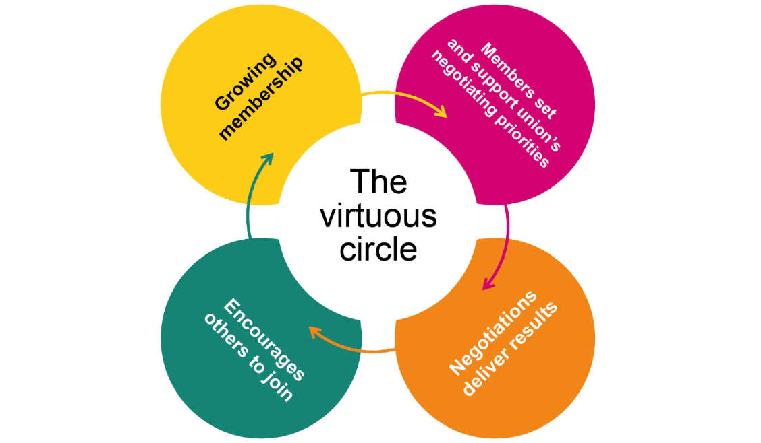

Discussion points:
Look back at your notes on the ‘ingredients of union influence’ (section 9). Pick your favourite, and tell us how it helps maintain the virtuous circle.
What is one aspect of the cycle, or one ingredient, that your branch does well? Which would you like to see improve?
Do you think other reps, or other members, would give the same answers as you?

How branch democracy works
It is very important that issues that affect the majority of the branch are dealt with as a priority.
Getting agreement at a meeting may not be easy. The chair will need to keep order and make sure all the sides of the argument are heard.
The committee should agree beforehand who will provide the information needed for the members to make an informed decision.
An issue is raised, and an action is voted on at a meeting.
A meeting needs to be quorate for a decision and a course of action to be made.
A quorum is enough members to be a reasonable representation of the branch – for example, 10%.
The branch usually instructs the committee to take action – this could be to call a meeting with management to discuss the issue.
In between meetings, the committee can discuss an issue that arises and decide a course of action. There may be occasions when a full branch meeting is needed.

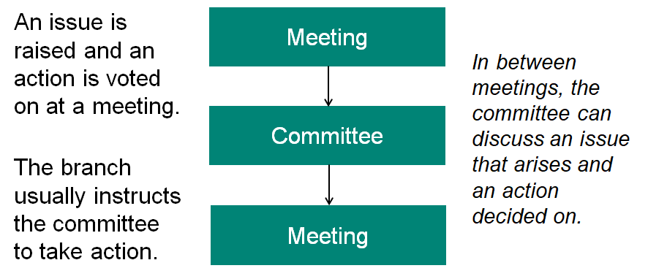

Unit 6
Effective campaigning for union reps
This unit will give you the framework to hang any campaign on, now or in the future, and is the basis for further work.
While FTOs/organisers can support with campaign issues reps need to own them and lead on them.
A reminder of the learning outcomes:
- Find out how to identify collective issues and build them into campaigns.
- Learn how your campaign can influence policy – in the workplace and in the wider union.

What is campaigning?
Campaigning is about achieving change. It might be about persuading people to take a particular course of action in relation to a particular issue or it might be about growing the strength of the branch, sometimes it might just be about making an issue more visible.
Campaigning means having a clear aim, knowing what you want to achieve and what is required to bring that change about. It involves planning and evaluation as well as clear goals and a clear strategy. It is more than organising individual events or publicity stunts.
It is useful when thinking about your own branch campaigns to think about wider campaigns that you have taken notice of or that you may have been involved in and think about them in terms of what made them noticeable, what got you involved and what planning might have been involved, this will help you to shape your own campaigns. It is also useful to look at campaigns that have failed and think about why they failed.

Activity: Thinking about campaigning
What campaigns have you noticed recently and why?

Who is a great campaigner?

What goes into a successful campaign?

What successful campaigns have you been a part of?

At the outset of your campaign, you need to be clear about the following things:
- What you want done
- Why it needs to be done
- Who you want to do it
- What message you want to get across
- How you are going to get that message across

Campaigns do not just happen and as already stated are more than a single event or tactic, they require planning, organisation, effective communication, resources and evaluation. A good campaign will have a well thought out and well-planned strategy.

Campaign planning will go through a campaign cycle and quite often several ‘revolutions’ of the campaign cycle.
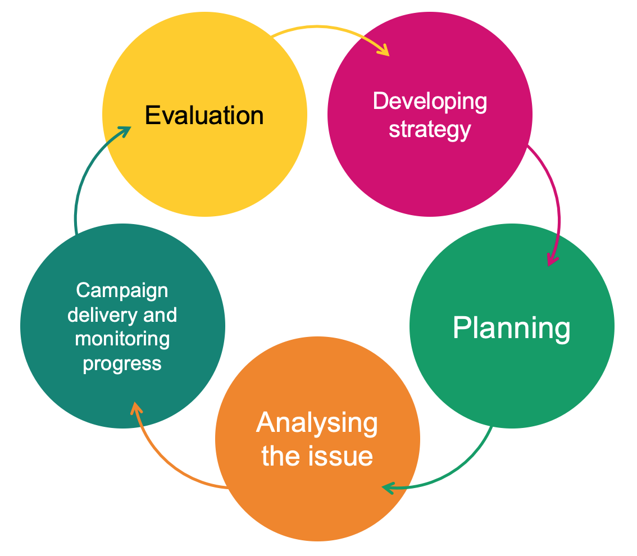

The building blocks of effective campaign planning
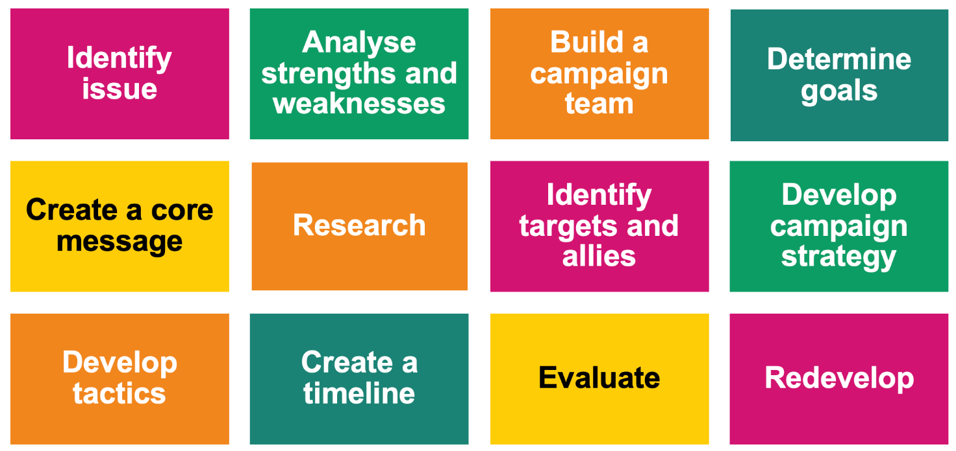

All campaigns can be built using these building blocks and these are what we will be working with throughout this course.
The components do not necessarily always happen in the same order and some parts of the campaign will be happening in parallel. For example, the identification of goals and targets may happen alongside the identification of the issue and then a campaign team built around that.
The ‘blocks’ are there to give you a structure to work within and as you become more experienced in campaigning you may develop your own structures.
Identify
issue

Identifying the issue
A good campaign issue will meet a few criteria, and this is what we need to test against.
A good issue will...
- ...be widely felt
- ...be deeply felt
- ...have a good chance of success
- ...be easily understood
- ...involve the workforce – both members and non-members
- ...be worth the effort involved
- ...support union values and be consistent with union priorities.
It is worth communicating with the wider membership to test if the issue meets the first two criteria. You may wish to do a survey or hold a members’ meeting, or even an open meeting, to get a feel for the support for a campaign. You want a sign of strength to the employer, not weakness. If not enough workers want to participate, look for tactics which are lower risk or better fit the culture.
Analyse strengths and weaknesses

Activity B: Testing your campaign issue.

Our potential campaign issue is...

Test your campaign issue against the list above. Does it meet all the criteria? Y / N
Are there any areas where it doesn’t meet the criteria? Could this be improved on? If so, how?
For example, are you complicating the issue, and could you make it more easily understood?
Remember: If an important issue is not widely and/or deeply felt, you can work to make it so through communication, education, appeals to fairness and generally making the issue more visible and better understood.

Activity C: Analyse the strengths and weaknesses of your campaign issue
You will have talked about a lot of the strengths in the previous activity when you were assessing if it was an issue worth campaigning on, but it is worth listing them here again in order to focus your thinking.
1.

2.

3.

4.

5.

You also need to think about any weaknesses in your campaign issue. These are the things that your critics and opponents will focus on! Knowing what they are and thinking about them will help you construct counter arguments.
1.

2.

3.

4.

5.

Build a campaign team
Build a campaign team
Those leading the campaign may, but do not necessarily have to be, the branch committee. When constructing a campaign plan, it is useful to think about what skills will be needed and who can supply those skills. This is an ideal opportunity to bring skills into the branch that could extend beyond the campaign, this is especially true of communications and, in the “new normal” digital organising skills.
Anyone involved in the campaign leadership needs to recognise the time commitment and be clear about how often meetings and events will be taking place.
When planning a campaign, it is also useful to think about the wider network of activists who will get the workforce involved. This is an ideal time to map!
Ideally there will be at least one activist in all areas of the workplace who will promote the message of the campaign. Look for the natural leaders who colleagues listen to and look up to, these could be reps but not necessarily, campaigning is an ideal way to involve other activists and even non-members.
Involve your full time Organiser, especially if you anticipate the need support from Prospect centrally.
Who?
- Will need to meet regularly.
- Not necessarily the branch committee
- What skills are needed?
- Can provide leadership and access different areas.
When?
- The earlier in the campaign the better
How?
- Map
- Identify potential activists.
- Communication strategy
Think about who would like to be involved in the campaign team:
- Are there activists/members who might want to
be more involved in the union but don’t know how?
- Do you need any particular skills that members have (e.g. social media skills, publishing skills)?
- Who is going to approach these people?

Determining goals
Determine goals
It is important to have campaign goals in mind in order to keep the campaign focused on what you are aiming to do. The goal might be focused on a workplace issue or on a union issue, so, for example, the goal might be maintaining terms and conditions by resisting changes or it might be to increase the number of reps in a branch.

Creating campaign goals
Why is it important to have goals?
Workplace issue: Terms & conditions under attack
Campaign goal: Maintain terms & conditions.
Union issue: Not enough reps
Campaign goal: Recruit, train and support five new reps
Set smaller, winnable goals.
Keep sight of the larger goals
Evaluate

Taking things forward
Think about:
- How you are going to communicate, with both the campaign team and members?
- How often the campaign team are going to meet?
- How often you are going to evaluate activity?
Core message

Campaign message and slogan
The campaign message is the public expression of the campaign, it describes the campaign clearly and briefly to the workforce and potentially to the public as well. A good campaign message will be a short statement, around three sentences, that will define the central issues, inspire members and non-members and might be used to win community and public support. It should also send a message to the employer.
The campaign message is different from the campaign slogan which is a short catchy phrase designed to attract attention and get people engaged with the campaign.
Things to remember when thinking about your campaign message:
Facts don’t always work
This doesn’t mean you should lie! It just means that facts and figures will not necessarily motivate and engage people when it comes to supporting your campaign.
Values and emotions often engage people
The values held by people and their emotional response to an issue is what will get people involved. It feeds into the widely felt, deeply felt aspect of deciding on a campaign issue. It is often surprising what will get people agitated and motivated to take action.
You need to anticipate opponent's arguments
Be ready to have your message challenged and be ready with your counter arguments. This may be where facts and figures will be useful.
Try not to go to the opposing side in your message/slogan
There is a temptation, particularly when your campaign is resisting a change, to use the opposing side’s message. Examples of this are things like “Stop the Cuts”. This focusses attention on what your opponent is doing and their arguments rather than on your message. A better slogan in this case would be something like “Keep the NHS funded” – this focuses on your message and your agenda.
Tests for a good campaign message
- It fits the situation.
- It is clear and uncomplicated.
- It unites the workforce.
- It could appeal to the broader community.
- It is not a slogan.

Target
Identify targets and allies.
This is the person, or small group of people, who can affect the change you are seeking or solve the issue you are addressing. It is important to identify the target of the campaign early on because this is the person who you need to influence or whose mind you need to change. Campaigns can lose focus if this person is not identified.

Secondary target
These are people who might have an influence on the target, who might help you to change the target’s mind or influence the target’s thinking.

Allies
These are the people who can help your campaign but are not a part of your immediate workplace. They are people who have a common interest and who you can you trust with your plans.
An example of these might be:
In a campaign to change the chairs in an office the target would be the person who makes the decisions on which chairs to buy, a secondary target might be the health and safety officer and allies might be another union.
It is important when planning a campaign to identify these people or groups of people but also to assess and re-evaluate as the campaign progresses.
You will find that as well as allies you will also have opponents, and these will form a spectrum as illustrated below. The aim of a campaign is to move people in each group to the left of the diagram so that active opponents become passive opponents who become neutral allies and so on. This is done through the persuasiveness of your arguments and the strength of your appeals to justice and reasonableness.

Spectrum of allies
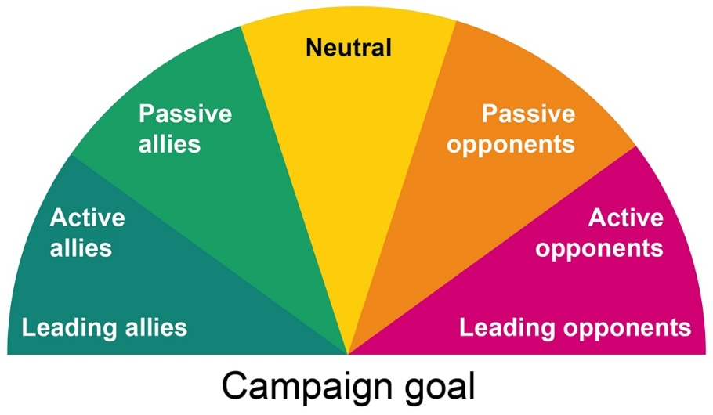

Activity D: Identify targets and allies
- Identify your target. Who is the one person (or group of people) who can make the change happen?
- Identify any secondary targets who might have an influence on the target.
- Identify any allies, eg other unions, general public etc.
Target
Secondary target(s)
Allies

Strategy and tactics are worth a mention in the course, as it is important to appreciate the difference between the two. Campaigns often fail because they are just a single tactic, or a series of tactics, rather than having a planned a defined strategy that involves a series of tactics.
Develop a strategy
Develop tactics

Strategy
The strategy is the overall plan for how to win a campaign, it is where you are trying to get to. Good strategies are based on good information and may focus on the vulnerabilities of the targets drive the strategy.
For example: in an anti-bullying campaign, the strategy may be to focus the target’s thinking on their reputation and if they want to be seen as a good employer in order to address a bullying issue in the workplace.
Your strategy should include a clear communications plan!

Tactics
Tactics are how you are going to bring the campaign to the attention of the workforce and possibly the wider community, they are also about how you are going to accomplish your goal. They might focus on a series of events that increase in intensity that increase the visibility of the issue and the campaign and engage people in the campaign.
Examples of this might be petitions, post card events, writing to MPs, information events etc. There is a list of suggestions in Appendix 2 of this workbook.
Top tips for campaigns
- Make it local.
- Stay focused on a simple message.
- Marshall your evidence
- Suggest opportunities for raising the issue.
- Anticipate counterarguments.
- Offer public praise when ‘targets’ do the right thing.
- Plan your hardest-hitting tactic first, then create lower-impact tactics leading up to it.
- Involve members in planning tactics that way they are more likely to participate.

Some reasons campaigns fail
- Incomplete buy-in
- Thinking tactically not strategically
- Campaign message was not appealing to the audience.
- Lack of understanding of the issue(s).

Remember
Campaigning relies on the strength of the branch so recruiting new members and using campaigning as a vehicle to do this is important too.
Include opportunities for non-members to join in your planning.
Advertise wins!
Don’t forget member-recruit-member.

Case studies.
https://prospect.org.uk/news/climate-emergency-webinar-the-reps-making-a-difference-in-their-workplace
Low carbon heating system
LED Lighting and controls upgrade
Electric vehicle charge points
Recycling of PPE
Goodlives Timebank
Move to Bio Diesel

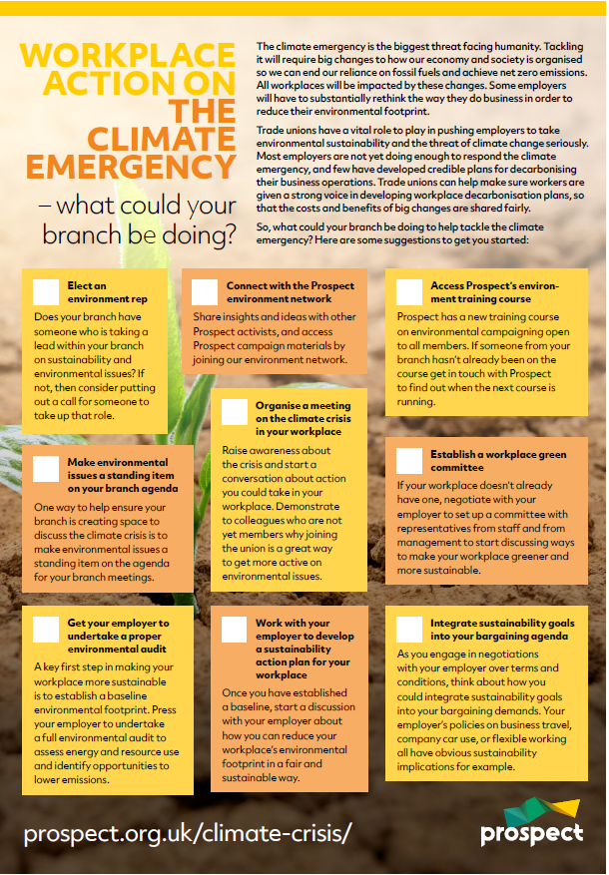
Starting point.
Elect an environment rep
Standing item on branch agenda
Environmental audit
Prospect environmental network
Climate crisis meeting
Develop a sustainability action plan
Training
Workplace green committee
Integrate sustainability into bargaining agenda

Networks to get involved with
Prospect Environmental Activists Group – contact your organiser to join the group
https://earthwatch.org/
https://carbonliteracy.com/toolkits/
Greener Jobs Alliance | DEMANDING CLIMATE JUSTICE
About us » Green Alliance (green-alliance.org.uk)

Strategies within workplaces
Financial: Circular economy
- Re-new
- Re-cycle
- Re-use
Pensions: Environmental options look for Environmental, Social and Governance (ESG) in schemes

Actions for a sustainable workplace
Make a pledge for individual action.
Negotiate with your employer for action.
Campaign for local action
Ask Prospect Union to take some action.
Campaign for national action.
https://prospect.org.uk/climate-emergency/
Have difficult conversations with confidence.
Look at what are the barriers and how to overcome them.
Action plan for the branch
- Structural
- Project based.
Campaign, how are you going to implement plans?
Remember – Publicising successes can inspire others to follow.

Action planning
Spend a few minutes thinking about what you would like to do when you get back to your workplace and what you need to achieve this.
Tasks
Engage in conversation with the branch about sustainability issues.

Find out if there any workplace sustainability issues currently

Find out when the branch/section committee next meet.

Is sustainability/climate change on the agenda?

What is your employers stance on the environment and sustainability?

What policies and procedures are in place in your workplace?

Sign up to the Prospect environment network

Reflecting on what you learnt about campaigning, is there a campaign you could run in your workplace?

Does your branch have a development plan? Is climate change included?

After attending this course, what will you stop doing?

After attending this course, what will you continue to do?

Appendix 1: Writing a motion to conference
You should remember from the ‘How Prospect works’ video, that union conferences are our main policy-setting bodies (go back and watch the video again if you need to).
Conferences will vote on a number of ‘motions’ or proposals for policy and action that are put before them by the membership. A member may put a motion to their branch conference – if it’s ‘passed’, then it may be enacted by the branch itself, or escalated to the sector conference, or national conference according to its scope.
This democratic process gives members a chance to steer the direction of the wider union.
A motion to conference should consider:

What?
- There should be a clear instruction; an objective

Who?
- It must be an instruction that the union can affect – we can’t instruct employers or governments!
- You should also remember WHO you are trying to persuade to vote for it – who are your likely supporters; who might object and how can you win their support or neutralise their opposition? Remember, if you want your motion to pass a national conference, you must first get it through your branch conference, but then you have to win over a majority of the broad church of Prospect members!

Why?
- It should explain why this should matter to the majority of the union.
It should also be as clear and concise as possible. There may be 100 or more motions for delegates to read, so it’s important to grab and keep their attention on yours!
Overleaf you will an example of an environmental-themed motion that was submitted for the 2020 national conference. As you read it, think about how effectively it meets the tests above.

EFRA branch motion to national conference 2020
Organisations should all have environmental policies in order to minimise their environmental impact and support a just transition to a low carbon society. Employers of Prospect members have a wide breadth of environmental policies, some of which are exemplary, and others are merely small sub-sections of wider Health, Safety, Environment and Quality (HSEQ) policies with little ambition.
Embedding environmental principles in organisations policies provides an effective mechanism to improve sustainability, reduce environmental impact and reduce organisational greenhouse gas emissions.
Prospect has relaunched the environment reps network and provided training courses for environmental reps, but these do not include any guidance on how to scrutinise and improve employers environmental and sustainability policies.
Conference instructs the NEC to produce guidance on environmental and sustainability policy best practices in the workplace and incorporate this guidance in training for environmental reps.

Appendix 2: The big issues in sustainability
We started this course with a session on climate change – arguably the biggest and most challenging environmental issue of them all. But it’s not the only one. Our environment reps are finding ways to organise their members to tackle a whole range of sustainability issues that loosely fit into a few broad themes:
- Climate change
- Pollution
- Biodiversity and ecological health
- Human factors
Of course, there is a huge degree of interplay between the themes, but it is important to distinguish between them, to understand the scope and the potential of our environmental action. There is a rich history of governments and businesses ‘greenwashing’ their reputations by token remedial action on one environmental issue to obscure their contribution to other problems.
In this session, we’re going to discuss some of the themes we’ve missed so far, and consider how they can be translated into branch activity.

Pollution
According to the UN, pollution is the direct or indirect introduction by humans of substances or energy into the environment, resulting in harm to living resources, hazards to human health, hindrances to human activities, impairment of environmental quality, and reduction of amenities.
It is not a new phenomenon. As far back as the 14th century, Edward III was motivated to impose punitive, though dubiously effective, laws on the burning of sea coal, in the hopes of improving air quality, and regulating waste disposal on the streets of London.
Industrialisation, in making society more efficient in consumption and waste of resources, has intensified issues of pollution. Concentration of populations into urban centres, and industries near natural resources, have further intensified specific, localised pollution issues:
- Hydrocarbon release near oil fields and shipping lanes
- Atmospheric particulates in urban centres
- Antifouling products around marinas
The history of environmental pollution has been marked by cycles, where particular contaminants or processes come into focus:
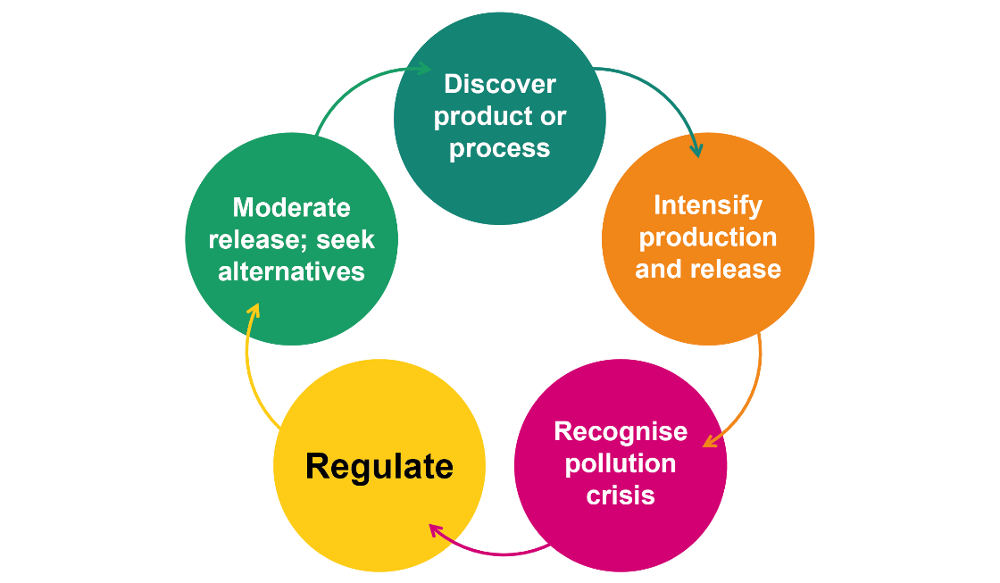
For optimists and activists, this pattern gives us many success stories, where our better knowledge and campaigns have reversed environmental damage. But it should also put us on watch for the environmental impacts of the next “wonder product” or process.

Biodiversity and ecological health
Biodiversity is a central concept in ecology – a marker of the maturity of an ecosystem or biome, and a predictor of its resilience to change. Ecology is the study of the interactions among organisms and with the environment they inhabit.
We have a tendency to worry most about the decline of big, mammal species: typically top-predators such as polar bears, or the orangutan, and they are often markers of wider damage to the ecosystem. However, there is a growing awareness of species loss among ‘lower’ niches.
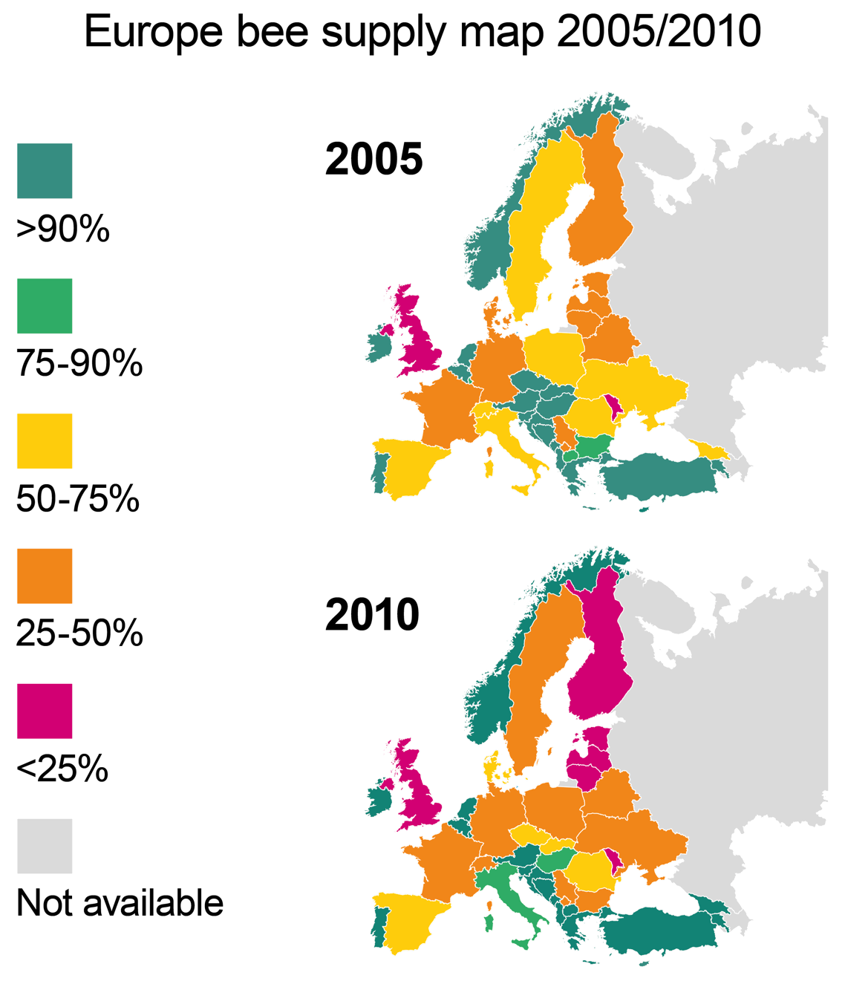
Bees are susceptible to many of the environmental impacts of modern society: habitat loss, global warming, and pollution. The decline in bee populations has become particularly well-publicised due to their essential role as pollinators in our own food webs – a compelling example of the interdependence of animal species (in this case, us and the bees!) that share an ecosystem.

Human factors
The human dimension is the common thread in all environmental crises. Human culture and behaviour is the greatest force of disturbance to the earth and its systems since an asteroid strike wiped out the dinosaurs. When it comes to understanding the sources of environmental crises, and the barriers and bridges to their solutions, we need to consider human factors from the individual to the industrial, national, and even international scale.
 | Negative factors | Helpful factors
Individual
Community
Industrial
National

Collective action on pollution and biodiversity
The following are real examples of initiatives championed by Prospect branches and reps.
- Campaign to eliminate paper cup use by the on-site café
- Branch-organised beach clean
- Workplace wormery
- Conversion of waste-ground to wildlife reserve
These initiatives have all offered brilliant opportunities for visible, collective action – lots of members engaged with jobs as diverse as pond-digging, leafletting, and ‘worm-husbandry’, and some eye-catching success-stories.

Appendix 3: Asking allies for support.
Below are some pointers that may help you formulate a statement or thoughts when approaching allies.
Before you begin, identify what you will be asking for.
We are...
How many and what kind of workers? Who are we in relation to the audience?
Things were...
How were things before they turned bad?
But now...
How are things getting worse?
Because...
Why are things getting worse?
Things will get better when...
What needs to happen to make things better?
Together we want...
What are our public demands, our goals?
To accomplish this, we must...
What needs to change to fix the problem?
What we are asking you to do...
What concrete things can this audience do now to help? Be very specific.
Together we will...
What will working together accomplish?

Appendix 4: Suggestions for tactics
- Petitions
- Distribution of information
- Leafleting (digital and/or hard copy)
- Talking about a particular problem in the workplace in a synchronised manner
- Competitions
- Social events (can be done online)
- Badges or stickers
- Digital stickers and backgrounds
- T-shirts all worn at the same time
- Investigations and reports from ally groups (NGOs, women’s groups, universities etc)
- Songs / slogans
- Gathering at a building (post-covid)
- Phone / email / postcard protests
- Appeals for justice from community allies
- Anonymous workers’ stories
- Surveys
  - Keep it short – one or two questions
  - Report the results when you’re ready – eg 85% of workers report and increase in workload, 75% report a worsening of work/life balance.

Appendix 5: Data protection
Prospect is covered by the General Data Protection Regulations. Here are some guidelines for reps drawn up by the union’s compliance officer.
The EU data protection regulations came into force on 25 May 2018. While these are underpinned by the Data Protection Act 2018, they introduce a new suite of rights and enhance existing ones.
Enhanced rights
- Right of access (right to request access to personal information, eg Data Subject Access Request)
- Right of rectification (right to request correction of incomplete or inaccurate personal information)
New rights
- Right to portability – allows individuals to obtain and reuse personal data for their own purposes across different services
- Right to be informed – providing people with clear and concise information about what we do with their data
- Right to erasure (the ‘right to be forgotten’)
You can find more information in our briefing: https://library.prospect.org.uk/id/2016/01617
Common-sense dos and don’ts to ensure you comply with data protection legislation
Do...
- mark all correspondence, electronic or otherwise, as private and confidential
- be aware that the Act applies to paper files, information held electronically, records of telephone conversations, audiotapes, photographs and social networking media (Facebook, twitter, LinkedIn etc)
- think of personal data held about individuals as though it were held about you
- tell people you hold personal data about them and tell them why you need to do so (fair processing). Be open with people about information held about them
- be open with people about information held about them
- respect confidentiality and the rights of the member
- review personal data in on-going cases from time to time and at least annually
- ensure all personal data is disposed of as confidential waste
- when writing reports, minutes etc, bear in mind that the member has a right to see information relating to them; even deleted emails may be retrieved and revealed to those about whom they are written
- refer all requests for access to a Prospect full-time official
- familiarise yourself with Prospect’s data destruction policy (reproduced overleaf).
Don’t...
- worry about the complexities of the Act - the Data Protection principles are simple
- reveal personal data to third parties without the data subject's permission or justification
- disclose any personal data over the telephone
- put personal data about a member on the Internet without his/her permission
- send personal data outside the European Economic Area (EEA) without taking advice from Prospect
- leave personal data insecure in any way, whether it is physical files or information held electronically
- take personal data home without ensuring that it can be securely stored
- use personal data held for one purpose for a different purpose without permission from the member.
Prospect’s data destruction policy
Destroy closed case files after:
- six years – equal pay cases
- seven years – employment related cases
- seven years – personal injury cases
- 12 years – industrial disease.
If you no longer handle cases, you must pass all files to your Prospect full-time official.

Appendix 6: Useful links
Prospect
Prospect rep’s handbook
https://library.prospect.org.uk/download/2009/00650
A leaflet setting out our legal team’s successes between November 2018 and November 2019
https://library.prospect.org.uk/download/2019/01668
Benefits and services
Member benefits | Prospect
Logos, templates and other resources
https://prospect.org.uk/ambition/
Members’ guides
https://members.prospect.org.uk/resources/guides-factcards/members-guides
Posters
https://members.prospect.org.uk/resources/leaflets-posters/posters
TUC
TUC
www.tuc.org.uk
Worksmart
https://worksmart.org.uk
Union reps’ forum
https://unionreps.org.uk
Health and safety, union effect
www.tuc.org.uk/research-analysis/reports/union-effect
Training
TUC Education | TUC
Collective bargaining and great jobs
www.tuc.org.uk/research-analysis/reports/great-jobs-are-union-jobs
Training benefit to economy
www.tuc.org.uk/sites/default/files/Skils_and_training.pdf
Other
ACAS code of practice 3
http://bit.ly/acas-time-off
ACAS
www.acas.org.uk
UK Government
www.gov.uk
Energy Saving Trust (Guides to measuring carbon footprint and engaging employees in energy saving)
https://energysavingtrust.org.uk/

Nature Scot (Guides to improving biodiversity at work)
https://www.nature.scot/

NetRegs.org.uk (guidance for business in Northern Ireland and Scotland)
https://www.netregs.org.uk/
https://www.netregs.org.uk/environmental-topics/guidance-for-pollution-prevention-gpp-documents/ (Pollution Prevention Guidelines)

Earth Watch
https://EarthWatch.org

https://carbonliteracy.com/toolkits/ Toolkits

https://green-alliance.org.uk/project/circular-economy/ policy sources

https://greenerjobsalliance.co.uk/courses/ free courses

https://shareaction.org/savers-resource-hub/pension-power-what-world-is-our-money-building pensions and investing talks

Carbon footprint information
https://footprint.wwf.org.uk/#/
https://www.carbonfootprint.com/calculator.aspx
https://www.positive.news/environment/what-can-i-do-about-climate-change-how-to-lower-your-carbon-footprint/

https://www.unep.org/explore-topics/climate-action/facts-about-climate-emergency
https://www.ipcc.ch/sr15/chapter/spm/
https://www.theccc.org.uk/publication/net-zero-the-uks-contribution-to-stopping-global-warming/
https://ec.europa.eu/info/strategy/priorities-2019-2024/european-green-deal/finance-and-green-deal/just-transition-mechanism_en
https://www.tuc.org.uk/resource/go-green-work-union-effect
https://prospect.org.uk/climate-emergency/
https://www.futurelearn.com/info/blog/how-to-reduce-your-carbon-footprint-tips

