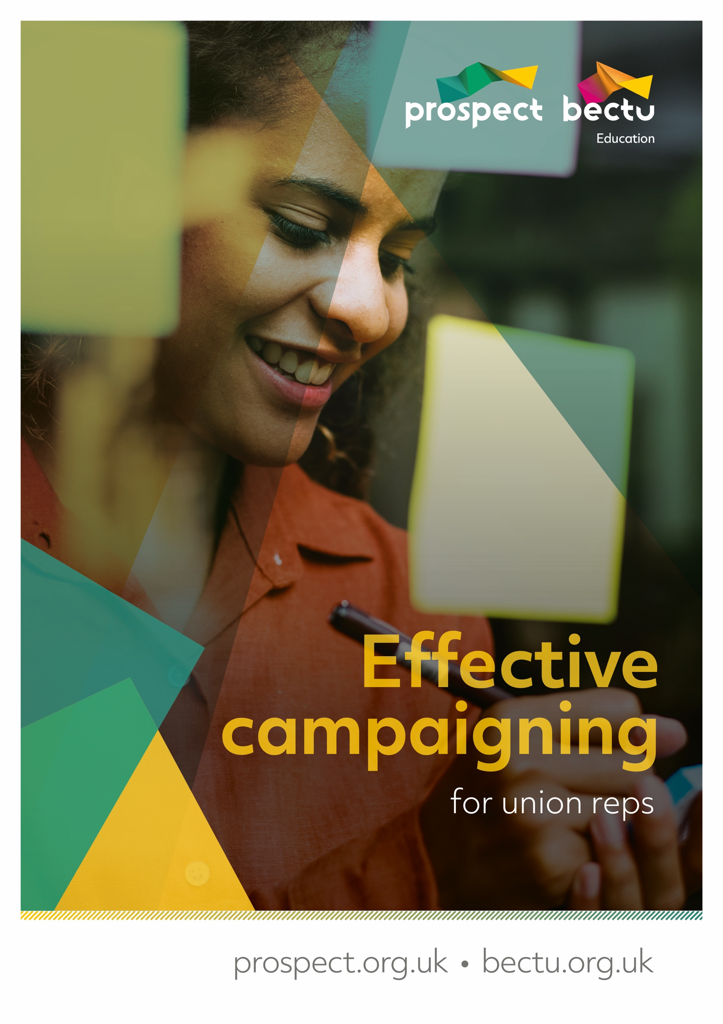

Effective campaigning
for union reps

Contents

Effective campaigning for union reps 3
Learning outcomes 3
About Prospect 4
What happens on trade union courses? 5
The tutor’s role 5
Your role 5
Using your knowledge and skills 6
Equality and diversity statement 7
Getting started 8
Activity A: Introductions 8
What is campaigning? 10
The building blocks of effective campaign planning 11
Identifying the issue 12
Activity B: Testing your campaign issue 12
Activity C: Analyse the strengths and weaknesses of your campaign issue 13
Determining goals 14
Build a campaign team 15
Activity D: Campaign team ideas 15
Campaign message and slogan 16
Activity E: Campaign message and campaign slogan 17
Targets and allies 18
Target 18
Secondary target 18
Allies 18
Spectrum of allies 18
Activity F: Identify targets and allies 19
Strategy and tactics 20
Strategy 20
Tactics 20
Activity G: Bringing it all together – action plan 21
Delivery stage 23
Are you ready? 23
Charting 24
Structure tests 25
GDPR and campaigning data 26
Finally… 27
Top tips for campaigns 27
Some reasons campaigns fail 27
Appendix 1: Campaign strategy chart 28
How to use this chart 28
Strengths and weaknesses 28
Goals 29
Messaging 30
Constituents, allies, targets and opponents 31
Resources we need 34
Timeline 35
Appendix 2: Asking allies for support 36
Appendix 3: Suggestions for tactics 37
Appendix 4: Data protection 38
Appendix 5: Useful links 40

Effective campaigning for union reps
Welcome to this course for Prospect representatives on Effective Campaigning which forms part of our toolkit of representatives’ training.
Our aims are to introduce you to campaigning and give you some practical tools to take out an use. The course will provide you with a planning framework that you can take away and use to formulate your campaigns.
The training is very informal and there is no pressure on anyone to do anything they are not comfortable with.
There is plenty of discussion and problem solving, as these are the most effective methods in adult learning.

Learning outcomes
- Understand what campaigning is
- Recognise a good campaign
- Develop a structure for your campaigning
- Gain confidence in running your own campaign

About Prospect
Most of the larger unions in the UK have grown and evolved through mergers and acquisitions with other unions, staff associations and professional bodies – either through necessity or strategy.
Prospect is no exception, having absorbed various groups of professional and specialist staff. It is now the tenth largest union in Britain out of the sixty-six affiliated to the Trades Union Congress – the umbrella body for Britain’s unions – and the most diverse.
Prospect was formed in 2001 through the merger of the Engineers and Managers Association and the Institution of Professionals, Managers and Specialists. IPMS originated from the Royal Corps of Naval Constructors of 1916, so the new union inherited extensive history.
The EMA’s power station managers and electricity distribution engineers complemented the IPMS demographic (scientists, engineers and managers in the defence, energy, heritage, environment and transport sectors) and strengthened our bargaining power.
Prospect merged with the telecoms professionals in Connect union in 2010 and with Aspect, which represents professionals in education, children’s services and social care in 2012. In January 2017, Bectu, the media and entertainment union, joined us to create a sector which includes broadcasting, cinema, film, digital media, independent production, leisure, IT and telecoms, theatre and the arts.
Despite the expansion, the union has managed to maintain four key principles of industrial relations that are consistently important to members, whichever union they originated from:
- we represent professional staff
- we are not affiliated to any party political
- one of our objectives is ‘…to promote the advancement and efficiency of industries and organisations where members are employed’
- as an affiliate, we enjoy the resources of the TUC.

What happens on trade union courses?
For many trade union activists, Prospect courses mark a return to education, sometimes when previous experiences have been less than positive.
Trade union education places great value on the knowledge that union reps bring to the course and seeks to enhance this by working co-operatively to gain new knowledge.
We place great emphasis on team working and involving everybody in the learning process. This not only makes learning interesting and challenging but is rooted in well-researched and tested educational methods.
As part of this approach, we will:
- encourage a cooperative approach to learning
- allow workplace experiences to be reflected and valued throughout the programme
- help you to build a useful resource pack to support your union activity
- encourage a collective approach to your role as a Prospect representative.

The tutor’s role
Trade union tutors are qualified to teach in the ‘learning and skills sector’ (adult education outside of university) and will also have extensive practical experience as trade unionists.
They should be inspiring, accessible and empowering – you should learn from them! Your tutor will:
- make sure that the expected learning outcomes are clear
- encourage and facilitate everyone’s participation
- introduce you to new ideas and concepts
- giving guidance on how to become an accredited rep
- help you understand your own preferred learning styles and ensure that everyone can participate and benefit.

Your role
The focus of trade union education is 'learning' rather than 'teaching'. The focus is on you and your colleagues as learners rather than on the tutor (although their role is absolutely vital) as teacher. In particular, we hope you will:
- feel confident to participate fully
- be able to support your colleagues
- enjoy the learning process
- add to your existing knowledge and skill
- use your new knowledge and skills to support Prospect’s aims in your workplace.
We ask that you take an active part in the course, support your fellow reps and course members when you can and be respectful of other delegates during the course – this will help you promote collective and co-operative activity at your own workplace.
We respect whatever pronoun you wish to be referred to during the course – please write it on your name card or on Zoom/MS Teams for online training.

Using your knowledge and skills
Learning and knowledge are valuable in their own right – they need no justification but as practical people we want to encourage you to develop further.
First, we want your experience of learning with us to encourage you to engage in other forms of learning.
Second, we hope you will use your learning to make a difference at work – for the better.
To help you put your learning to good use we will provide you with a small ‘action plan’ for you to apply at your workplace. We will also support you to carry it out.

Equality and diversity statement
Prospect is dedicated to providing training for all its representatives and activists that aspires to the highest standards of respect for difference and diversity.
This statement is inspired by our trade union values of justice, fairness, democracy, solidarity and equality. As a trade union, we oppose any view, action or organisation that undermines the ability of working people to act collectively to pursue their democratically determined policies and objectives.
We are opposed to discrimination against people on the basis of their gender, nationality, ethnicity, religion, disability, sexual orientation, marital status, social class, age, politics or education.
We defend the right to freedom of expression and to political opinions and beliefs except where these conflict with, or tend to undermine, the freedom of other people from discrimination on the grounds listed above.
In particular, we are opposed to sexist, racist and fascist ideologies and will not permit such views to be promoted at Prospect education events.
We will seek to ensure that all Prospect training is accessible to all who wish to attend. Recruitment to courses will be open, fair and in line with our commitments above.
All courses will allow opinions to be put forward and defended (consistent with the statement above). All members who attend Prospect courses are entitled to respect.
Members who want to raise issues relating to our commitment to equality and diversity, or if they wish to lodge a complaint about any incident or failure concerning this policy, should use the following procedure:
- any issue occurring during a course to be raised with the tutor
- if this is not practicable, or if the complaint is not dealt with to the satisfaction of the member, it should be raised with Prospect’s education officer or the education and skills manager
- if a member is not satisfied, the matter should be referred to the General Secretary.

Getting started

Activity A: Introductions
The tutor will split you into pairs.
Please gather the following information about your partner and fill in the form overleaf:
- their name
- the company/organisation they work for
- current union role/s
- an example of a negotiating experience they have had
- what they would they like to know before returning to their workplace.
The tutor will then ask you to introduce your 'partner' to the rest of the course participants.

PLEASE NOTE: Complete this form for the person you interview, not yourself.
Name
Company and job role
Union role
A campaigning experience
What does the person you are interviewing want from the course?

What is campaigning?
Campaigning is about achieving change. It might be about persuading people to take a particular course of action in relation to a particular issue or it might be about growing the strength of the branch, sometimes it might just be about making an issue more visible.
Campaigning means having a clear aim, knowing what you want to achieve and what is required to bring that change about. It involves planning and evaluation as well as clear goals and a clear strategy. It is more than organising individual events or publicity stunts.
It is useful when thinking about your own branch campaigns to think about wider campaigns that you have taken notice of or that you may have been involved in and think about them in terms of what made them noticeable, what got you involved and what planning might have been involved, this will help you to shape your own campaigns. It is also useful to look at campaigns that have failed and think about why they failed.
At the outset of your campaign, you need to be clear about the following things:
- What you want done
- Why it needs to be done
- Who you want to do it
- What message you want to get across
- How you are going to get that message across
Campaigns do not just happen and as already stated are more than a single event or tactic, they require planning, organisation, effective communication, resources and evaluation. A good campaign will have a well thought out and well-planned strategy.

Campaign planning will go through a campaign cycle and quite often several ‘revolutions’ of the campaign cycle.
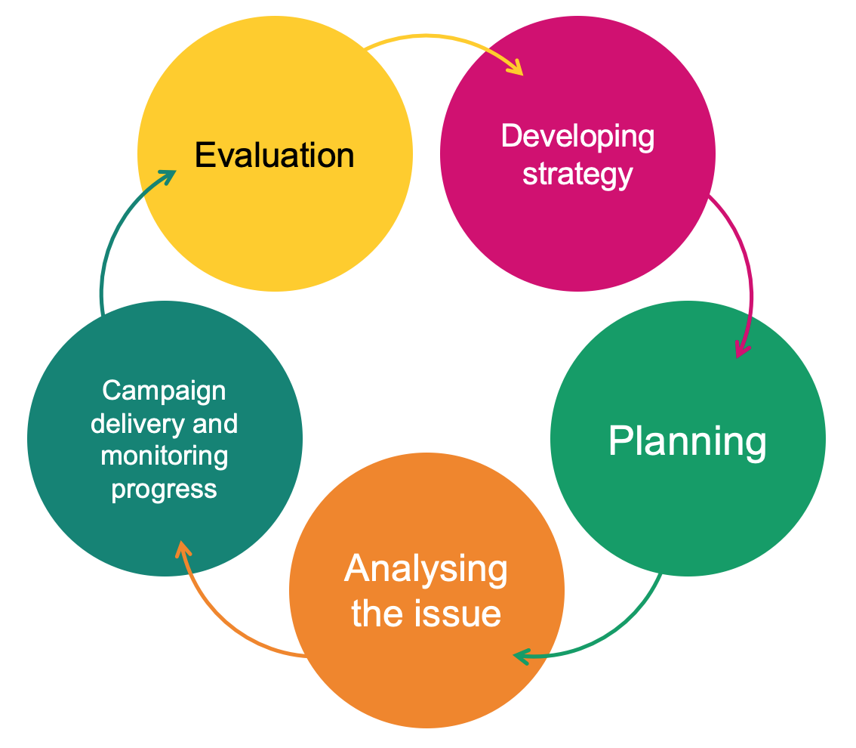

The building blocks of effective campaign planning
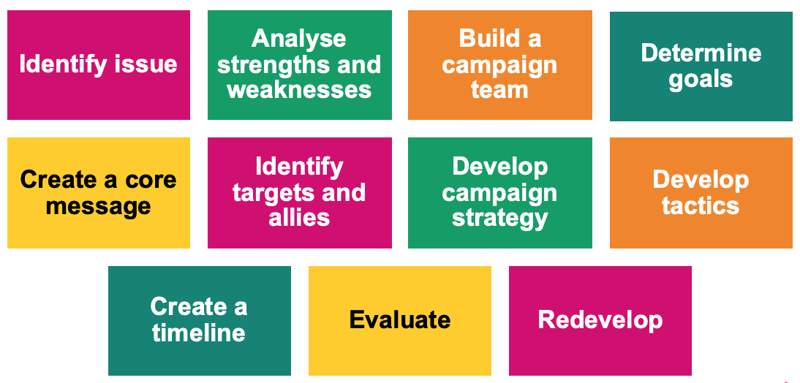

All campaigns can be built using these building blocks and these are what we will be working with throughout this course.
The components do not necessarily always happen in the same order and some parts of the campaign will be happening in parallel. For example, the identification of goals and targets may happen alongside the identification of the issue and then a campaign team built around that.
The ‘blocks’ are there to give you a structure to work within and as you become more experienced in campaigning you may develop your own structures.

Identifying the issue
A good campaign issue will meet a few criteria, and this is what we need to test against.
A good issue will...
- ...be widely felt
- ...be deeply felt
- ...have a good chance of success
- ...be easily understood
- ...involve the workforce – both members and non-members
- ...be worth the effort involved
- ...support union values and be consistent with union priorities.
It is worth communicating with the wider membership to test if the issue meets the first two criteria. You may wish to do a survey or hold a members’ meeting, or even an open meeting, to get a feel for the support for a campaign. You want a sign of strength to the employer, not weakness. If not enough workers want to participate, look for tactics which are lower risk or better fit the culture.

Activity B: Testing your campaign issue

Our potential campaign issue is...

Test your campaign issue against the list above. Does it meet all the criteria? Y / N
Are there any areas where it doesn’t meet the criteria? Could this be improved on? If so, how?
For example, are you complicating the issue, and could you make it more easily understood?
Remember: If an important issue is not widely and/or deeply felt, you can work to make it so through communication, education, appeals to fairness and generally making the issue more visible and better understood.

Activity C: Analyse the strengths and weaknesses of your campaign issue
You will have talked about a lot of the strengths in the previous activity when you were assessing if it was an issue worth campaigning on, but it is worth listing them here again in order to focus your thinking.
1.

2.

3.

4.

5.

You also need to think about any weaknesses in your campaign issue. These are the things that your critics and opponents will focus on! Knowing what they are and thinking about them will help you construct counter arguments.
1.

2.

3.

4.

5.

Determining goals
It is important to have campaign goals in mind in order to keep the campaign focused on what you are aiming to do. The goal might be focused on a workplace issue or on a union issue, so, for example, the goal might be maintaining terms and conditions by resisting changes or it might be to increase the number of reps in a branch.
Notes

Build a campaign team
Those leading the campaign may, but do not necessarily have to be, the branch committee. When constructing a campaign plan, it is useful to think about what skills will be needed and who can supply those skills. This is an ideal opportunity to bring skills into the branch that could extend beyond the campaign, this is especially true of communications and, in the “new normal” digital organising skills.
Anyone involved in the campaign leadership needs to recognise the time commitment and be clear about how often meetings and events will be taking place.
When planning a campaign, it is also useful to think about the wider network of activists who will get the workforce involved. This is an ideal time to map!
Ideally there will be at least one activist in all areas of the workplace who will promote the message of the campaign. Look for the natural leaders who colleagues listen to and look up to, these could be reps but not necessarily, campaigning is an ideal way to involve other activists and even non-members.
Involve your full time Organiser, especially if you anticipate the need support from Prospect centrally.

Activity D: Campaign team ideas
In your breakout groups list your initial ideas for your campaign team:
Are there activists/members who might want to be more involved in the union but don’t know how?
Do you need any particular skills that members have (e.g. social media skills, publishing skills etc)
Who is going to approach these people to join the team?

Notes

Campaign message and slogan
The campaign message is the public expression of the campaign, it describes the campaign clearly and briefly to the workforce and potentially to the public as well. A good campaign message will be a short statement, around three sentences, that will define the central issues, inspire members and non-members and might be used to win community and public support. It should also send a message to the employer.
The campaign message is different from the campaign slogan which is a short catchy phrase designed to attract attention and get people engaged with the campaign.
Things to remember when thinking about your campaign message:
Facts don’t always work
This doesn’t mean you should lie! It just means that facts and figures will not necessarily motivate and engage people when it comes to supporting your campaign.
Values and emotions often engage people
The values held by people and their emotional response to an issue is what will get people involved. It feeds into the widely felt, deeply felt aspect of deciding on a campaign issue. It is often surprising what will get people agitated and motivated to take action.
You need to anticipate opponent's arguments
Be ready to have your message challenged and be ready with your counter arguments. This may be where facts and figures will be useful.
Try not to go to the opposing side in your message/slogan
There is a temptation, particularly when your campaign is resisting a change, to use the opposing side’s message. Examples of this are things like “Stop the Cuts”. This focusses attention on what your opponent is doing and their arguments rather than on your message. A better slogan in this case would be something like “Keep the NHS funded” – this focuses on your message and your agenda.
Tests for a good campaign message
- It fits the situation
- It is clear and uncomplicated
- It unites the workforce
- It could appeal to the broader community
- It is not a slogan.

Activity E: Campaign message and campaign slogan
Discuss what your core message is going to be:
Campaign message:

Come up with a campaign slogan:
Slogan:

Give some thought to how both of these are going to engage and inform people and test them against the criteria above.

Targets and allies

Target
This is the person, or small group of people, who can affect the change you are seeking or solve the issue you are addressing. It is important to identify the target of the campaign early on because this is the person who you need to influence or whose mind you need to change. Campaigns can lose focus if this person is not identified.

Secondary target
These are people who might have an influence on the target, who might help you to change the target’s mind or influence the target’s thinking.

Allies
These are the people who can help your campaign but are not a part of your immediate workplace. They are people who have a common interest and who you can you trust with your plans.
An example of these might be:
In a campaign to change the chairs in an office the target would be the person who makes the decisions on which chairs to buy, a secondary target might be the health and safety officer and allies might be another union.
It is important when planning a campaign to identify these people or groups of people but also to assess and re-evaluate as the campaign progresses.
You will find that as well as allies you will also have opponents, and these will form a spectrum as illustrated below. The aim of a campaign is to move people in each group to the left of the diagram so that active opponents become passive opponents who become neutral allies and so on. This is done through the persuasiveness of your arguments and the strength of your appeals to justice and reasonableness.

Spectrum of allies
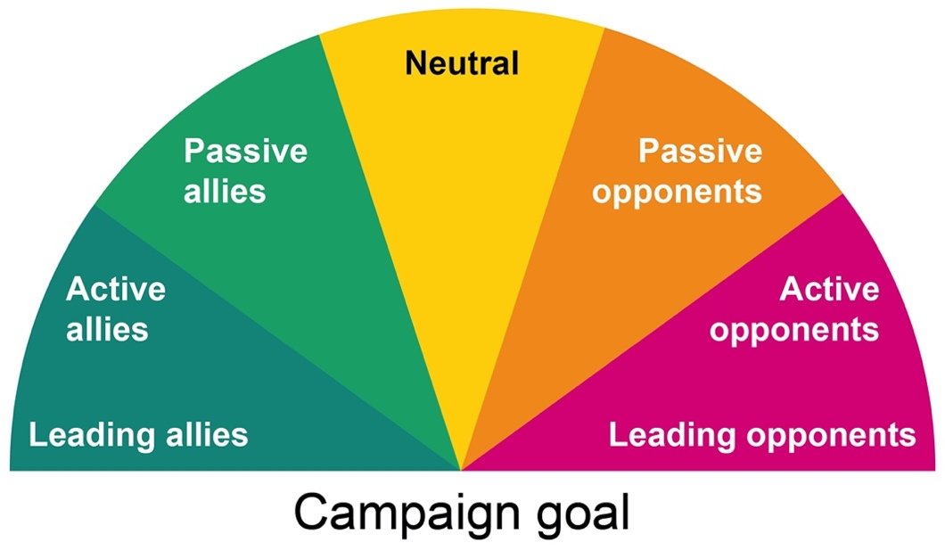

Activity F: Identify targets and allies
- Identify your target. Who is the one person (or group of people) who can make the change happen?
- Identify any secondary targets who might have an influence on the target.
- Identify any allies, eg other unions, general public etc.
Target
Secondary target(s)
Allies

Strategy and tactics
Strategy and tactics are worth a mention in the course, as it is important to appreciate the difference between the two. Campaigns often fail because they are just a single tactic, or a series of tactics, rather than having a planned a defined strategy that involves a series of tactics.

Strategy
The strategy is the overall plan for how to win a campaign, it is where you are trying to get to. Good strategies are based on good information and may focus on the vulnerabilities of the targets drive the strategy.
For example: in an anti-bullying campaign, the strategy may be to focus the target’s thinking on their reputation and if they want to be seen as a good employer in order to address a bullying issue in the workplace.
Your strategy should include a clear communications plan!

Tactics
Tactics are how you are going to bring the campaign to the attention of the workforce and possibly the wider community, they are also about how you are going to accomplish your goal. They might focus on a series of events that increase in intensity that increase the visibility of the issue and the campaign and engage people in the campaign.
Examples of this might be petitions, post card events, writing to MPs, information events etc. There is a list of suggestions in Appendix 2 of this workbook.
Top tips
- Plan your hardest-hitting tactic first, then create lower-impact tactics leading up to it.
- Involve members in planning tactics that way they are more likely to participate.

Activity G: Bringing it all together – action plan
Check you are clear about what you want to achieve.
- How often the campaign team are going to meet
- How often you are going to evaluate activity.
Discuss some of the tactics you might use to put pressure on the target.
How are the tactics going to bring members and non-members on board?
Create a timeline
List what resources are you going to need. Include both materials and people.
Write a communication plan.
Include both the campaign team and the workforce. Build this into your timeline.

Delivery stage

Are you ready?
Now that have all your campaign plans in place it is time to actually launch and commence with the campaign. It is important to make sure members (and non-members) in your workplace are aware of the campaign, its core message and its aims so some sort of launch may be a good idea. This could be part of the communications plan and/or the first campaign event.
A good way to check if you are ready is to use the Prospect/Bectu campaign checklist (https://library.prospect.org.uk/download/2022/00436) which will allow you to assess any gaps in your readiness. Some of the suggestions, such as mapping and member details cleanse, may become part of your planning approach whereas events like organising meetings or pressure meetings may be additions to your timeline.
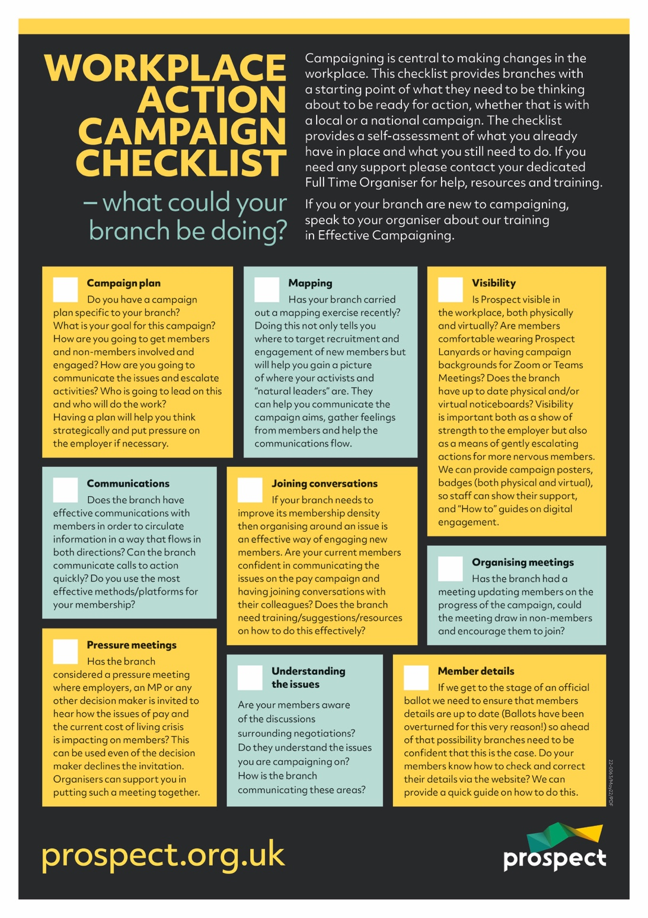

Charting
Charting is a technique used by experienced campaigners to keep a track of the progress of a campaign and to evaluate if the campaign is going well or if the plans need adjusting or re-thinking. Charing allows you to assess:

- How engaged are your members?​
- Are non-members engaging and how are you progressing them?​
- How many members are engaging with communications?​
- How many members come to meetings?​
- If you asked members to do something – how many responded, and who?
Charting can be done electronically (using Excel for example) or physically using an actual chart (see the example below). Whatever method is used it must be stored securely and only shared appropriately to comply with GDPR. We will cover how GDPR interacts with campaigning later in the course.
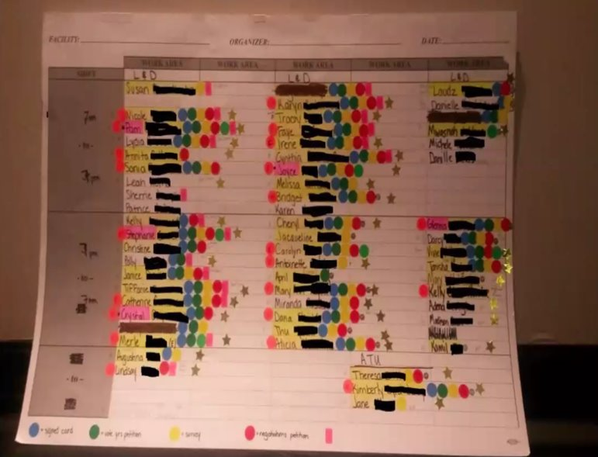

Structure tests
Charting activity within a campaign alongside campaign tactics form what are called structure tests. Each campaign tactic will be engaged with (or not!) by members and non-members, measuring this engagement will give an indication of the progress of the campaign and if anything needs re-evaluating and this is what is known as structure testing. The process has the advantage of:
- Measuring actions that involve your branch​
- Measuring engagement which gives you evidence and confidence as a campaign builds​
- Encouraging two-way communications​
- Building solidarity amongst members
Below are two examples of very simple charts which provide structure testing information.
Example 1

In this example the campaign is going well, there is engagement on the majority of “events” and people are continuing to take action. However, there are one or two issues that this chart raises that the campaign team might want to discuss and seek more information on. Can you think of any others?
- Sue has not attended either meeting despite being engaged with other things. The campaign team will want to investigate this and see if the timings of the meeting are excluding people in some way
- Ash is really engaged apart from the wearing of a lanyard; this might warrant further investigation. Maybe Ash fears he will be treated differently or bullied in some way if he reveals his union membership? Maybe he’s not a member yet?
 | Lanyards | Meet 1 | Survey | Meet 2 | Petition
John
Sue
Sahid
Elspeth
Andy
Ash

Example 2

In this example the campaign is flagging! It started well with everyone taking up the first “call to action” but then engagement has dropped off. The campaign team will want to investigate this and re-evaluate the campaign plan. Perhaps the step from wearing a lanyard to attending a meeting is too big a step, so the campaign might need to progress more slowly? Maybe there is a failure in communication, or the meetings aren’t in a convenient place or format?

A positive outcome of this chart is Obi’s engagement. Does the campaign team know Obi or could they be someone who wants to become more active in the campaign?
 | Lanyards | Meet 1 | Survey | Meet 2 | Petition
Elli
Mary
Hafsa
Sade
Zoe
Obi

GDPR and campaigning data
There is more detailed information in the appendices of this workbook on GDPR but a few points specific to campaigning are:

- Mapping/Charting are legitimate union activities.​
- The right to organise cannot be taken away by GDPR legislation.​
- All the usual GDPR rules do apply so protect data, keep data secure, limit audience, password protect.​
- Distribute activity and data – like a distributed network, more secure less chance of any GDPR issues.

If in any doubt, make a discussion with Prospect’s data compliance officer part of your planning.

Finally…

Top tips for campaigns
- Make it local
- Stay focused on a simple message
- Marshall your evidence
- Suggest opportunities for raising the issue
- Anticipate counterarguments
- Offer public praise when ‘targets’ do the right thing.

Some reasons campaigns fail
- Incomplete buy-in
- Thinking tactically not strategically
- Campaign message was not appealing to the audience
- Lack of understanding of the issue(s).

Appendix 1: Campaign strategy chart

How to use this chart
Once you have identified your campaign issue and built your core campaign team, use this chart for your overall strategy. Create five sections (ideally on a flipchart or online equivalent) and start completing them. It will form the masterplan for your campaign. It’s a fluid chart, so revisit and revise it throughout the duration of the campaign.

Strengths and weaknesses
Strengths of the campaign | Weaknesses of the campaign

Goals
Nothing goes here that you can’t win from targets and allies.
Short-term goals
Intermediate goals
Long-term goals

Messaging
Main issues
Core messaging
Secondary messaging
Slogan ideas

Constituents, allies, targets and opponents
Constituents
People organised, or potentially organisable. Directly affected by this issue.
- What’s in it for them?
- How can they be mobilised?
- What power do they have?

Targets
Decision makers
Those who have the power to create change.
- What do they care about?
- What are their motivations?
- What are their weaknesses?

Secondary targets
Decision makers
- What do they care about?
- What are their motivations?
- What are their weaknesses?
Allies
People who would support us, but are not organisable (already organised elsewhere)
- What’s in it for them?
- How can they be mobilised?
- What power do they have?

Opponents
Unlike targets, you have little power over them or them over you.
- What do they care about?
- What are their weaknesses?
- How can we neutralise them?

Tactics
How do we mobilise constituents to pressure the target into giving us what we want?

Resources we need
People | Items

Timeline
 | Week 1 | Week 2 | Week 3 | Week 4
March
April
May
June
July
August

Appendix 2: Asking allies for support
Below are some pointers that may help you formulate a statement or thoughts when approaching allies.
Before you begin, identify what you will be asking for.
We are...
How many and what kind of workers? Who are we in relation to the audience?
Things were...
How were things before they turned bad?
But now...
How are things getting worse?
Because...
Why are things getting worse?
Things will get better when...
What needs to happen to make things better?
Together we want...
What are our public demands, our goals?
To accomplish this, we must...
What needs to change to fix the problem?
What we are asking you to do...
What concrete things can this audience do now to help? Be very specific.
Together we will...
What will working together accomplish?

Appendix 3: Suggestions for tactics
- Petitions
- Distribution of information
- Leafleting (digital and/or hard copy)
- Talking about a particular problem in the workplace in a synchronised manner
- Competitions
- Social events (can be done online)
- Badges or stickers
- Digital stickers and backgrounds
- T-shirts all worn at the same time
- Investigations and reports from ally groups (NGOs, women’s groups, universities etc)
- Songs / slogans
- Gathering at a building or online meeting
- Phone / email / postcard protests
- Appeals for justice from community allies
- Anonymous workers’ stories
- Surveys / petitions
  - Keep it short – one or two questions
  - Report the results when you’re ready – eg 85% of workers report and increase in workload, 75% report a worsening of work/life balance.

Appendix 4: Data protection
Prospect is covered by the General Data Protection Regulations. Here are some guidelines for reps drawn up by the union’s compliance officer.
The EU data protection regulations came into force on 25 May 2018. While these are underpinned by the Data Protection Act 2018, they introduce a new suite of rights and enhance existing ones.
Enhanced rights
- Right of access (right to request access to personal information, eg Data Subject Access Request)
- Right of rectification (right to request correction of incomplete or inaccurate personal information)
New rights
- Right to portability – allows individuals to obtain and reuse personal data for their own purposes across different services
- Right to be informed – providing people with clear and concise information about what we do with their data
- Right to erasure (the ‘right to be forgotten’)
You can find more information in our briefing: https://library.prospect.org.uk/id/2016/01617
Common-sense dos and don’ts to ensure you comply with data protection legislation
Do...
- mark all correspondence, electronic or otherwise, as private and confidential
- be aware that the Act applies to paper files, information held electronically, records of telephone conversations, audiotapes, photographs and social networking media (Facebook, twitter, LinkedIn etc)
- think of personal data held about individuals as though it were held about you
- tell people you hold personal data about them and tell them why you need to do so (fair processing). Be open with people about information held about them
- be open with people about information held about them
- respect confidentiality and the rights of the member
- review personal data in on-going cases from time to time and at least annually
- ensure all personal data is disposed of as confidential waste
- when writing reports, minutes etc, bear in mind that the member has a right to see information relating to them; even deleted emails may be retrieved and revealed to those about whom they are written
- refer all requests for access to a Prospect full-time official
- familiarise yourself with Prospect’s data destruction policy (reproduced overleaf).

Don’t...
- worry about the complexities of the Act - the Data Protection principles are simple
- reveal personal data to third parties without the data subject's permission or justification
- disclose any personal data over the telephone
- put personal data about a member on the Internet without his/her permission
- send personal data outside the European Economic Area (EEA) without taking advice from Prospect
- leave personal data insecure in any way, whether it is physical files or information held electronically
- take personal data home without ensuring that it can be securely stored
- use personal data held for one purpose for a different purpose without permission from the member.
Enquiries relating to GDPR within Prospect should be directed to datacompliance@prospect.org.uk.

Appendix 5: Useful links
Prospect
Prospect rep’s handbook
https://library.prospect.org.uk/download/2009/00650
A leaflet setting out our legal team’s successes between November 2021 and November 2022
https://library.prospect.org.uk/download/2022/00953
Benefits and services leaflet
https://library.prospect.org.uk/download/2014/01255
Logos, templates and other resources
https://prospect.org.uk/ambition/
Members’ guides
https://members.prospect.org.uk/resources/guides-factcards/members-guides
Posters
https://members.prospect.org.uk/resources/leaflets-posters/posters
https://library.prospect.org.uk/download/2022/00436
TUC
TUC
www.tuc.org.uk
Worksmart
https://worksmart.org.uk
Union reps’ forum
https://unionreps.org.uk
Health and safety, union effect
www.tuc.org.uk/research-analysis/reports/union-effect
Training
www.tuc.org.uk/sites/default/files/Skils_and_training.pdf
Collective bargaining and great jobs
www.tuc.org.uk/research-analysis/reports/great-jobs-are-union-jobs
Training benefit to economy
www.tuc.org.uk/sites/default/files/Skils_and_training.pdf
Other
ACAS code of practice 3
http://bit.ly/acas-time-off
ACAS
www.acas.org.uk
Union wage premium
http://bit.ly/union-wage-premium
UK Government
www.gov.uk

