

Sexual Harassment in defence  
Time for Action - Survey results

A Prospect briefing • March 2025

1. A picture containing text, sign

   Description automatically generated
2. Sexual Harassment in defence Time for action – Survey Results

A Prospect briefing • March 2025

Contents

Introduction 3

Key findings 4

What action has been taken in the last 12 months? 5

Have the actions taken been effective? 5

Communicating with staff 6

Confidence in the actions taken 6

Confidence in reporting 6

Does the defence sector have a toxic culture? 7

Awareness of the Prospect helpline 8

What action would you like your employer to take in the next 12 months? 8

Prospect  
100 Rochester Row  
London SW1P 1JP

Tel: 0300 600 1878

[prospect.org.uk](https://prospect.org.uk/)

## Introduction

A year ago Prospect conducted a survey of women working in defence to find out the scale of sexual harassment in the sector. The survey was launched following the publication of a letter by sixty senior women at the Ministry of Defence (MoD) to the department’s Permanent Secretary making allegations of sexual assault, harassment, and abuse by male colleagues. The survey confirmed our fears that this is a widespread problem across the sector.

The union circulated a follow-up survey during February 2025 to find out what has happened in the last 12 months. This report summarises the survey results.

**Survey Respondents**

The survey was completed by 174 respondents; 47 from MoD, 70 from MoD arm’s length bodies and 51 from private sector organisations. Respondents are spread over four age groups; 25% are under 35, 24% are aged between 35 and 44, 27% are aged 45 to 54 and 22% are aged 55 years and over.

There is a different age spread for each type of organisation; 60% of those working for MoD are aged over 45 years of age, this falls to 49% for MoD ALBs and 41% of respondents working in the private sector. Just over a third of respondents in the private sector are under 35 years of age (35%), this falls to 24% at MoD ALBs and 17% of those working for MoD. There is a similar profile for length of service, nearly two thirds of MoD respondents (62%) have worked for their organisation for more than 10 years, this falls to 47% of those working for MoD ALBs, and 33% of those working in the private sector.

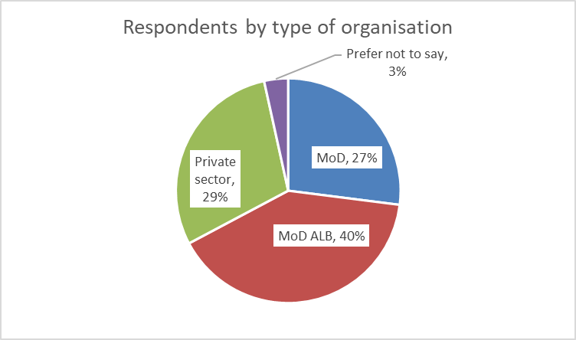

## Key findings

* A majority of respondents (57%) are not aware of any action being taken in the last 12 months to raise awareness of the harms of sexual harassment at work. The most common actions that have been taken are the publication of guidance pages on staff intranet, and staff briefings to raise awareness of the employer’s sexual harassment policy.
* Just 28% of respondents think that the action taken by their employer to deter sexual harassment in the last year has been effective, 26% say that the action has not been effective, and 46% say that no action has been taken.
* Most respondents have either not seen communications from their employer on sexual harassment (41%), or the policy has not been widely circulated (22%), less than 30% say that the policy on sexual harassment has been clearly communicated to staff.
* Confidence in the effectiveness of the actions taken to deter sexual harassment has fallen in the last year, from 47% in January 2024 to 39% in February 2025. The fall is sharpest in MoD ALBs, where confidence has fallen from 46% in 2024 to 29% in 2025.
* Confidence in reporting incidents of sexual harassment has fallen in all organisations. In 2024, 65% of respondents felt confident enough to report an incident of sexual harassment, this has fallen to 58% in 2025. In the MoD confidence has fallen from 63% to 55%, in MoD ALBs from 61% to 56%, and in the private sector from 72% to 67%.
* A majority of respondents view behaviours in the defence sector as toxic and inappropriate. There has been a fall from 65% in 2024 to 58% in 2025, however a majority still hold a negative perception of the defence sector’s culture. Those with the least positive perception of work cultures are MoD respondents, 70% say that the workplace culture is toxic, a small fall from 73% last year.
* Only 32% of respondents had heard about Prospect’s helpline for members who have been sexually harassed. Members working for MoD ALBs are most likely to have heard about the service, 40% compared to 28% of members in MoD and 27% respondents working in the private sector.

To improve workplace culture, respondents suggest that their organisation:

* Builds trust by acknowledging that sexual harassment complaints have been raised, and reassuring staff that complaints of sexual harassment will be taken seriously.
* Provide clear communications on the behaviours that are unacceptable,
* Take action if there is evidence of sexual harassment.
* Publicise how the employer has dealt with complaints as a way of raising awareness and encouraging those that have been harassed to use the reporting process.
* Provide mandatory training for staff to raise awareness of the behaviours that will not be tolerated.

## What action has been taken in the last 12 months?

A majority of respondents (57%) are not aware of any action being taken by their employer in the last 12 months to raise awareness of the harms of sexual harassment at work. A similar proportion of those working for MoD (55%) and private sector organisations (54%) were not aware of any actions being taken, this rises to 61% of those working for MoD ALBs.

The most common action taken by employers is to add new pages on the staff intranet (27% of respondents). Other actions include staff briefings to highlight unacceptable behaviours (18%), adoption of a policy on deterring sexual harassment at work (17%), staff awareness training (16%) and publication of a poster or leaflet highlighting unacceptable behaviours (14%).

Respondents working for MoD are most likely to have seen new staff intranet pages (36%), or a leaflet or poster (20%). More than one in five of respondents in the private sector, and MoD, have attended a staff briefing that highlights unacceptable behaviours (24% and 20% respectively). Private sector respondents are most likely to report that their employer has adopted a policy on deterring sexual harassment at work (22%). Very few respondents report that there has been line manager training (7%).

## Have the actions taken been effective?

Just 28% of respondents think that the action taken by their employer to deter sexual harassment in the last year has been effective, 26% say that the action has not been effective, and 46% say that no action has been taken.

Where an action has been taken those working for private sector organisations are most likely to say that the action taken has been effective (35%). Those working for MoD are most likely to say that the action has not been effective (35%), those working for MoD ALBs are most likely to say that no action has been taken (51%).

## Communicating with staff

Most respondents have either not seen communications from their employer (41%), or the policy has not been widely circulated (22%). Less than 30% of respondents say that the sexual harassment policy has clearly communicated to staff.

Respondents working in the private sector or for MoD ALBs are most likely to say they have not seen a communication (37% and 43% respectively), or that the policy has not been widely circulated (31% and 20%).

Respondents working for MoD are most likely to say that the organisation’s policy has been clearly communicated (35%, compared to 27% in the private sector and 24% of those working for MoD ALBs). However, 39% of MoD respondents have not seen a communication, and 17% say the policy has not been widely circulated.

## Confidence in the actions taken

Overall, confidence in the effectiveness of the actions taken to deter sexual harassment has fallen in the last year, from 47% in January 2024 to 39% in February 2025. The fall is sharpest in MoD ALBs, where confidence has fallen from 46% to 29% this year. The fall in confidence is small in the private sector, from 53% to 49%, and MoD, from 42% to 41%.

In MoD and MoD ALBs confidence in the effectiveness of employer action is lower for respondents under 45 years of age (33% in MoD and 18% in MoD ALBs) when compared with those that are 45 years and older (48% in MoD and 44% in MoD ALBs). In the private sector there is little difference in the confidence rating based on age, with about 50% of respondents saying they are confident in both age groups.

## Confidence in reporting

Confidence in reporting has fallen in all organisations. In 2024 nearly two thirds of respondents (65%) felt confident enough to report an incident of sexual harassment, this has fallen to 58% in 2025. In the MoD confidence in reporting has fallen from 63% to 55%, in MoD ALBs confidence has fallen from 61% to 56%, and in the private sector from 72% to 67%.

The change in confidence rating is not uniform. There has been a slight rise in those that are extremely or very confident in reporting, from 32% in 2024 to 34% in 2025, but there has also been an increase in those that are not confident, from 35% in 2024 to 42% in 2025.

Respondents that are 45 years of age and over are more confident than those aged under 45 years of age. In the private sector 60% of respondents under 45 years of age have confidence in reporting, this rises to 76% of those aged 45 years and over. There is a narrower confidence gap for respondents working for MoD ALBs, 59% of those aged 45 years and over feel confident reporting incidents, this falls to 53% of those aged under 45 years. The lowest confidence rating is for respondents aged under 45 years of age working for MoD, just 44% of respondents have confidence in the reporting system, rising to 61% of those aged 45 years and over.

## Does the defence sector have a toxic culture?

A majority of respondents view behaviours in the defence sector as toxic and inappropriate. Although there has been a fall from 65% in 2024 there are still 58% of respondents that believe that the defence sector tolerates unwelcome and inappropriate behaviours.

There are some variations by sector. Those with the least positive perceptions of work cultures are MoD respondents, 70% say that the culture is toxic, a small fall from 73% in the previous year. This negative perception is most strongly held by those under 45 years of age, 83% agree that behaviours are often inappropriate, 61% of those aged 45 years and older hold this view.

There has been a fall in proportion of respondents that view the work culture as toxic in MoD ALBs, from 64% to 57%. However, there is significant division between younger and older respondents, 68% of those under 45 years of age agree that the workplace in toxic compared to just 45% of those aged 45 years and older.

In the private sector there has been a sharp fall in the proportion of respondents that view workplace culture as toxic, down from 61% to 51% this year. There is very little difference in the perceptions based on age, 50% of under 45 years agree with the statement compared with 52% of those aged 45 years or older.

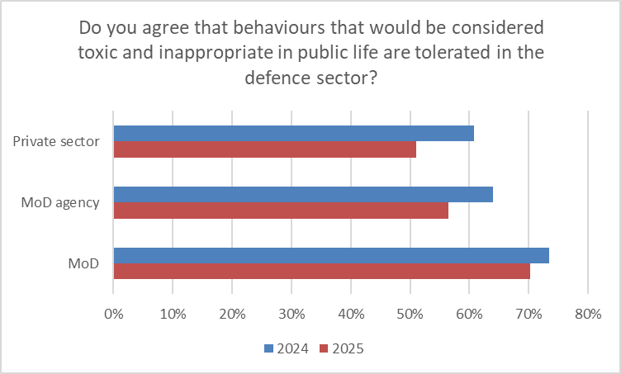

## Awareness of the Prospect helpline

Prospect launched a helpline to provide support for those that have been sexually harassed. The new service has been publicised on the union’s website and through communications with members. Despite these efforts to publicise the new service only 32% of respondents had heard about the helpline. Members working for MoD ALBs are most likely to have heard about the service, 40% compared to 28% of respondents in MoD and 27% working in the private sector. There was very little difference based on the age of the respondent, the only group of respondents that were more aware of the service are respondents aged 45 years and over working for MoD ALBs (44%).

## What action would you like your employer to take in the next 12 months?

Nearly two thirds of respondents made a suggested action that their employer could take in the next year. The Table below summarises more common comments.

**What action would you like your employer to take to deter sexual harassment?**

|  |  |  |  |  |
| --- | --- | --- | --- | --- |
| Comment | MoD | MoD ALBs | Private sector | Total |
| Highlight policy, communicate what behaviours are unacceptable | 10 | 20 | 18 | 50 |
| Be prepared to act | 3 | 11 | 6 | 20 |
| Train staff and raise awareness | 4 | 8 | 6 | 19 |
| Build trust - Acknowledge incidents that have happened | 5 | 7 | 2 | 14 |
| Believe female staff when complaints are made/Encourage reporting | 4 | 7 | 2 | 13 |
| Raise awareness of action taken on allegations | 5 | 1 | 1 | 7 |
| Policies are already in place | 4 | 2 | 1 | 7 |
| Adopt a sexual harassment policy | 0 | 1 | 3 | 5 |
| Mandatory training to change behaviours | 0 | 3 | 0 | 3 |

**The most common comment in all sectors is to provide clear communications on the behaviours that are unacceptable.**

*“Go into the finer details of what is acceptable rather than general policies.” (Private sector)*

*“Explicitly talk about this behaviour being unacceptable.” (MoD ALB)*

*“Educate teams by specifying what they mean when they are referring to what sexual harassment is, as there are so many staff members that do not believe/understand why some of their behaviours amount to sexual harassment.” (Private sector)*

**Positive reinforcement of the employer’s policy on sexual harassment, and ensuring that staff understand that the issue will be taken seriously.**

*“Just keep on communicating to all members of staff and reminding them that it won't be tolerated in the workplace.” (Anonymous comment)*

*“Raise awareness company level. Like they have done with cyber crime.” (Private sector)*

**As well as communication, respondents also want their employer to take action if there are unacceptable behaviours.**

*“State they have zero tolerance for sexual harassment in the workplace and show they are prepared to act to put an end to this behaviour.” (MoD ALB)*

*“Deal with specific incidents quickly and effectively.” (MoD ALB)*

**Building trust by acknowledging that sexual harassment complaints have been raised.**

*“Acknowledge the letter written by female MOD staff last year instead of deleting all copies from the intranet. Then state what they intend to do about it.” (MoD ALB)*

*“Build trust that the victim will not be persecuted.” (Mod)*

*“How about treating people with respect from the top down and setting a good example of how you expect your employees to behave.” (MoD)*

**Building on the theme of trust, respondents also saw this as a way of encouraging reporting.**

*“Further awareness of the issues and encourage people to speak up if made to feel uncomfortable.” (MoD ALB)*

*“Stop protecting each other in the management chain. Take claims / concerns seriously.” (MoD)*

**Publicising how the employer has dealt with complaints is seen as a way of raising awareness.**

*“Anonymise and publicly circulate case studies of how sexual harassment/assault events occurred and how the organisation handled it.” (MoD)*

*“Report on the anonymised stats so that we can see what action was taken, not just how many were reported. We need to know what the consequences were for the perpetrator. This would give more confidence to someone who was thinking of reporting an incident.” (MoD)*

**Provide mandatory training for staff to ensure that all staff are aware of what behaviours will not be tolerated.**

*“More internal training courses on the topic, so people are aware it will not be tolerated.” (MoD ALB)*

*“More than just a page on the intranet. Perhaps workshops, mandatory training, as the perpetrators wouldn't attend unless mandatory.” (MoD ALB)*

*“Mandatory training for men at first low level accusation to prevent it escalating.” (MoD ALB)*