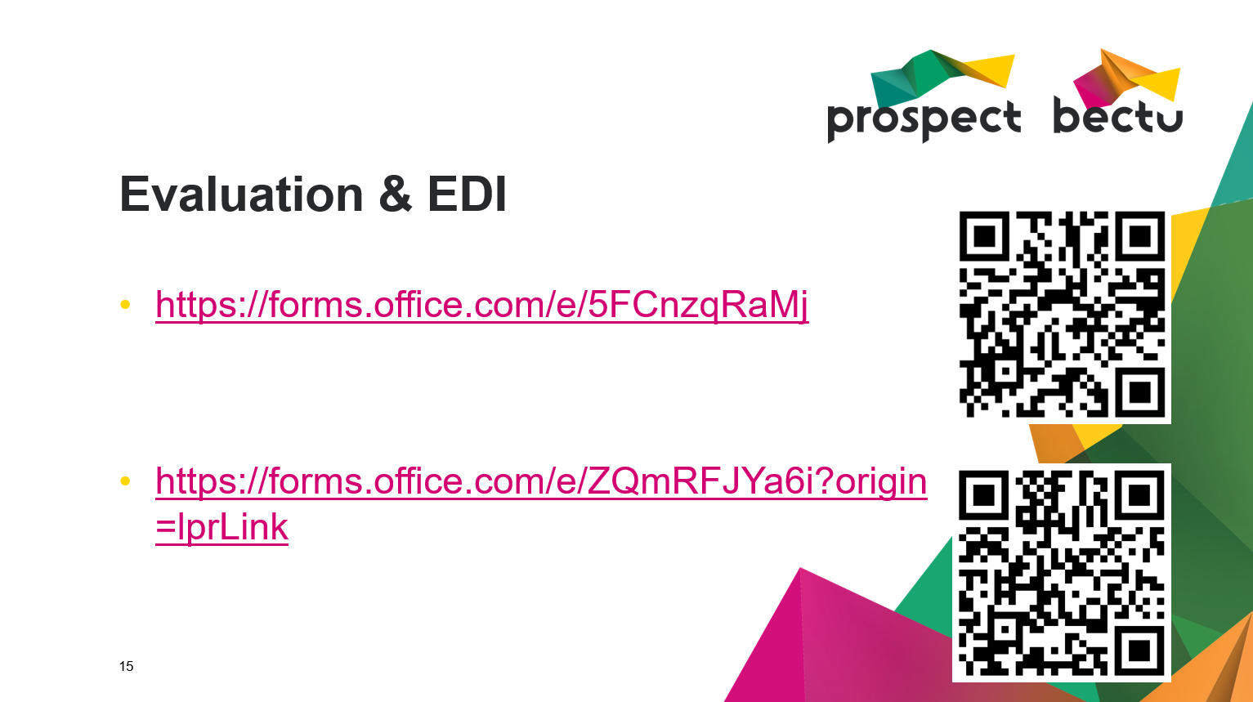

<https://forms.office.com/e/5FCnzqRaMj>

<https://forms.office.com/e/ZQmRFJYa6i?origin=lprLink>